UNITED STATES
SECURITIES AND EXCHANGE COMMISSION
Washington, DC 20549
____________
FORM 8-K
CURRENT REPORT
PURSUANT TO SECTION 13 OR 15(d) OF THE
SECURITIES EXCHANGE ACT OF 1934

Date of Report (Date of earliest event reported):
February 17, 2022

CHIMERA INVESTMENT CORPORATION
(Exact name of registrant as specified in its charter)

Maryland |  |  | 1-33796 |  |  | 26-0630461
(State or Other Jurisdiction |  |  | (Commission |  |  | (IRS Employer
of Incorporation) |  |  | File Number) |  |  | Identification No.)

630 Fifth Avenue, STE 2400
New York, New York
(Address of principal executive offices)
10111
(Zip Code)

Registrant’s telephone number, including area code: (212) 626-2300

Securities registered pursuant to Section 12(b) of the Act:

Title of Each Class |  |  | Trading Symbol(s) |  |  | Name of Each Exchange on Which Registered
Common Stock, par value $0.01 per share |  |  | CIM |  |  | New York Stock Exchange
8.00% Series A Cumulative Redeemable Preferred Stock |  |  | CIM PRA |  |  | New York Stock Exchange
8.00% Series B Fixed-to-Floating Rate Cumulative Redeemable Preferred Stock |  |  | CIM PRB |  |  | New York Stock Exchange
7.75% Series C Fixed-to-Floating Rate Cumulative Redeemable Preferred Stock |  |  | CIM PRC |  |  | New York Stock Exchange
8.00% Series D Fixed-to-Floating Rate Cumulative Redeemable Preferred Stock |  |  | CIM PRD |  |  | New York Stock Exchange
Registrant's Web site address: www.chimerareit.com

(Former Name or Former Address, if Changed Since Last Report)

Check the appropriate box below if the Form 8-K filing is intended to simultaneously satisfy the filing obligation of the registrant under any of the following provisions:

☐ Written communications pursuant to Rule 425 under the Securities Act (17 CFR 230.425)

☐ Soliciting material pursuant to Rule 14a-12 under the Exchange Act (17 CFR 240.14a-12)

☐ Pre-commencement communications pursuant to Rule 14d-2(b) under the Exchange Act (17 CFR 240.14d-2(b))

☐ Pre-commencement communications pursuant to Rule 13e-4(c) under the Exchange Act (17 CFR 240.13e-4(c))

Indicate by check mark whether the registrant is an emerging growth company as defined in Rule 405 of the Securities Act of 1933 (§230.405 of this chapter) or Rule 12b-2 of the Securities Exchange Act of 1934 (§240.12b-2 of this chapter).

Emerging growth company ☐

If an emerging growth company, indicate by check mark if the registrant has elected not to use the extended transition period for complying with any new or revised financial accounting standards provided pursuant to Section 13(a) of the Exchange Act. ☐

Item 2.02. Results of Operations and Financial Condition

On February 17, 2022, the registrant issued a press release announcing its financial results for the quarter and year ended December 31, 2021. A copy of the press release is furnished as Exhibit 99.1 to this report.

On February 17, 2022, the registrant posted supplemental financial information on the News & Events - Press Releases section of its website (www.chimerareit.com). A copy of the supplemental financial information is furnished as Exhibit 99.2 to this report and incorporated herein by reference.

Item 9.01 Financial Statements and Exhibits

(d) Exhibits

99.1 Press Release, dated February 17, 2022, issued by Chimera Investment Corporation
99.2 Supplemental Financial Information for the quarter ended December 31, 2021

SIGNATURES
Pursuant to the requirements of the Securities Exchange Act of 1934, the registrant has duly caused this report to be signed on its behalf by the undersigned hereunto duly authorized.

Chimera Investment Corporation
By: /s/ Subramaniam Viswanathan
Name: Subramaniam Viswanathan
Title: Chief Financial Officer

Date: February 17, 2022


PRESS RELEASE
NYSE: CIM
CHIMERA INVESTMENT CORPORATION
630 Fifth Ave, Ste 2400
New York, New York 10111
_________________________________________________________________________________________________

Investor Relations
888-895-6557
www.chimerareit.com
FOR IMMEDIATE RELEASE
CHIMERA INVESTMENT CORPORATION REPORTS 4TH QUARTER 2021 EARNINGS
•4TH QUARTER GAAP NET LOSS OF $718 THOUSAND, OR $0.00 PER DILUTED COMMON SHARE
•4TH QUARTER EARNINGS AVAILABLE FOR DISTRIBUTION(1) OF $111 MILLION, OR $0.46 PER DILUTED COMMON SHARE WHICH INCLUDES $0.08 OF INCOME FROM AGENCY CMBS SECURITIES THAT HAVE BEEN CALLED
•FULL YEAR GAAP NET INCOME OF $596 MILLION, OR $2.44 PER DILUTED COMMON SHARE
•FULL YEAR EARNINGS AVAILABLE FOR DISTRIBUTION(1) OF $429 MILLION, OR $1.78 PER DILUTED COMMON SHARE WHICH INCLUDES $0.26 OF INCOME FROM AGENCY CMBS SECURITIES THAT HAVE BEEN CALLED
•GAAP BOOK VALUE OF $11.84 PER COMMON SHARE
NEW YORK - (BUSINESS WIRE) - Chimera Investment Corporation (NYSE:CIM) today announced its financial results for the fourth quarter ended December 31, 2021. The Company’s GAAP net loss for the fourth quarter was $718 thousand, or $0.00 per diluted common share and net income was $596 million, or $2.44 per diluted common share for the full year ended December 31, 2021. Earnings available for distribution(1) for the fourth quarter and full year ended December 31, 2021 was $111 million, or $0.46 per diluted common share and $429 million, or $1.78 per diluted common share, respectively.

“Low interest rates throughout most of 2021, combined with strong investor demand for high-quality fixed-income assets, allowed Chimera to optimize its liability structure which we believe will benefit our shareholders over the long-term,” said Mohit Marria, CEO and Chief Investment Officer. “Securitization of mortgage assets is at the core of our company’s DNA. Through securitizations this year, Chimera increased its advance rate by 14% while reducing its overall cost of debt by 120 basis points,” Mr. Marria added, “This quarter we purchased an additional $540 million loans for our portfolio which brought Chimera’s total loan purchases for the full year to $3.2 billion.”

(1) Earnings available for distribution per adjusted diluted common share is a non-GAAP measure. See additional discussion on page 5.
(2) Economic return on book value is based on the change in GAAP book value per common share plus the dividend declared per common share.
1

Other Information
Chimera Investment Corporation is a publicly traded real estate investment trust, or REIT, that is primarily engaged in the business of investing directly or indirectly through its subsidiaries, on a leveraged basis, in a diversified portfolio of mortgage assets, including residential mortgage loans, Non-Agency RMBS, Agency CMBS, Agency RMBS, and other real estate related securities.

CHIMERA INVESTMENT CORPORATION
CONSOLIDATED STATEMENTS OF FINANCIAL CONDITION
(dollars in thousands, except share and per share data)
(Unaudited)
 |  |  | December 31, 2021 |  |  | December 31, 2020
Cash and cash equivalents |  |  | $ | 385,741 |  | $ | 269,090
Non-Agency RMBS, at fair value (net of allowance for credit losses of $213 thousand and $180 thousand, respectively) |  |  | 1,810,208 |  |  | 2,150,714
Agency RMBS, at fair value |  |  | 60,487 |  |  | 90,738
Agency CMBS, at fair value |  |  | 761,208 |  |  | 1,740,368
Loans held for investment, at fair value |  |  | 12,261,926 |  |  | 13,112,129
Accrued interest receivable |  |  | 69,513 |  |  | 81,158
Other assets |  |  | 58,320 |  |  | 78,822
Total assets (1) |  |  | $ | 15,407,403 |  | $ | 17,523,019
Liabilities:
Secured financing agreements ($4.4 billion and $6.7 billion pledged as collateral, respectively) |  |  | $ | 3,261,613 |  | $ | 4,636,847
Securitized debt, collateralized by Non-Agency RMBS ($365 million and $505 million pledged as collateral, respectively) |  |  | 87,999 |  |  | 113,433
Securitized debt at fair value, collateralized by Loans held for investment ($11.0 billion and $12.4 billion pledged as collateral, respectively) |  |  | 7,726,043 |  |  | 8,711,677
Long term debt |  |  | — |  |  | 51,623
Payable for investments purchased |  |  | 477,415 |  |  | 106,169
Accrued interest payable |  |  | 20,416 |  |  | 40,950
Dividends payable |  |  | 86,152 |  |  | 77,213
Accounts payable and other liabilities |  |  | 11,574 |  |  | 5,721
Total liabilities (1) |  |  | $ | 11,671,212 |  | $ | 13,743,633
Stockholders' Equity:
Preferred Stock, par value of $0.01 per share, 100,000,000 shares authorized:
8.00% Series A cumulative redeemable: 5,800,000 shares issued and outstanding, respectively ($145,000 liquidation preference) |  |  | $ | 58 |  | $ | 58
8.00% Series B cumulative redeemable: 13,000,000 shares issued and outstanding, respectively ($325,000 liquidation preference) |  |  | 130 |  |  | 130
7.75% Series C cumulative redeemable: 10,400,000 shares issued and outstanding, respectively ($260,000 liquidation preference) |  |  | 104 |  |  | 104
8.00% Series D cumulative redeemable: 8,000,000 shares issued and outstanding, respectively ($200,000 liquidation preference) |  |  | 80 |  |  | 80
Common stock: par value $0.01 per share; 500,000,000 shares authorized, 236,951,266 and 230,556,760 shares issued and outstanding, respectively |  |  | 2,370 |  |  | 2,306
Additional paid-in-capital |  |  | 4,359,045 |  |  | 4,538,029
Accumulated other comprehensive income |  |  | 405,054 |  |  | 558,096
Cumulative earnings |  |  | 4,552,008 |  |  | 3,881,894
Cumulative distributions to stockholders |  |  | (5,582,658) |  |  | (5,201,311)
Total stockholders' equity |  |  | $ | 3,736,191 |  | $ | 3,779,386
Total liabilities and stockholders' equity |  |  | $ | 15,407,403 |  | $ | 17,523,019
(1) The Company's consolidated statements of financial condition include assets of consolidated variable interest entities, or VIEs, that can only be used to settle obligations and liabilities of the VIE for which creditors do not have recourse to the primary beneficiary (Chimera Investment Corporation). As of December 31, 2021, and December 31, 2020, total assets of consolidated VIEs were $10,666,591 and $12,165,017, respectively, and total liabilities of consolidated VIEs were $7,223,655 and $8,063,110, respectively.
2

CHIMERA INVESTMENT CORPORATION
CONSOLIDATED STATEMENTS OF OPERATIONS
(dollars in thousands, except share and per share data)
(Unaudited)
 |  |  | For the Year Ended
 |  |  | December 31, 2021 |  |  | December 31, 2020 |  |  | December 31, 2019
Net interest income:
Interest income (1) |  |  | $ | 937,546 |  | $ | 1,030,250 |  | $ | 1,361,110
Interest expense (2) |  |  | 326,628 |  |  | 516,181 |  |  | 758,814
Net interest income |  |  | 610,918 |  |  | 514,069 |  |  | 602,296
Increase/(decrease) in provision for credit losses |  |  | 33 |  |  | 180 |  |  | —
Net other-than-temporary credit impairment losses |  |  | — |  |  | — |  |  | (4,853)
Other investment gains (losses):
Net unrealized gains (losses) on derivatives |  |  | — |  |  | 201,000 |  |  | (106,209)
Realized gains (losses) on terminations of interest rate swaps |  |  | — |  |  | (463,966) |  |  | (359,726)
Net realized gains (losses) on derivatives |  |  | — |  |  | (41,086) |  |  | (34,423)
Net gains (losses) on derivatives |  |  | — |  |  | (304,052) |  |  | (500,358)
Net unrealized gains (losses) on financial instruments at fair value |  |  | 437,357 |  |  | (110,664) |  |  | 409,634
Net realized gains (losses) on sales of investments |  |  | 45,313 |  |  | 166,946 |  |  | 20,360
Gains (losses) on extinguishment of debt |  |  | (283,556) |  |  | (54,418) |  |  | 9,318
Total other gains (losses) |  |  | 199,114 |  |  | (302,188) |  |  | (61,046)
Other expenses:
Compensation and benefits |  |  | 46,823 |  |  | 44,811 |  |  | 48,880
General and administrative expenses |  |  | 22,246 |  |  | 22,914 |  |  | 23,915
Servicing and asset manager fees |  |  | 36,555 |  |  | 39,896 |  |  | 38,930
Transaction expenses |  |  | 29,856 |  |  | 15,068 |  |  | 10,928
Total other expenses |  |  | 135,480 |  |  | 122,689 |  |  | 122,653
Income (loss) before income taxes |  |  | 674,519 |  |  | 89,012 |  |  | 413,744
Income tax expense (benefit) |  |  | 4,405 |  |  | 158 |  |  | 193
Net income (loss) |  |  | $ | 670,114 |  | $ | 88,854 |  | $ | 413,551
Dividends on preferred stock |  |  | 73,764 |  |  | 73,750 |  |  | 72,704
Net income (loss) available to common shareholders |  |  | $ | 596,350 |  | $ | 15,104 |  | $ | 340,847
Net income (loss) per share available to common shareholders:
Basic |  |  | $ | 2.55 |  | $ | 0.07 |  | $ | 1.82
Diluted |  |  | $ | 2.44 |  | $ | 0.07 |  | $ | 1.81
Weighted average number of common shares outstanding:
Basic |  |  | 233,770,474 |  |  | 212,995,533 |  |  | 187,156,990
Diluted |  |  | 245,496,926 |  |  | 226,438,341 |  |  | 188,406,444

(1) Includes interest income of consolidated VIEs of $586,580, $683,456 and $780,746 for the years ended December 31, 2021, 2020 and 2019, respectively.

(2) Includes interest expense of consolidated VIEs of $203,135, $285,142 and $337,387 for the years ended December 31, 2021, 2020 and 2019, respectively.

3

CHIMERA INVESTMENT CORPORATION
CONSOLIDATED STATEMENTS OF COMPREHENSIVE INCOME (LOSS)
(dollars in thousands, except share and per share data)
(Unaudited)
 |  |  | For the Year Ended
 |  |  | December 31, 2021 |  |  | December 31, 2020 |  |  | December 31, 2019
Comprehensive income (loss):
Net income (loss) |  |  | $ | 670,114 |  | $ | 88,854 |  | $ | 413,551
Other comprehensive income:
Unrealized gains (losses) on available-for-sale securities, net |  |  | (115,926) |  |  | $ | (94,136) |  | $ | 70,855
Reclassification adjustment for net losses included in net income for other-than-temporary credit impairment losses |  |  | — |  |  | $ | — |  | $ | 4,853
Reclassification adjustment for net realized losses (gains) included in net income |  |  | (37,116) |  |  | $ | (56,104) |  | $ | 5,796
Other comprehensive income (loss) |  |  | (153,042) |  |  | $ | (150,240) |  | $ | 81,504
Comprehensive income (loss) before preferred stock dividends |  |  | $ | 517,072 |  | $ | (61,386) |  | $ | 495,055
Dividends on preferred stock |  |  | $ | 73,764 |  | $ | 73,750 |  | $ | 72,704
Comprehensive income (loss) available to common stock shareholders |  |  | $ | 443,308 |  | $ | (135,136) |  | $ | 422,351

4

Earnings available for distribution

Earnings available for distribution is a non-GAAP measure and is defined as GAAP net income excluding unrealized gains or losses on financial instruments carried at fair value with changes in fair value recorded in earnings, realized gains or losses on the sales of investments, gains or losses on the extinguishment of debt, interest expense on long term debt, changes in the provision for credit losses, and transaction expenses incurred. In addition, stock compensation expense charges incurred on awards to retirement eligible employees is reflected as an expense over a vesting period (36 months) rather than reported as an immediate expense.

As defined, Earnings available for distribution is the economic net interest income, as defined previously, reduced by compensation and benefits expenses (adjusted for awards to retirement eligible employees), general and administrative expenses, servicing and asset manager fees, income tax benefits or expenses incurred during the period, as well as the preferred dividend charges. We view Earnings available for distribution as a consistent measure of our investment portfolio's ability to generate income for distribution to common stockholders. Earnings available for distribution is one of the metrics, but not the exclusive metric, that our board of directors uses to determine the amount, if any, of dividends on our common stock. In addition, Earnings available for distribution is different than REIT taxable income and the determination of whether we have met the requirement to distribute at least 90% of our annual REIT taxable income (subject to certain adjustments) to our stockholders in order to maintain qualification as a REIT is not based on Earnings available for distribution. Therefore, Earnings available for distribution should not be considered as an indication of our REIT taxable income, a guaranty of our ability to pay dividends, or as a proxy for the amount of dividends we may pay, because Earnings available for distribution excludes certain items that impact our cash needs. We believe Earnings available for distribution as described above helps us and investors evaluate our financial performance period over period without the impact of certain transactions. Therefore, Earnings available for distribution should not be viewed in isolation and is not a substitute for net income or net income per basic share computed in accordance with GAAP. In addition, our methodology for calculating Earnings available for distribution may differ from the methodologies employed by other REITs to calculate the same or similar supplemental performance measures, and accordingly, our Earnings available for distribution may not be comparable to the Earnings available for distribution reported by other REITs.

The following table provides GAAP measures of net income and net income per diluted share available to common stockholders for the periods presented and details with respect to reconciling the line items to Earnings available for distribution and related per average diluted common share amounts. Earnings available for distribution is presented on an adjusted dilutive shares basis. Certain prior period amounts have been reclassified to conform to the current period's presentation.

 |  |  | For the Quarters Ended
 |  |  | December 31, 2021 |  |  | September 30, 2021 |  |  | June 30, 2021 |  |  | March 31, 2021 |  |  | December 31, 2020
 |  |  | (dollars in thousands, except per share data)
GAAP Net income (loss) available to common stockholders |  |  | $ | (718) |  | $ | 313,030 |  | $ | 144,883 |  | $ | 139,153 |  | $ | 128,797
Adjustments:
Net unrealized (gains) losses on financial instruments at fair value |  |  | 108,286 |  |  | (239,524) |  |  | (36,108) |  |  | (270,012) |  |  | (61,379)
Net realized (gains) losses on sales of investments |  |  | — |  |  | — |  |  | (7,517) |  |  | (37,796) |  |  | 329
(Gains) losses on extinguishment of debt |  |  | (980) |  |  | 25,622 |  |  | 21,777 |  |  | 237,137 |  |  | (919)
Interest expense on long term debt |  |  | — |  |  | 238 |  |  | 959 |  |  | 1,076 |  |  | 1,197
Increase (decrease) in provision for credit losses |  |  | 92 |  |  | (386) |  |  | 453 |  |  | (126) |  |  | 13
Transaction expenses |  |  | 4,241 |  |  | 3,432 |  |  | 5,745 |  |  | 16,437 |  |  | 3,827
Stock Compensation expense for retirement eligible awards |  |  | (363) |  |  | (365) |  |  | (361) |  |  | 661 |  |  | (225)
Earnings available for distribution |  |  | $ | 110,558 |  | $ | 102,047 |  | $ | 129,831 |  | $ | 86,530 |  | $ | 71,640
GAAP net income (loss) per diluted common share |  |  | $ | (0.00) |  | $ | 1.30 |  | $ | 0.60 |  | $ | 0.54 |  | $ | 0.49
Earnings available for distribution per adjusted diluted common share |  |  | $ | 0.46 |  | $ | 0.42 |  | $ | 0.54 |  | $ | 0.36 |  | $ | 0.29
(1) We note that earnings available for distribution and taxable earnings will typically differ, and may materially differ, due to differences on realized gains and losses on investments and related hedges, credit loss recognition, timing differences in premium amortization, accretion of discounts, equity compensation and other items.

5

The following tables provide a summary of the Company’s MBS portfolio at December 31, 2021 and December 31, 2020.

 |  |  | December 31, 2021
 |  |  | Principal or Notional Value  at Period-End  (dollars in thousands) |  |  | Weighted Average Amortized  Cost Basis |  |  | Weighted Average Fair Value |  |  | Weighted Average  Coupon |  |  | Weighted Average Yield at Period-End (1)
Non-Agency RMBS
Senior |  |  | $ | 1,283,788 |  | $ | 48.02 |  | 76.78 |  |  | 4.5 |  | % | 18.0 |  | %
Subordinated |  |  | 845,432 |  |  | 68.10 |  |  | 77.12 |  |  | 3.8 |  | % | 7.1 |  | %
Interest-only |  |  | 3,904,665 |  |  | 4.90 |  |  | 4.42 |  |  | 1.7 |  | % | 13.2 |  | %
Agency RMBS
Interest-only |  |  | 992,978 |  |  | 10.37 |  |  | 6.09 |  |  | 1.3 |  | % | 0.3 |  | %
Agency CMBS
Project loans |  |  | 560,565 |  |  | 101.77 |  |  | 109.61 |  |  | 4.3 |  | % | 4.1 |  | %
Interest-only |  |  | 2,578,640 |  |  | 5.70 |  |  | 5.69 |  |  | 0.7 |  | % | 4.6 |  | %
(1) Bond Equivalent Yield at period end.

 |  |  | December 31, 2020
 |  |  | Principal or Notional Value at Period-End  (dollars in thousands) |  |  | Weighted Average Amortized  Cost Basis |  |  | Weighted Average Fair Value |  |  | Weighted Average  Coupon |  |  | Weighted Average Yield at Period-End (1)
Non-Agency RMBS
Senior |  |  | $ | 1,560,135 |  | $ | 50.65 |  | $ | 81.90 |  | 4.5 |  | % | 16.9 |  | %
Subordinated |  |  | 905,674 |  |  | 62.46 |  |  | 67.43 |  |  | 3.8 |  | % | 6.3 |  | %
Interest-only |  |  | 5,628,240 |  |  | 4.43 |  |  | 4.66 |  |  | 1.5 |  | % | 16.2 |  | %
Agency RMBS
Interest-only |  |  | 1,262,963 |  |  | 9.41 |  |  | 7.18 |  |  | 1.7 |  | % | 1.6 |  | %
Agency CMBS
Project loans |  |  | 1,527,621 |  |  | 101.81 |  |  | 112.23 |  |  | 4.1 |  | % | 3.8 |  | %
Interest-only |  |  | 1,326,665 |  |  | 1.78 |  |  | 1.95 |  |  | 0.6 |  | % | 8.4 |  | %
(1) Bond Equivalent Yield at period end.
6

At December 31, 2021 and December 31, 2020, the secured financing agreements collateralized by MBS and Loans held for investment had the following remaining maturities and borrowing rates.

 |  |  | December 31, 2021 |  |  |  |  |  |  |  |  |  |  |  | December 31, 2020
 |  |  | (dollars in thousands)
 |  |  | Principal (1) |  |  | Weighted Average Borrowing Rates |  |  | Range of Borrowing Rates |  |  |  |  |  | Principal (1) |  |  | Weighted Average Borrowing Rates |  |  | Range of Borrowing Rates
Overnight |  |  | $ | — |  | NA |  |  | —% - —% |  |  |  |  |  | $ | — |  | NA |  |  | NA
1 to 29 days |  |  | 1,018,670 |  |  | 0.73% |  |  | 0.11% - 1.95% |  |  |  |  |  | 1,521,134 |  |  | 0.38% |  |  | 0.20% - 2.72%
30 to 59 days |  |  | 379,031 |  |  | 1.66% |  |  | 1.55% - 1.70% |  |  |  |  |  | 481,257 |  |  | 4.35% |  |  | 2.42% - 6.61%
60 to 89 days |  |  | 342,790 |  |  | 1.86% |  |  | 0.90% - 2.35% |  |  |  |  |  | 352,684 |  |  | 2.78% |  |  | 1.34% - 6.30%
90 to 119 days |  |  | 67,840 |  |  | 1.66% |  |  | 1.66% - 1.66% |  |  |  |  |  | 301,994 |  |  | 7.97% |  |  | 7.97% - 7.97%
120 to 180 days |  |  | 157,944 |  |  | 1.38% |  |  | 0.95% - 1.45% |  |  |  |  |  | 595,900 |  |  | 5.29% |  |  | 2.40% - 6.26%
180 days to 1 year |  |  | 895,210 |  |  | 3.70% |  |  | 1.95% - 4.38% |  |  |  |  |  | 345,204 |  |  | 3.60% |  |  | 3.25% - 4.50%
1 to 2 years |  |  | 143,239 |  |  | 3.05% |  |  | 3.05% - 3.05% |  |  |  |  |  | — |  |  | NA |  |  | NA
2 to 3 years |  |  | — |  |  | NA |  |  | NA |  |  |  |  |  | 642,696 |  |  | 4.91% |  |  | 1.65% - 7.00%
Greater than 3 years |  |  | 256,889 |  |  | 5.56% |  |  | 5.56% - 5.56% |  |  |  |  |  | 395,978 |  |  | 5.56% |  |  | 5.56% - 5.56%
Total |  |  | $ | 3,261,613 |  | 2.30% |  |  |  |  |  |  |  |  | $ | 4,636,847 |  | 3.41%
(1) The values for secured financing agreements in the table above is net of $3 million and $8 million of deferred financing cost as of December 31, 2021 and December 31, 2020, respectively.

The following table summarizes certain characteristics of our portfolio at December 31, 2021 and December 31, 2020.

 |  |  | December 31, 2021 |  |  | December 31, 2020
GAAP Leverage at period-end |  |  | 3.0:1 |  |  | 3.6:1
GAAP Leverage at period-end (recourse) |  |  | 0.9:1 |  |  | 1.2:1

 |  |  | December 31, 2021 |  |  | December 31, 2020 |  |  |  |  |  | December 31, 2021 |  |  | December 31, 2020
Portfolio Composition |  |  | Amortized Cost |  |  |  |  |  |  |  |  | Fair Value
Non-Agency RMBS |  |  | 10.1 |  | % | 10.2 |  | % |  |  |  | 12.1 |  | % | 12.6 |  | %
Senior |  |  | 4.5 |  | % | 5.0 |  | % |  |  |  | 6.5 |  | % | 7.5 |  | %
Subordinated |  |  | 4.2 |  | % | 3.6 |  | % |  |  |  | 4.4 |  | % | 3.6 |  | %
Interest-only |  |  | 1.4 |  | % | 1.6 |  | % |  |  |  | 1.2 |  | % | 1.5 |  | %
Agency RMBS |  |  | 0.8 |  | % | 0.7 |  | % |  |  |  | 0.4 |  | % | 0.5 |  | %
Pass-through |  |  | — |  | % | — |  | % |  |  |  | — |  | % | — |  | %
Interest-only |  |  | 0.8 |  | % | 0.7 |  | % |  |  |  | 0.4 |  | % | 0.5 |  | %
Agency CMBS |  |  | 5.3 |  | % | 10.0 |  | % |  |  |  | 5.2 |  | % | 10.2 |  | %
Project loans |  |  | 4.2 |  | % | 9.9 |  | % |  |  |  | 4.2 |  | % | 10.0 |  | %
Interest-only |  |  | 1.1 |  | % | 0.1 |  | % |  |  |  | 1.0 |  | % | 0.2 |  | %
Loans held for investment |  |  | 83.8 |  | % | 79.1 |  | % |  |  |  | 82.3 |  | % | 76.7 |  | %
Fixed-rate percentage of portfolio |  |  | 95.4 |  | % | 94.9 |  | % |  |  |  | 94.4 |  | % | 93.2 |  | %
Adjustable-rate percentage of portfolio |  |  | 4.6 |  | % | 5.1 |  | % |  |  |  | 5.6 |  | % | 6.8 |  | %

7

Economic Net Interest Income

Our Economic net interest income is a non-GAAP financial measure that equals GAAP net interest income adjusted for net realized gains or losses on interest rate swaps, interest expense on long term debt and any interest earned on cash. Realized gains or losses on our interest rate swaps are the periodic net settlement payments made or received. For the purpose of computing Economic net interest income and ratios relating to cost of funds measures throughout this section, interest expense includes net payments on our interest rate swaps, which is presented as a part of Net realized gains (losses) on derivatives in our Consolidated Statements of Operations. Interest rate swaps are used to manage the increase in interest paid on secured financing agreements in a rising rate environment. Presenting the net contractual interest payments on interest rate swaps with the interest paid on interest bearing liabilities reflects our total contractual interest payments. We believe this presentation is useful to investors because it depicts the economic value of our investment strategy by showing all components of interest expense and net interest income. However, Economic net interest income should not be viewed in isolation and is not a substitute for net interest income computed in accordance with GAAP. Where indicated, interest expense, adjusting for interest payments on interest rate swaps, is referred to as Economic interest expense. Where indicated, net interest income reflecting interest payments on interest rate swaps, is referred to as Economic net interest income.

The following table reconciles the Economic net interest income to GAAP net interest income and Economic interest expense to GAAP interest expense for the periods presented.

 |  |  | GAAP  Interest  Income |  |  |  |  |  | GAAP  Interest  Expense |  |  | Net Realized (Gains)  Losses on Interest Rate Swaps |  |  | Interest Expense on Long Term Debt |  |  | Economic Interest  Expense |  |  |  |  |  | GAAP Net Interest  Income |  |  | Net Realized  Gains (Losses) on Interest Rate Swaps |  |  | Other (1) |  |  | Economic  Net  Interest  Income
For the Year Ended December 31, 2021 |  |  | $ | 937,546 |  |  |  |  | $ | 326,628 |  | $ | — |  | $ | (2,274) |  | $ | 324,354 |  |  |  |  | $ | 610,918 |  | $ | — |  | $ | 2,208 |  | $ | 613,126
For the Year Ended December 31, 2020 |  |  | $ | 1,030,250 |  |  |  |  | $ | 516,181 |  | $ | 6,385 |  | $ | (7,082) |  | $ | 515,484 |  |  |  |  | $ | 514,069 |  | $ | (6,385) |  | $ | 5,755 |  | $ | 513,439
For the Year Ended December 31, 2019 |  |  | $ | 1,361,110 |  |  |  |  | $ | 758,814 |  | $ | (3,012) |  | $ | — |  | $ | 755,802 |  |  |  |  | $ | 602,296 |  | $ | 3,012 |  | $ | (7,938) |  | $ | 597,370
For the Quarter Ended December 31, 2021 |  |  | $ | 221,162 |  |  |  |  | $ | 66,598 |  | $ | — |  | $ | — |  | $ | 66,598 |  |  |  |  | $ | 154,564 |  | $ | — |  | $ | (12) |  | $ | 154,552
For the Quarter Ended September 30, 2021 |  |  | $ | 220,579 |  |  |  |  | $ | 71,353 |  | $ | — |  | $ | (239) |  | $ | 71,114 |  |  |  |  | $ | 149,226 |  | $ | — |  | $ | 220 |  | $ | 149,446
For the Quarter Ended June 30, 2021 |  |  | $ | 252,677 |  |  |  |  | $ | 80,610 |  | $ | — |  | $ | (959) |  | $ | 79,651 |  |  |  |  | $ | 172,067 |  | $ | — |  | $ | 936 |  | $ | 173,003
For the Quarter Ended March 31, 2021 |  |  | $ | 243,127 |  |  |  |  | $ | 108,066 |  | $ | — |  | $ | (1,076) |  | $ | 106,990 |  |  |  |  | $ | 135,061 |  | $ | — |  | $ | 1,065 |  | $ | 136,126
(1) Primarily interest expense on Long term debt and interest income on cash and cash equivalents.

8

The table below shows our average earning assets held, interest earned on assets, yield on average interest earning assets, average debt balance, economic interest expense, economic average cost of funds, economic net interest income, and net interest rate spread for the periods presented.

 |  |  | For the Quarter Ended
 |  |  | December 31, 2021 |  |  |  |  |  |  |  |  |  |  |  | December 31, 2020
 |  |  | (dollars in thousands) |  |  |  |  |  |  |  |  |  |  |  | (dollars in thousands)
 |  |  | Average  Balance |  |  | Interest |  |  | Average  Yield/Cost |  |  |  |  |  | Average  Balance |  |  | Interest |  |  | Average  Yield/Cost
Assets:
Interest-earning assets (1):
Agency RMBS |  |  | $ | 104,684 |  | $ | 71 |  | 0.3 |  | % |  |  |  | $ | 121,440 |  | $ | 479 |  | 1.6 |  | %
Agency CMBS |  |  | 851,886 |  |  | 27,711 |  |  | 13.0 |  | % |  |  |  | 1,455,855 |  |  | 15,400 |  |  | 4.2 |  | %
Non-Agency RMBS |  |  | 1,406,876 |  |  | 51,644 |  |  | 14.7 |  | % |  |  |  | 1,650,268 |  |  | 56,259 |  |  | 13.6 |  | %
Loans held for investment |  |  | 11,498,173 |  |  | 141,724 |  |  | 4.9 |  | % |  |  |  | 12,770,508 |  |  | 163,998 |  |  | 5.1 |  | %
Total |  |  | $ | 13,861,619 |  | $ | 221,150 |  | 6.4 |  | % |  |  |  | $ | 15,998,071 |  | $ | 236,136 |  | 5.9 |  | %
Liabilities and stockholders' equity:
Interest-bearing liabilities:
Secured financing agreements collateralized by:
Agency RMBS |  |  | $ | 23,824 |  | $ | 40 |  | 0.7 |  | % |  |  |  | $ | 71,689 |  | $ | 173 |  | 1.0 |  | %
Agency CMBS |  |  | 731,577 |  |  | 346 |  |  | 0.2 |  | % |  |  |  | 1,323,972 |  |  | 738 |  |  | 0.2 |  | %
Non-Agency RMBS |  |  | 839,898 |  |  | 5,837 |  |  | 2.8 |  | % |  |  |  | 1,069,348 |  |  | 13,797 |  |  | 5.2 |  | %
Loans held for investment |  |  | 1,872,915 |  |  | 13,281 |  |  | 2.8 |  | % |  |  |  | 2,200,314 |  |  | 26,627 |  |  | 4.8 |  | %
Securitized debt |  |  | 8,009,117 |  |  | 47,094 |  |  | 2.4 |  | % |  |  |  | 8,630,854 |  |  | 77,753 |  |  | 3.6 |  | %
Total |  |  | $ | 11,477,331 |  | $ | 66,598 |  | 2.3 |  | % |  |  |  | $ | 13,296,177 |  | $ | 119,088 |  | 3.6 |  | %
Economic net interest income/net interest rate spread |  |  |  |  |  | $ | 154,552 |  | 4.1 |  | % |  |  |  |  |  |  | $ | 117,048 |  | 2.3 |  | %
Net interest-earning assets/net interest margin |  |  | $ | 2,384,288 |  |  |  |  | 4.5 |  | % |  |  |  | $ | 2,701,894 |  |  |  |  | 2.9 |  | %
Ratio of interest-earning assets to interest bearing liabilities |  |  | 1.21 |  |  |  |  |  |  |  |  |  |  |  | 1.20
(1) Interest-earning assets at amortized cost

The table below shows our Net Income and Economic net interest income as a percentage of average stockholders' equity and Earnings available for distribution as a percentage of average common stockholders' equity. Return on average equity is defined as our GAAP net income (loss) as a percentage of average equity. Average equity is defined as the average of our beginning and ending stockholders' equity balance for the period reported. Economic Net Interest Income and Earnings available for distribution are non-GAAP measures as defined in previous sections.

 |  |  | Return on Average Equity |  |  | Economic Net Interest Income/Average Equity * |  |  | Earnings available for distribution/Average Common Equity
 |  |  | (Ratios have been annualized)
For the Year Ended December 31, 2021 |  |  | 18.05 |  | % | 16.52 |  | % | 15.42 |  | %
For the Year Ended December 31, 2020 |  |  | 2.46 |  | % | 14.21 |  | % | 12.43 |  | %
For the Year Ended December 31, 2019 |  |  | 10.56 |  | % | 15.26 |  | % | 13.93 |  | %
For the Quarter Ended December 31, 2021 |  |  | 1.87 |  | % | 16.30 |  | % | 15.45 |  | %
For the Quarter Ended September 30, 2021 |  |  | 35.47 |  | % | 15.99 |  | % | 14.54 |  | %
For the Quarter Ended June 30, 2021 |  |  | 18.16 |  | % | 19.24 |  | % | 19.47 |  | %
For the Quarter Ended March 31, 2021 |  |  | 17.16 |  | % | 14.82 |  | % | 12.62 |  | %
* Includes effect of realized losses on interest rate swaps and excludes long term debt expense.
9

The following table presents changes to Accretable Discount (net of premiums) as it pertains to our Non-Agency RMBS portfolio, excluding premiums on IOs, during the previous five quarters.

 |  |  | For the Quarters Ended
 |  |  | (dollars in thousands)
Accretable Discount (Net of Premiums) |  |  | December 31, 2021 |  |  | September 30, 2021 |  |  | June 30, 2021 |  |  | March 31, 2021 |  |  | December 31, 2020
Balance, beginning of period |  |  | $ | 352,545 |  | $ | 338,024 |  | $ | 358,562 |  | $ | 409,690 |  | $ | 422,981
Accretion of discount |  |  | (22,172) |  |  | (21,820) |  |  | (37,986) |  |  | (24,023) |  |  | (21,281)
Purchases |  |  | — |  |  | 1,995 |  |  | (3,453) |  |  | — |  |  | 758
Sales and deconsolidation |  |  | — |  |  | — |  |  | (17,123) |  |  | (41,651) |  |  | 98
Transfers from/(to) credit reserve, net |  |  | 3,173 |  |  | 34,346 |  |  | 38,024 |  |  | 14,546 |  |  | 7,134
Balance, end of period |  |  | $ | 333,546 |  | $ | 352,545 |  | $ | 338,024 |  | $ | 358,562 |  | $ | 409,690

Disclaimer
This press release includes “forward-looking statements” within the meaning of the safe harbor provisions of the United States Private Securities Litigation Reform Act of 1995. Actual results may differ from expectations, estimates and projections and, consequently, readers should not rely on these forward-looking statements as predictions of future events. Words such as “expect,” “target,” “assume,” “estimate,” “project,” “budget,” “forecast,” “anticipate,” “intend,” “plan,” “may,” “will,” “could,” “should,” “believe,” “predicts,” “potential,” “continue,” and similar expressions are intended to identify such forward-looking statements. These forward-looking statements involve significant risks and uncertainties that could cause actual results to differ materially from expected results, including, among other things, those described in our most recent Annual Report on Form 10-K, and any subsequent Quarterly Reports on Form 10-Q and Current Reports on Form 8-K, under the caption “Risk Factors.” Factors that could cause actual results to differ include, but are not limited to: our business and investment strategy; our ability to accurately forecast the payment of future dividends on our common and preferred stock, and the amount of such dividends; our ability to determine accurately the fair market value of our assets; availability of investment opportunities in real estate-related and other securities, including our valuation of potential opportunities that may arise as a result of current and future market dislocations; effect of the novel coronavirus (or COVID-19) pandemic on real estate market, financial markets and our Company, including the impact on the value, availability, financing and liquidity of mortgage assets; how COVID-19 may affect us, our operations and our personnel; our expected investments; changes in the value of our investments, including negative changes resulting in margin calls related to the financing of our assets; changes in interest rates and mortgage prepayment rates; prepayments of the mortgage and other loans underlying our mortgage-backed securities, or RMBS, or other asset-backed securities, or ABS; rates of default, delinquencies or decreased recovery rates on our investments; general volatility of the securities markets in which we invest; our ability to maintain existing financing arrangements and our ability to obtain future financing arrangements; our ability to effect our strategy to securitize residential mortgage loans; interest rate mismatches between our investments and our borrowings used to finance such purchases; effects of interest rate caps on our adjustable-rate investments; the degree to which our hedging strategies may or may not protect us from interest rate volatility; the impact of and changes to various government programs, including in response to COVID-19; impact of and changes in governmental regulations, tax law and rates, accounting guidance, and similar matters; market trends in our industry, interest rates, the debt securities markets or the general economy; estimates relating to our ability to make distributions to our stockholders in the future; our understanding of our competition; availability of qualified personnel; our ability to maintain our classification as a real estate investment trust, or, REIT, for U.S. federal income tax purposes; our ability to maintain our exemption from registration under the Investment Company Act of 1940, as amended, or 1940 Act; our expectations regarding materiality or significance; and the effectiveness of our disclosure controls and procedures.
Readers are cautioned not to place undue reliance upon any forward-looking statements, which speak only as of the date made. Chimera does not undertake or accept any obligation to release publicly any updates or revisions to any forward-looking statement to reflect any change in its expectations or any change in events, conditions or circumstances on which any such statement is based. Additional information concerning these and other risk factors is contained in Chimera’s most recent filings with the Securities and Exchange Commission (SEC). All subsequent written and oral forward-looking statements concerning Chimera or matters attributable to Chimera or any person acting on its behalf are expressly qualified in their entirety by the cautionary statements above.
10

Readers are advised that the financial information in this press release is based on Company data available at the time of this presentation and, in certain circumstances, may not have been audited by the Company’s independent auditors.

11

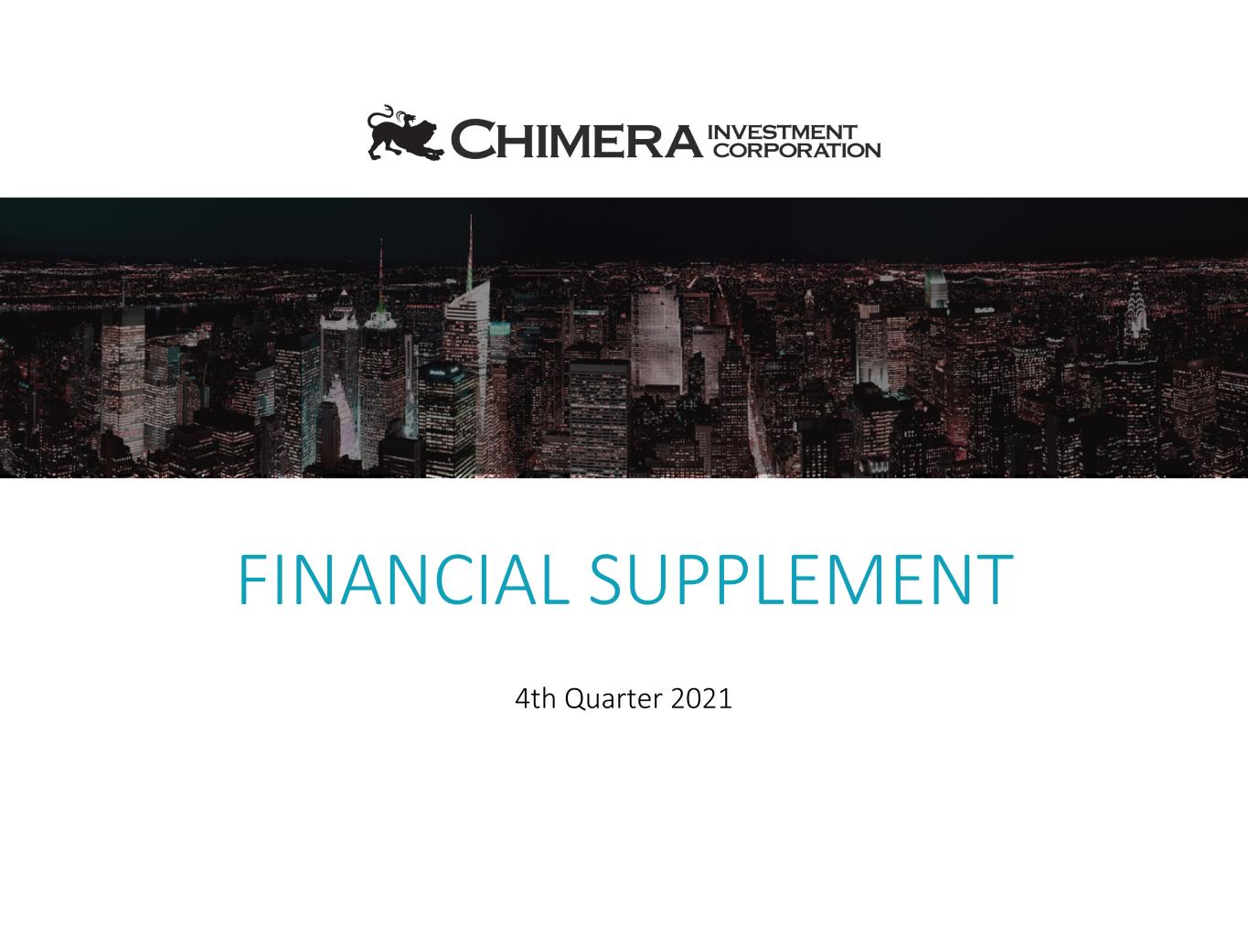
FINANCIAL SUPPLEMENT 4th Quarter 2021

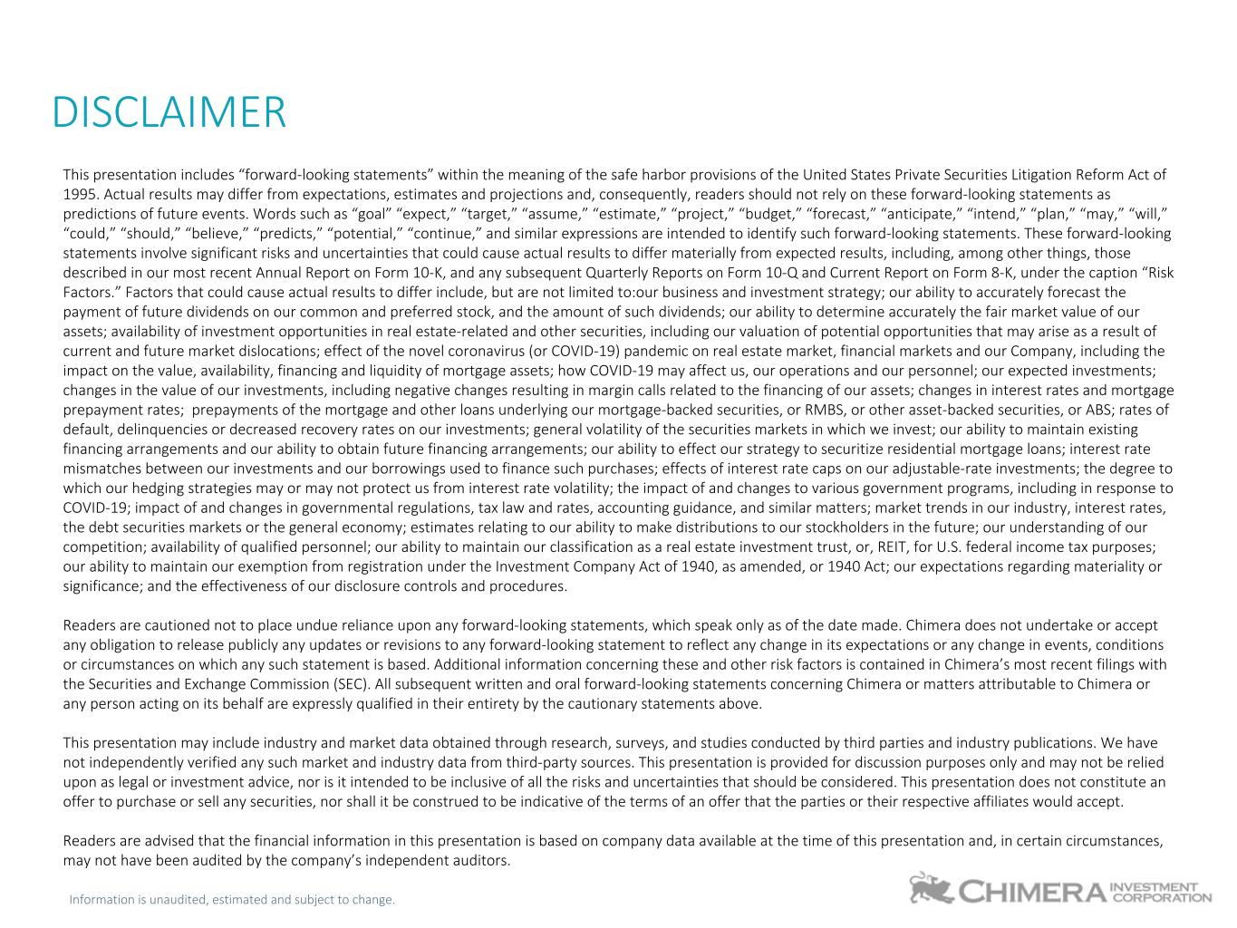
Information is unaudited, estimated and subject to change. DISCLAIMER This presentation includes “forward-looking statements” within the meaning of the safe harbor provisions of the United States Private Securities Litigation Reform Act of 1995. Actual results may differ from expectations, estimates and projections and, consequently, readers should not rely on these forward-looking statements as predictions of future events. Words such as “goal” “expect,” “target,” “assume,” “estimate,” “project,” “budget,” “forecast,” “anticipate,” “intend,” “plan,” “may,” “will,” “could,” “should,” “believe,” “predicts,” “potential,” “continue,” and similar expressions are intended to identify such forward-looking statements. These forward-looking statements involve significant risks and uncertainties that could cause actual results to differ materially from expected results, including, among other things, those described in our most recent Annual Report on Form 10-K, and any subsequent Quarterly Reports on Form 10-Q and Current Report on Form 8-K, under the caption “Risk Factors.” Factors that could cause actual results to differ include, but are not limited to:our business and investment strategy; our ability to accurately forecast the payment of future dividends on our common and preferred stock, and the amount of such dividends; our ability to determine accurately the fair market value of our assets; availability of investment opportunities in real estate-related and other securities, including our valuation of potential opportunities that may arise as a result of current and future market dislocations; effect of the novel coronavirus (or COVID-19) pandemic on real estate market, financial markets and our Company, including the impact on the value, availability, financing and liquidity of mortgage assets; how COVID-19 may affect us, our operations and our personnel; our expected investments; changes in the value of our investments, including negative changes resulting in margin calls related to the financing of our assets; changes in interest rates and mortgage prepayment rates; prepayments of the mortgage and other loans underlying our mortgage-backed securities, or RMBS, or other asset-backed securities, or ABS; rates of default, delinquencies or decreased recovery rates on our investments; general volatility of the securities markets in which we invest; our ability to maintain existing financing arrangements and our ability to obtain future financing arrangements; our ability to effect our strategy to securitize residential mortgage loans; interest rate mismatches between our investments and our borrowings used to finance such purchases; effects of interest rate caps on our adjustable-rate investments; the degree to which our hedging strategies may or may not protect us from interest rate volatility; the impact of and changes to various government programs, including in response to COVID-19; impact of and changes in governmental regulations, tax law and rates, accounting guidance, and similar matters; market trends in our industry, interest rates, the debt securities markets or the general economy; estimates relating to our ability to make distributions to our stockholders in the future; our understanding of our competition; availability of qualified personnel; our ability to maintain our classification as a real estate investment trust, or, REIT, for U.S. federal income tax purposes; our ability to maintain our exemption from registration under the Investment Company Act of 1940, as amended, or 1940 Act; our expectations regarding materiality or significance; and the effectiveness of our disclosure controls and procedures. Readers are cautioned not to place undue reliance upon any forward-looking statements, which speak only as of the date made. Chimera does not undertake or accept any obligation to release publicly any updates or revisions to any forward-looking statement to reflect any change in its expectations or any change in events, conditions or circumstances on which any such statement is based. Additional information concerning these and other risk factors is contained in Chimera’s most recent filings with the Securities and Exchange Commission (SEC). All subsequent written and oral forward-looking statements concerning Chimera or matters attributable to Chimera or any person acting on its behalf are expressly qualified in their entirety by the cautionary statements above. This presentation may include industry and market data obtained through research, surveys, and studies conducted by third parties and industry publications. We have not independently verified any such market and industry data from third-party sources. This presentation is provided for discussion purposes only and may not be relied upon as legal or investment advice, nor is it intended to be inclusive of all the risks and uncertainties that should be considered. This presentation does not constitute an offer to purchase or sell any securities, nor shall it be construed to be indicative of the terms of an offer that the parties or their respective affiliates would accept. Readers are advised that the financial information in this presentation is based on company data available at the time of this presentation and, in certain circumstances, may not have been audited by the company’s independent auditors.

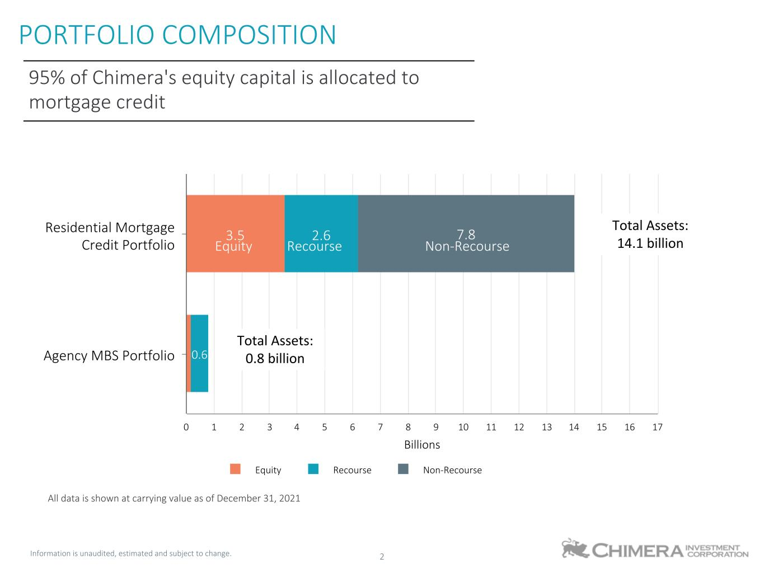
Information is unaudited, estimated and subject to change. 2 PORTFOLIO COMPOSITION 95% of Chimera's equity capital is allocated to mortgage credit Billions 3.5 2.6 0.6 7.8 Equity Recourse Non-Recourse Residential Mortgage Credit Portfolio Agency MBS Portfolio 0 1 2 3 4 5 6 7 8 9 10 11 12 13 14 15 16 17 Total Assets: 14.1 billion Total Assets: 0.8 billion All data is shown at carrying value as of December 31, 2021 Equity Recourse Non-Recourse

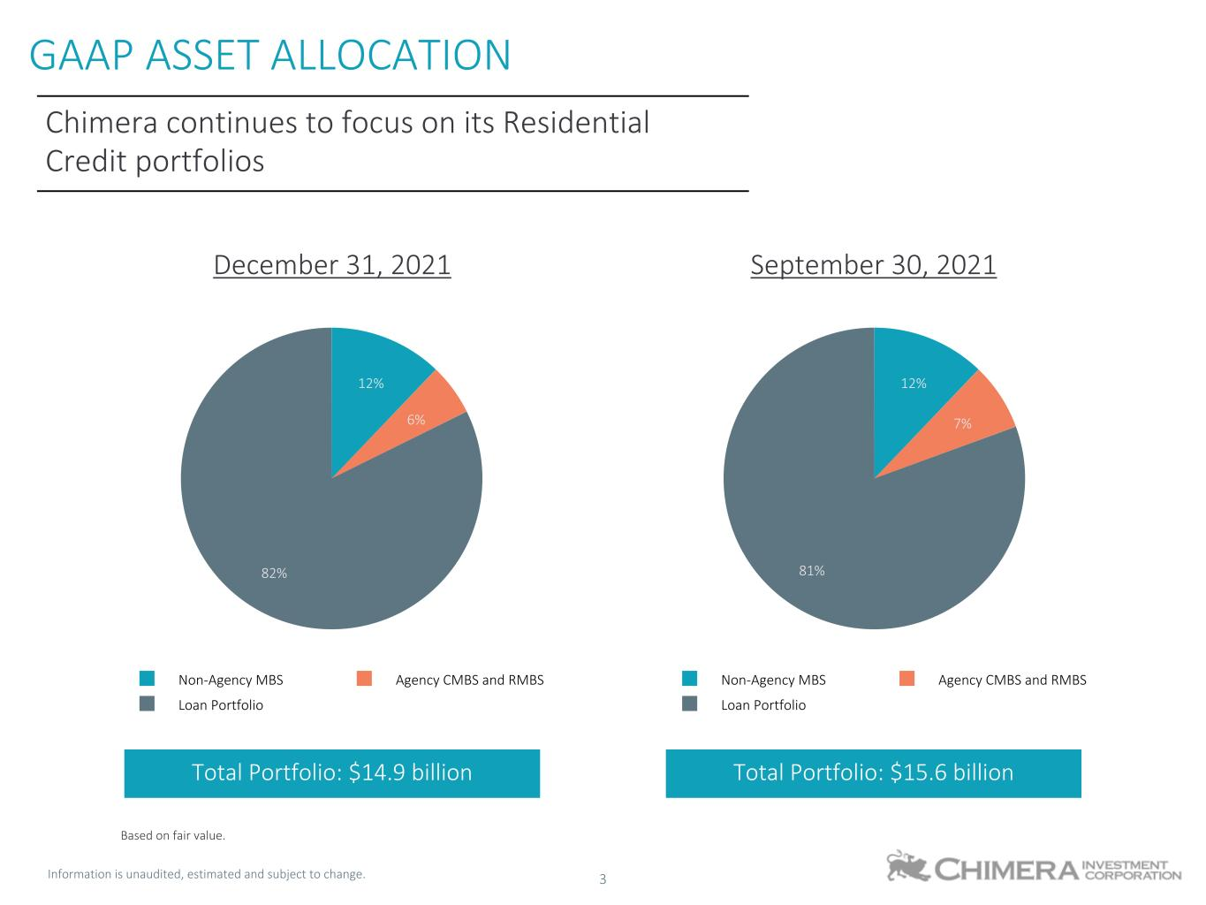
Information is unaudited, estimated and subject to change. 3 12% 6% 82% Non-Agency MBS Agency CMBS and RMBS Loan Portfolio GAAP ASSET ALLOCATION Based on fair value. 12% 7% 81% Non-Agency MBS Agency CMBS and RMBS Loan Portfolio December 31, 2021 September 30, 2021 Chimera continues to focus on its Residential Credit portfolios Total Portfolio: $14.9 billion Total Portfolio: $15.6 billion

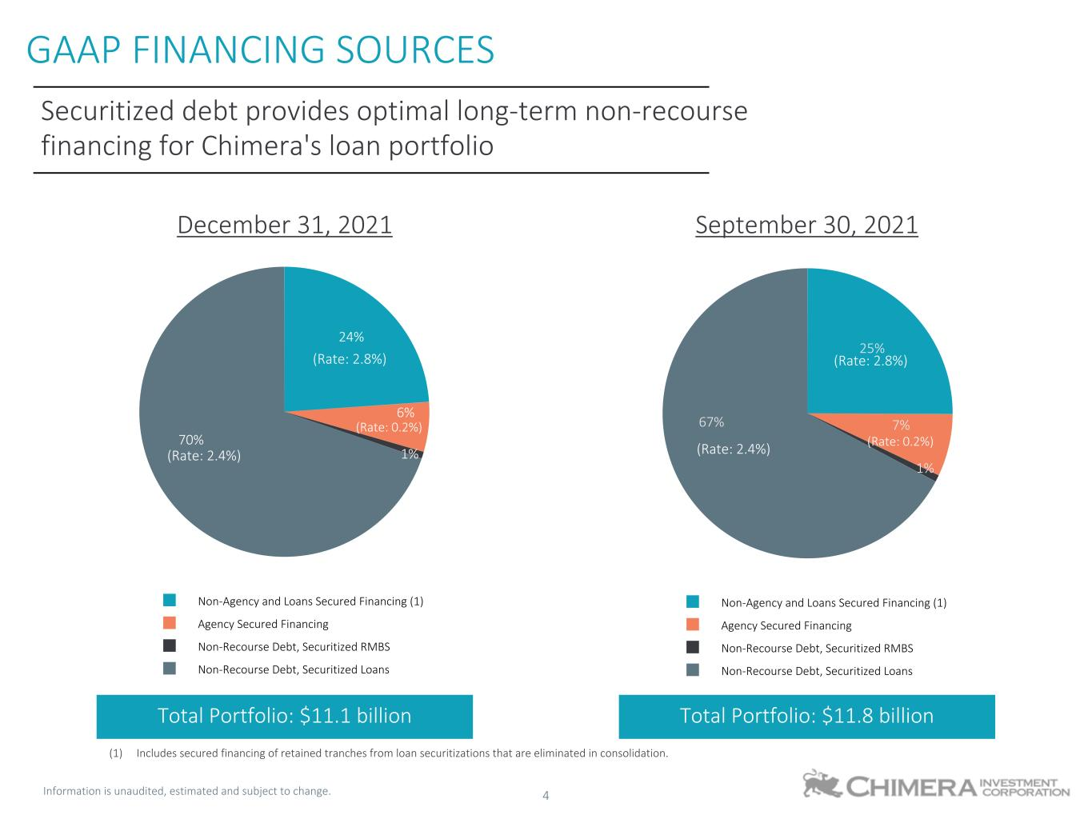
Information is unaudited, estimated and subject to change. 4 24% 6% 1% 70% Non-Agency and Loans Secured Financing (1) Agency Secured Financing Non-Recourse Debt, Securitized RMBS Non-Recourse Debt, Securitized Loans GAAP FINANCING SOURCES 25% 7% 1% 67% Non-Agency and Loans Secured Financing (1) Agency Secured Financing Non-Recourse Debt, Securitized RMBS Non-Recourse Debt, Securitized Loans (1) Includes secured financing of retained tranches from loan securitizations that are eliminated in consolidation. Securitized debt provides optimal long-term non-recourse financing for Chimera's loan portfolio December 31, 2021 September 30, 2021 Total Portfolio: $11.1 billion Total Portfolio: $11.8 billion (Rate: 2.4%) (Rate: 2.4%) (Rate: 0.2%) (Rate: 2.8%) (Rate: 0.2%) (Rate: 2.8%)

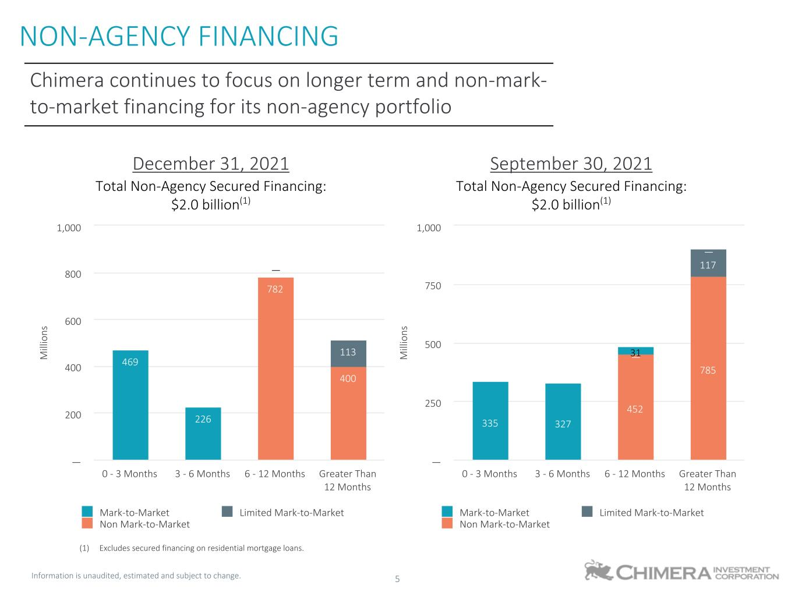
Information is unaudited, estimated and subject to change. 5 NON-AGENCY FINANCING Chimera continues to focus on longer term and non-mark- to-market financing for its non-agency portfolio M ill io ns 782 400 — — 113 469 226 — Mark-to-Market Limited Mark-to-Market Non Mark-to-Market 0 - 3 Months 3 - 6 Months 6 - 12 Months Greater Than 12 Months — 200 400 600 800 1,000 M ill io ns — — 452 785 — 117 335 327 31 — Mark-to-Market Limited Mark-to-Market Non Mark-to-Market 0 - 3 Months 3 - 6 Months 6 - 12 Months Greater Than 12 Months — 250 500 750 1,000 December 31, 2021 September 30, 2021 Total Non-Agency Secured Financing: $2.0 billion(1) Total Non-Agency Secured Financing: $2.0 billion(1) (1) Excludes secured financing on residential mortgage loans.

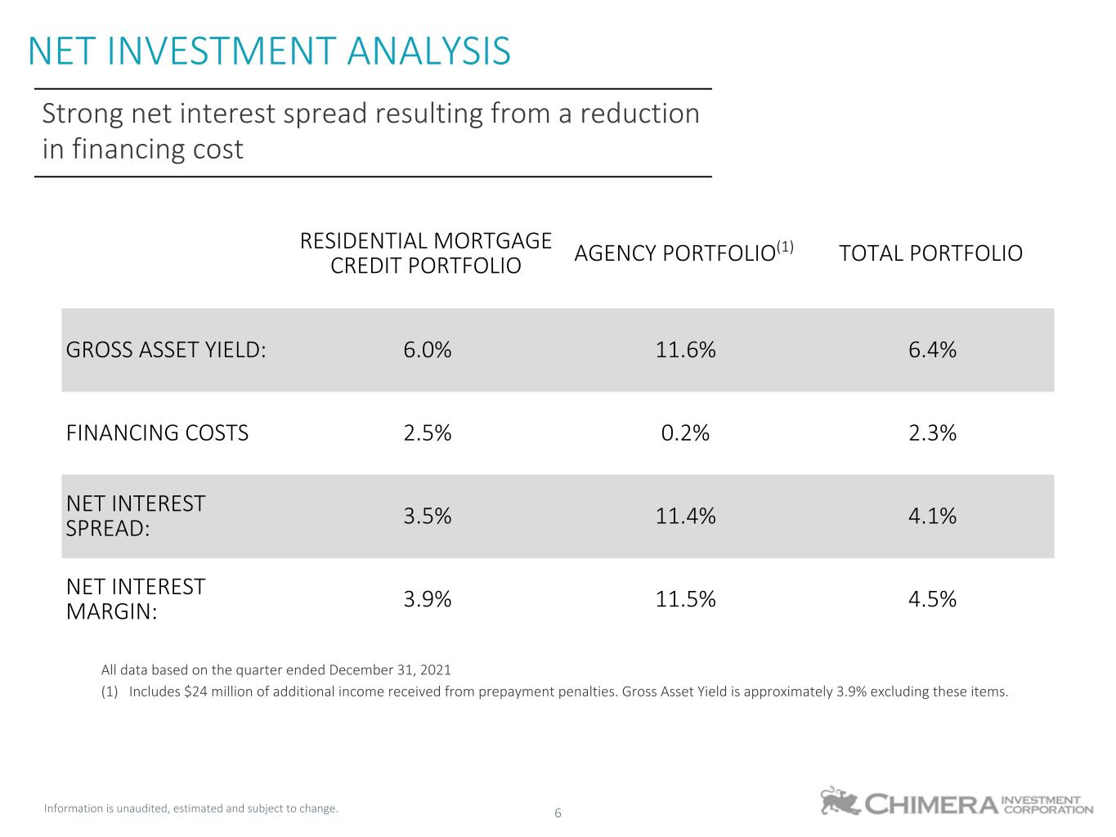
Information is unaudited, estimated and subject to change. 6 RESIDENTIAL MORTGAGE CREDIT PORTFOLIO AGENCY PORTFOLIO(1) TOTAL PORTFOLIO GROSS ASSET YIELD: 6.0% 11.6% 6.4% FINANCING COSTS 2.5% 0.2% 2.3% NET INTEREST SPREAD: 3.5% 11.4% 4.1% NET INTEREST MARGIN: 3.9% 11.5% 4.5% All data based on the quarter ended December 31, 2021 (1) Includes $24 million of additional income received from prepayment penalties. Gross Asset Yield is approximately 3.9% excluding these items. NET INVESTMENT ANALYSIS Strong net interest spread resulting from a reduction in financing cost

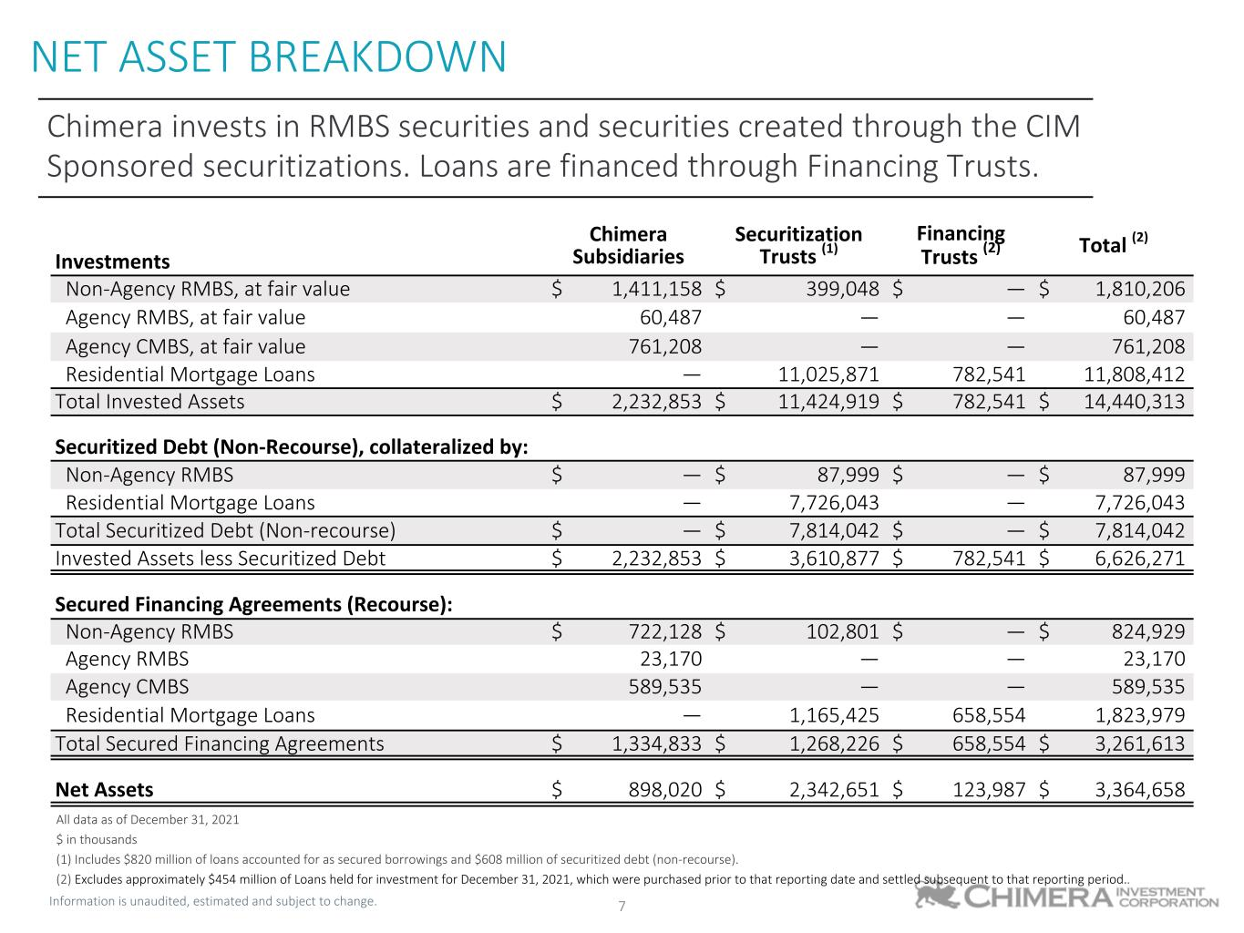
Information is unaudited, estimated and subject to change. 7 Chimera Subsidiaries Securitization Trusts (1) Financing Trusts (2) Total (2) Investments Non-Agency RMBS, at fair value $ 1,411,158 $ 399,048 $ — $ 1,810,206 Agency RMBS, at fair value 60,487 — — 60,487 Agency CMBS, at fair value 761,208 — — 761,208 Residential Mortgage Loans — 11,025,871 782,541 11,808,412 Total Invested Assets $ 2,232,853 $ 11,424,919 $ 782,541 $ 14,440,313 Securitized Debt (Non-Recourse), collateralized by: Non-Agency RMBS $ — $ 87,999 $ — $ 87,999 Residential Mortgage Loans — 7,726,043 — 7,726,043 Total Securitized Debt (Non-recourse) $ — $ 7,814,042 $ — $ 7,814,042 Invested Assets less Securitized Debt $ 2,232,853 $ 3,610,877 $ 782,541 $ 6,626,271 Secured Financing Agreements (Recourse): Non-Agency RMBS $ 722,128 $ 102,801 $ — $ 824,929 Agency RMBS 23,170 — — 23,170 Agency CMBS 589,535 — — 589,535 Residential Mortgage Loans — 1,165,425 658,554 1,823,979 Total Secured Financing Agreements $ 1,334,833 $ 1,268,226 $ 658,554 $ 3,261,613 Net Assets $ 898,020 $ 2,342,651 $ 123,987 $ 3,364,658 All data as of December 31, 2021 $ in thousands (1) Includes $820 million of loans accounted for as secured borrowings and $608 million of securitized debt (non-recourse). (2) Excludes approximately $454 million of Loans held for investment for December 31, 2021, which were purchased prior to that reporting date and settled subsequent to that reporting period.. NET ASSET BREAKDOWN Chimera invests in RMBS securities and securities created through the CIM Sponsored securitizations. Loans are financed through Financing Trusts.

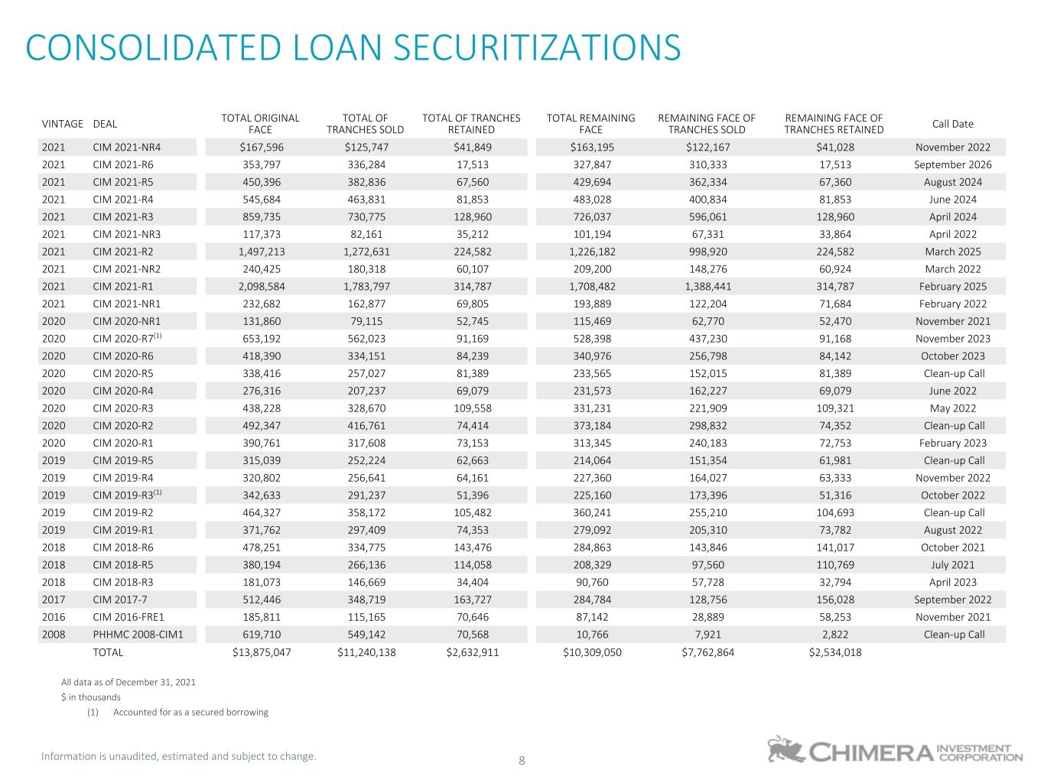
Information is unaudited, estimated and subject to change. 8 VINTAGE DEAL TOTAL ORIGINAL FACE TOTAL OF TRANCHES SOLD TOTAL OF TRANCHES RETAINED TOTAL REMAINING FACE REMAINING FACE OF TRANCHES SOLD REMAINING FACE OF TRANCHES RETAINED Call Date 2021 CIM 2021-NR4 $167,596 $125,747 $41,849 $163,195 $122,167 $41,028 November 2022 2021 CIM 2021-R6 353,797 336,284 17,513 327,847 310,333 17,513 September 2026 2021 CIM 2021-R5 450,396 382,836 67,560 429,694 362,334 67,360 August 2024 2021 CIM 2021-R4 545,684 463,831 81,853 483,028 400,834 81,853 June 2024 2021 CIM 2021-R3 859,735 730,775 128,960 726,037 596,061 128,960 April 2024 2021 CIM 2021-NR3 117,373 82,161 35,212 101,194 67,331 33,864 April 2022 2021 CIM 2021-R2 1,497,213 1,272,631 224,582 1,226,182 998,920 224,582 March 2025 2021 CIM 2021-NR2 240,425 180,318 60,107 209,200 148,276 60,924 March 2022 2021 CIM 2021-R1 2,098,584 1,783,797 314,787 1,708,482 1,388,441 314,787 February 2025 2021 CIM 2021-NR1 232,682 162,877 69,805 193,889 122,204 71,684 February 2022 2020 CIM 2020-NR1 131,860 79,115 52,745 115,469 62,770 52,470 November 2021 2020 CIM 2020-R7(1) 653,192 562,023 91,169 528,398 437,230 91,168 November 2023 2020 CIM 2020-R6 418,390 334,151 84,239 340,976 256,798 84,142 October 2023 2020 CIM 2020-R5 338,416 257,027 81,389 233,565 152,015 81,389 Clean-up Call 2020 CIM 2020-R4 276,316 207,237 69,079 231,573 162,227 69,079 June 2022 2020 CIM 2020-R3 438,228 328,670 109,558 331,231 221,909 109,321 May 2022 2020 CIM 2020-R2 492,347 416,761 74,414 373,184 298,832 74,352 Clean-up Call 2020 CIM 2020-R1 390,761 317,608 73,153 313,345 240,183 72,753 February 2023 2019 CIM 2019-R5 315,039 252,224 62,663 214,064 151,354 61,981 Clean-up Call 2019 CIM 2019-R4 320,802 256,641 64,161 227,360 164,027 63,333 November 2022 2019 CIM 2019-R3(1) 342,633 291,237 51,396 225,160 173,396 51,316 October 2022 2019 CIM 2019-R2 464,327 358,172 105,482 360,241 255,210 104,693 Clean-up Call 2019 CIM 2019-R1 371,762 297,409 74,353 279,092 205,310 73,782 August 2022 2018 CIM 2018-R6 478,251 334,775 143,476 284,863 143,846 141,017 October 2021 2018 CIM 2018-R5 380,194 266,136 114,058 208,329 97,560 110,769 July 2021 2018 CIM 2018-R3 181,073 146,669 34,404 90,760 57,728 32,794 April 2023 2017 CIM 2017-7 512,446 348,719 163,727 284,784 128,756 156,028 September 2022 2016 CIM 2016-FRE1 185,811 115,165 70,646 87,142 28,889 58,253 November 2021 2008 PHHMC 2008-CIM1 619,710 549,142 70,568 10,766 7,921 2,822 Clean-up Call TOTAL $13,875,047 $11,240,138 $2,632,911 $10,309,050 $7,762,864 $2,534,018 All data as of December 31, 2021 $ in thousands (1) Accounted for as a secured borrowing CONSOLIDATED LOAN SECURITIZATIONS


chimerareit.com

