UNITED STATES
SECURITIES AND EXCHANGE COMMISSION
Washington, DC 20549
______________

FORM 8-K

CURRENT REPORT
PURSUANT TO SECTION 13 OR 15(d) OF THE
SECURITIES EXCHANGE ACT OF 1934

Date of Report (Date of earliest event reported):
June 13, 2023

CHIMERA INVESTMENT CORPORATION
(Exact name of registrant as specified in its charter)

Maryland | 001-33796 | 26-0630461
(State or Other Jurisdiction  of Incorporation) | (Commission  File Number) | (IRS Employer  Identification No.)

630 Fifth Avenue,  Suite 2400  New York, New York | 10111
(Address of principal executive offices) | (Zip Code)

Registrant’s telephone number, including area code: (888) 895-6557

Securities registered pursuant to Section 12(b) of the Act:

Title of each class |  | Trading Symbol(s) |  | Name of Each Exchange on Which Registered
Common Stock, par value $0.01 per share |  | CIM |  | New York Stock Exchange
8.00% Series A Cumulative Redeemable Preferred Stock |  | CIM PRA |  | New York Stock Exchange
8.00% Series B Cumulative Fixed-to-Floating Rate Redeemable Preferred Stock |  | CIM PRB |  | New York Stock Exchange
7.75% Series C Cumulative Fixed-to-Floating Rate Redeemable Preferred Stock |  | CIM PRC |  | New York Stock Exchange
8.00% Series D Cumulative Fixed-to-Floating Rate Redeemable Preferred Stock |  | CIM PRD |  | New York Stock Exchange

Registrant's Web site address: www.chimerareit.com

(Former Name or Former Address, if Changed Since Last Report)

Check the appropriate box below if the Form 8-K filing is intended to simultaneously satisfy the filing obligation of the registrant under any of the following provisions:

☐ Written communications pursuant to Rule 425 under the Securities Act (17 CFR 230.425)

☐ Soliciting material pursuant to Rule 14a-12 under the Exchange Act (17 CFR 240.14a-12)

☐ Pre-commencement communications pursuant to Rule 14d-2(b) under the Exchange Act (17 CFR 240.14d-2(b))

☐ Pre-commencement communications pursuant to Rule 13e-4(c) under the Exchange Act (17 CFR 240.13e-4(c))

Indicate by check mark whether the registrant is an emerging growth company as defined in Rule 405 of the Securities Act of 1933 (§230.405 of this chapter) or Rule 12b-2 of the Securities Exchange Act of 1934 (§240.12b-2 of this chapter).

Emerging growth company ☐

If an emerging growth company, indicate by check mark if the registrant has elected not to use the extended transition period for complying with any new or revised financial accounting standards provided pursuant to Section 13(a) of the Exchange Act. ☐

Item 7.01 | Regulation FD Disclosure

On June 13, 2023, the registrant posted investor presentation information on the News & Events - Presentations section of its website (www.chimerareit.com). A copy of the investor presentation information is furnished as Exhibit 99.1 to this report and incorporated herein by reference.

In accordance with General Instruction B.2 of Form 8-K, the information furnished pursuant to Item 7.01, including Exhibits 99.1 furnished herewith, shall not be deemed “filed” for purposes of Section 18 of the Securities Exchange Act of 1934, as amended (the “Exchange Act”), nor shall it be deemed incorporated by reference in any filing under the Securities Act of 1933, as amended, or the Exchange Act, except as shall be expressly set forth by specific reference in such a filing.

Item 9.01 | Financial Statements and Exhibits
(d) |  | Exhibits
99.1 |  | Investor Presentation, dated June 13, 2023, issued by Chimera Investment Corporation
104 |  | Cover Page Interactive Data File (embedded within the Inline XBRL document).

SIGNATURES

Pursuant to the requirements of the Securities Exchange Act of 1934, the registrant has duly caused this report to be signed on its behalf by the undersigned hereunto duly authorized.

 | Chimera Investment Corporation
 | By: | /s/ Subramaniam Viswanathan
 |  | Name: Subramaniam Viswanathan
 |  | Title: Chief Financial Officer

Date: June 13, 2023

Exhibit 99.1


INVESTOR PRESENTATION June 2023

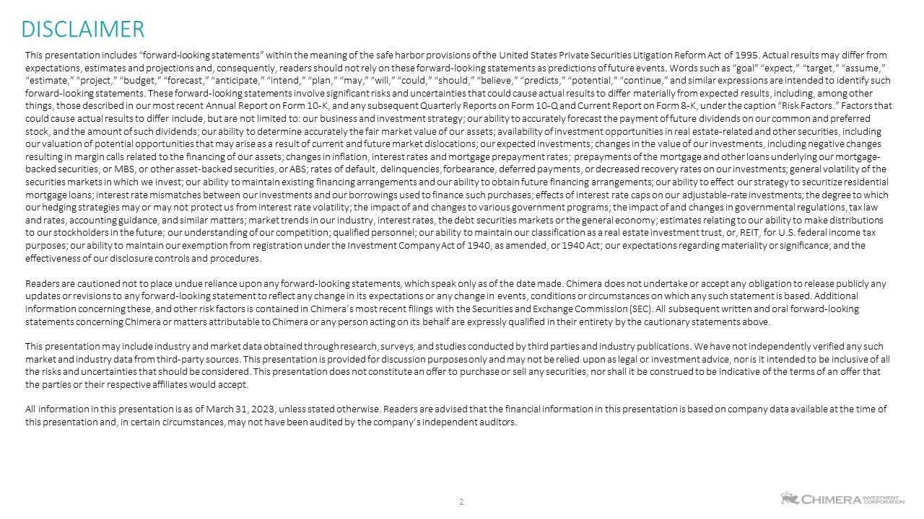
2 DISCLAIMER This presentation includes “forward-looking statements” within the meaning of the safe harbor provisions of the United States Private Securities Litigation Reform Act of 1995. Actual results may differ from expectations, estimates and projections and, consequently, readers should not rely on these forward-looking statements as predictions of future events. Words such as “goal” “expect,” “target,” “assume,” “estimate,” “project,” “budget,” “forecast,” “anticipate,” “intend,” “plan,” “may,” “will,” “could,” “should,” “believe,” “predicts,” “potential,” “continue,” and similar expressions are intended to identify such forward-looking statements. These forward-looking statements involve significant risks and uncertainties that could cause actual results to differ materially from expected results, including, among other things, those described in our most recent Annual Report on Form 10-K, and any subsequent Quarterly Reports on Form 10-Q and Current Report on Form 8-K, under the caption “Risk Factors.” Factors that could cause actual results to differ include, but are not limited to: our business and investment strategy; our ability to accurately forecast the payment of future dividends on our common and preferred stock, and the amount of such dividends; our ability to determine accurately the fair market value of our assets; availability of investment opportunities in real estate-related and other securities, including our valuation of potential opportunities that may arise as a result of current and future market dislocations; our expected investments; changes in the value of our investments, including negative changes resulting in margin calls related to the financing of our assets; changes in inflation, interest rates and mortgage prepayment rates; prepayments of the mortgage and other loans underlying our mortgage- backed securities, or MBS, or other asset-backed securities, or ABS; rates of default, delinquencies, forbearance, deferred payments, or decreased recovery rates on our investments; general volatility of the securities markets in which we invest; our ability to maintain existing financing arrangements and our ability to obtain future financing arrangements; our ability to effect our strategy to securitize residential mortgage loans; interest rate mismatches between our investments and our borrowings used to finance such purchases; effects of interest rate caps on our adjustable-rate investments; the degree to which our hedging strategies may or may not protect us from interest rate volatility; the impact of and changes to various government programs; the impact of and changes in governmental regulations, tax law and rates, accounting guidance, and similar matters; market trends in our industry, interest rates, the debt securities markets or the general economy; estimates relating to our ability to make distributions to our stockholders in the future; our understanding of our competition; qualified personnel; our ability to maintain our classification as a real estate investment trust, or, REIT, for U.S. federal income tax purposes; our ability to maintain our exemption from registration under the Investment Company Act of 1940, as amended, or 1940 Act; our expectations regarding materiality or significance; and the effectiveness of our disclosure controls and procedures. Readers are cautioned not to place undue reliance upon any forward-looking statements, which speak only as of the date made. Chimera does not undertake or accept any obligation to release publicly any updates or revisions to any forward-looking statement to reflect any change in its expectations or any change in events, conditions or circumstances on which any such statement is based. Additional information concerning these, and other risk factors is contained in Chimera’s most recent filings with the Securities and Exchange Commission (SEC). All subsequent written and oral forward-looking statements concerning Chimera or matters attributable to Chimera or any person acting on its behalf are expressly qualified in their entirety by the cautionary statements above. This presentation may include industry and market data obtained through research, surveys, and studies conducted by third parties and industry publications. We have not independently verified any such market and industry data from third-party sources. This presentation is provided for discussion purposes only and may not be relied upon as legal or investment advice, nor is it intended to be inclusive of all the risks and uncertainties that should be considered. This presentation does not constitute an offer to purchase or sell any securities, nor shall it be construed to be indicative of the terms of an offer that the parties or their respective affiliates would accept. All information in this presentation is as of March 31, 2023, unless stated otherwise. Readers are advised that the financial information in this presentation is based on company data available at the time of this presentation and, in certain circumstances, may not have been audited by the company’s independent auditors.

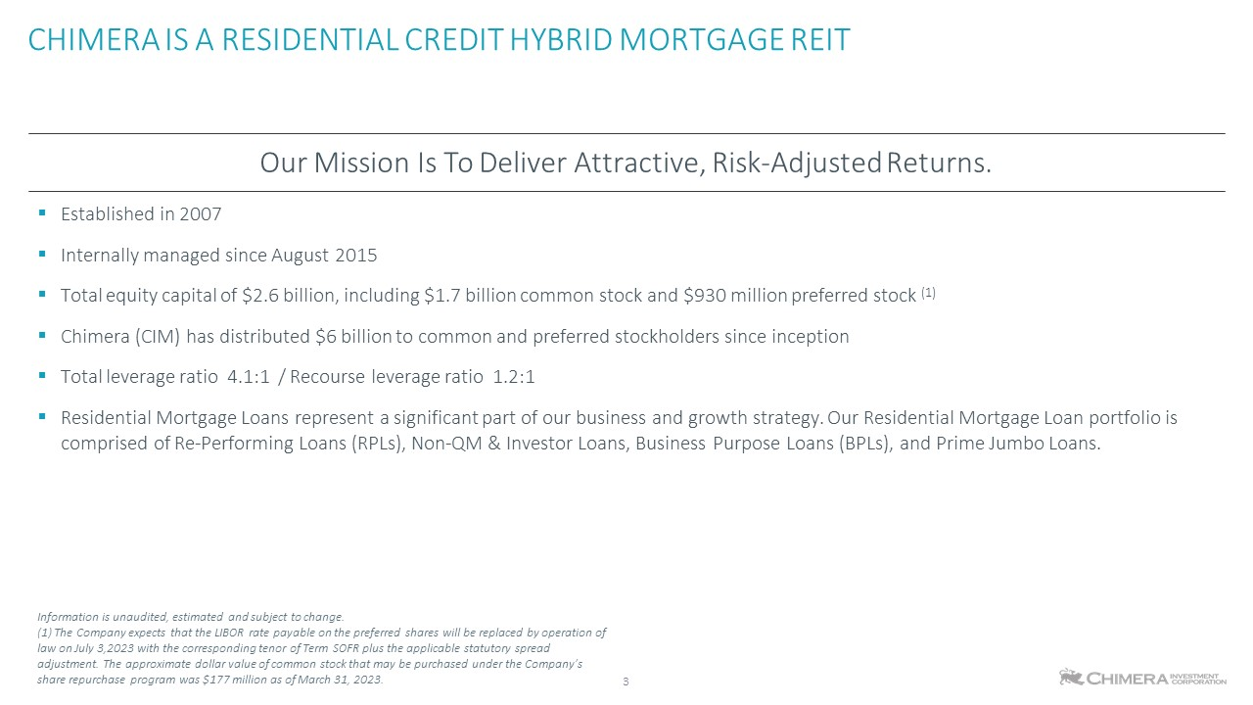
CHIMERA IS A RESIDENTIAL CREDIT HYBRID MORTGAGE REIT 3 Established in 2007 Internally managed since August 2015 Total equity capital of $2.6 billion, including $1.7 billion common stock and $930 million preferred stock (1) Chimera (CIM) has distributed $6 billion to common and preferred stockholders since inception Total leverage ratio 4.1:1 / Recourse leverage ratio 1.2:1 Residential Mortgage Loans represent a significant part of our business and growth strategy. Our Residential Mortgage Loan portfolio is comprised of Re-Performing Loans (RPLs), Non-QM & Investor Loans, Business Purpose Loans (BPLs), and Prime Jumbo Loans. Our Mission Is To Deliver Attractive, Risk-Adjusted Returns. Information is unaudited, estimated and subject to change. (1) The Company expects that the LIBOR rate payable on the preferred shares will be replaced by operation of law on July 3,2023 with the corresponding tenor of Term SOFR plus the applicable statutory spread adjustment. The approximate dollar value of common stock that may be purchased under the Company’s share repurchase program was $177 million as of March 31, 2023.

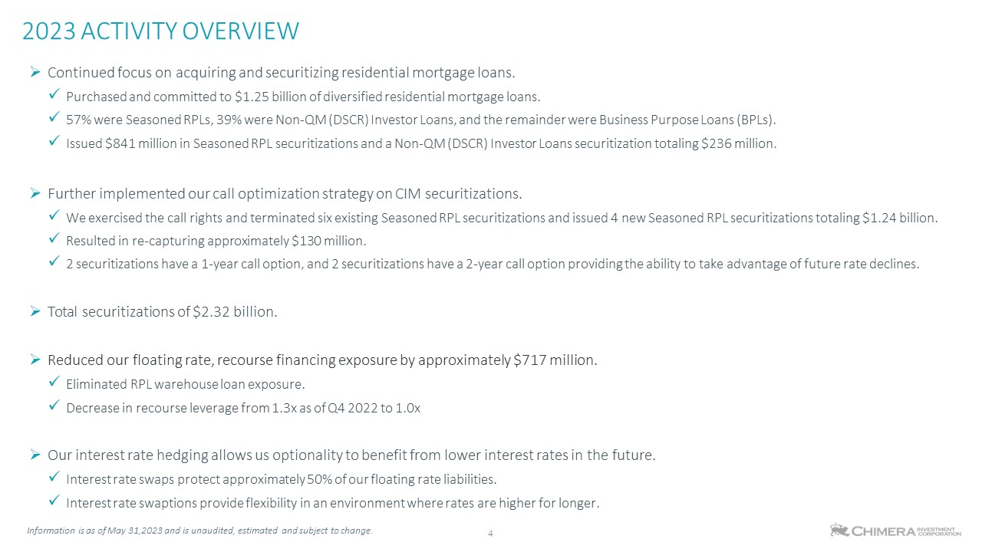
2023 ACTIVITY OVERVIEW 4 Information is as of May 31,2023 and is unaudited, estimated and subject to change. Continued focus on acquiring and securitizing residential mortgage loans. Purchased and committed to $1.25 billion of diversified residential mortgage loans. 57% were Seasoned RPLs, 39% were Non-QM (DSCR) Investor Loans, and the remainder were Business Purpose Loans (BPLs). Issued $841 million in Seasoned RPL securitizations and a Non-QM (DSCR) Investor Loans securitization totaling $236 million. Further implemented our call optimization strategy on CIM securitizations. We exercised the call rights and terminated six existing Seasoned RPL securitizations and issued 4 new Seasoned RPL securitizations totaling $1.24 billion. Resulted in re-capturing approximately $130 million. 2 securitizations have a 1-year call option, and 2 securitizations have a 2-year call option providing the ability to take advantage of future rate declines. Total securitizations of $2.32 billion. Reduced our floating rate, recourse financing exposure by approximately $717 million. Eliminated RPL warehouse loan exposure. Decrease in recourse leverage from 1.3x as of Q4 2022 to 1.0x Our interest rate hedging allows us optionality to benefit from lower interest rates in the future. Interest rate swaps protect approximately 50% of our floating rate liabilities. Interest rate swaptions provide flexibility in an environment where rates are higher for longer.

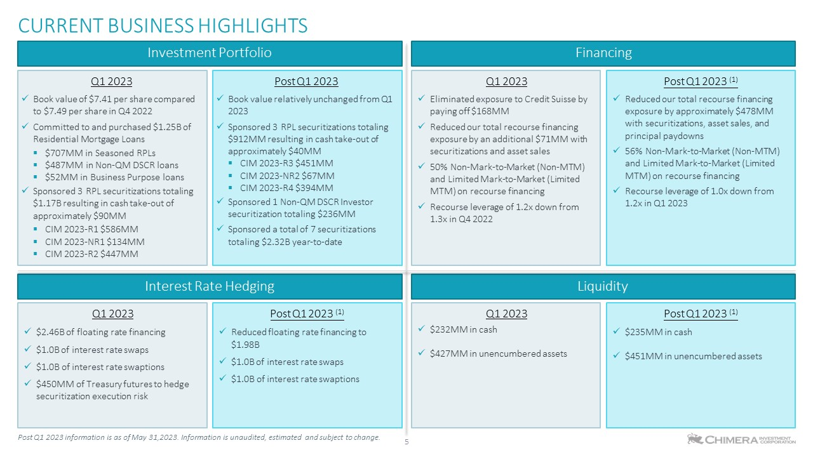
CURRENT BUSINESS HIGHLIGHTS Q1 2023 Book value of $7.41 per share compared to $7.49 per share in Q4 2022 Committed to and purchased $1.25B of Residential Mortgage Loans $707MM in Seasoned RPLs $487MM in Non-QM DSCR loans $52MM in Business Purpose loans Sponsored 3 RPL securitizations totaling $1.17B resulting in cash take-out of approximately $90MM CIM 2023-R1 $586MM CIM 2023-NR1 $134MM CIM 2023-R2 $447MM Post Q1 2023 Book value relatively unchanged from Q1 2023 Sponsored 3 RPL securitizations totaling $912MM resulting in cash take-out of approximately $40MM CIM 2023-R3 $451MM CIM 2023-NR2 $67MM CIM 2023-R4 $394MM Sponsored 1 Non-QM DSCR Investor securitization totaling $236MM Sponsored a total of 7 securitizations totaling $2.32B year-to-date Investment Portfolio Financing Q1 2023 Eliminated exposure to Credit Suisse by paying off $168MM Reduced our total recourse financing exposure by an additional $71MM with securitizations and asset sales 50% Non-Mark-to-Market (Non-MTM) and Limited Mark-to-Market (Limited MTM) on recourse financing Recourse leverage of 1.2x down from 1.3x in Q4 2022 Post Q1 2023 (1) Reduced our total recourse financing exposure by approximately $478MM with securitizations, asset sales, and principal paydowns 56% Non-Mark-to-Market (Non-MTM) and Limited Mark-to-Market (Limited MTM) on recourse financing Recourse leverage of 1.0x down from 1.2x in Q1 2023 Interest Rate Hedging Q1 2023 $2.46B of floating rate financing $1.0B of interest rate swaps $1.0B of interest rate swaptions $450MM of Treasury futures to hedge securitization execution risk Post Q1 2023 (1) Reduced floating rate financing to $1.98B $1.0B of interest rate swaps $1.0B of interest rate swaptions Liquidity Q1 2023 $232MM in cash $427MM in unencumbered assets Post Q1 2023 (1) $235MM in cash $451MM in unencumbered assets 5 Post Q1 2023 information is as of May 31,2023. Information is unaudited, estimated and subject to change.

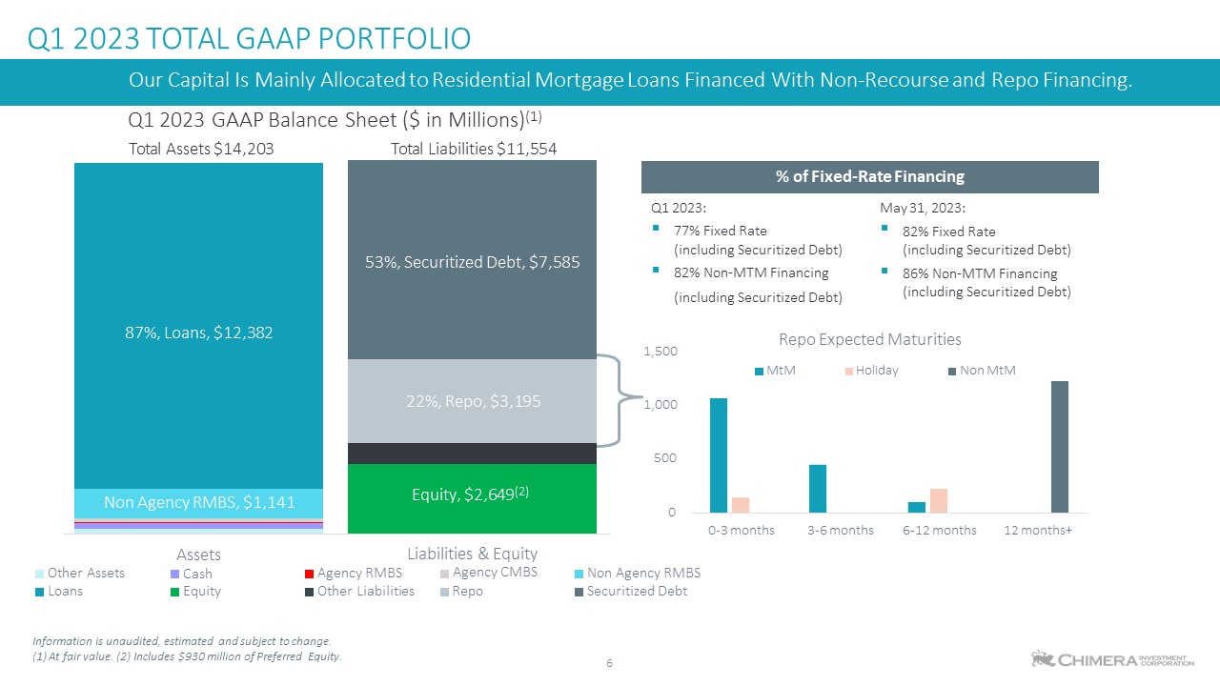
Q1 2023 TOTAL GAAP PORTFOLIO 6 Information is unaudited, estimated and subject to change. (1) At fair value. (2) Includes $930 million of Preferred Equity. % of Fixed-Rate Financing Q1 2023: May 31, 2023: 77% Fixed Rate ▪ (including Securitized Debt) 82% Non-MTM Financing (including Securitized Debt) 82% Fixed Rate (including Securitized Debt) 86% Non-MTM Financing (including Securitized Debt) Non Agency RMBS, $1,141 87%, Loans, $12,382 Equity, $2,649(2) 22%, Repo, $3,195 53%, Securitized Debt, $7,585 Our Capital Is Mainly Allocated to Residential Mortgage Loans Financed With Non-Recourse and Repo Financing. Q1 2023 GAAP Balance Sheet ($ in Millions)(1) Total Assets $14,203 Total Liabilities $11,554 Other Assets Loans Agency RMBS Liabilities & Equity Agency CMBS Non Agency RMBS Securitized Debt Assets Cash Equity Other Liabilities Repo 0 500 1,000 1,500 0-3 months 3-6 months 6-12 months 12 months+ Repo Expected Maturities MtM Holiday Non MtM

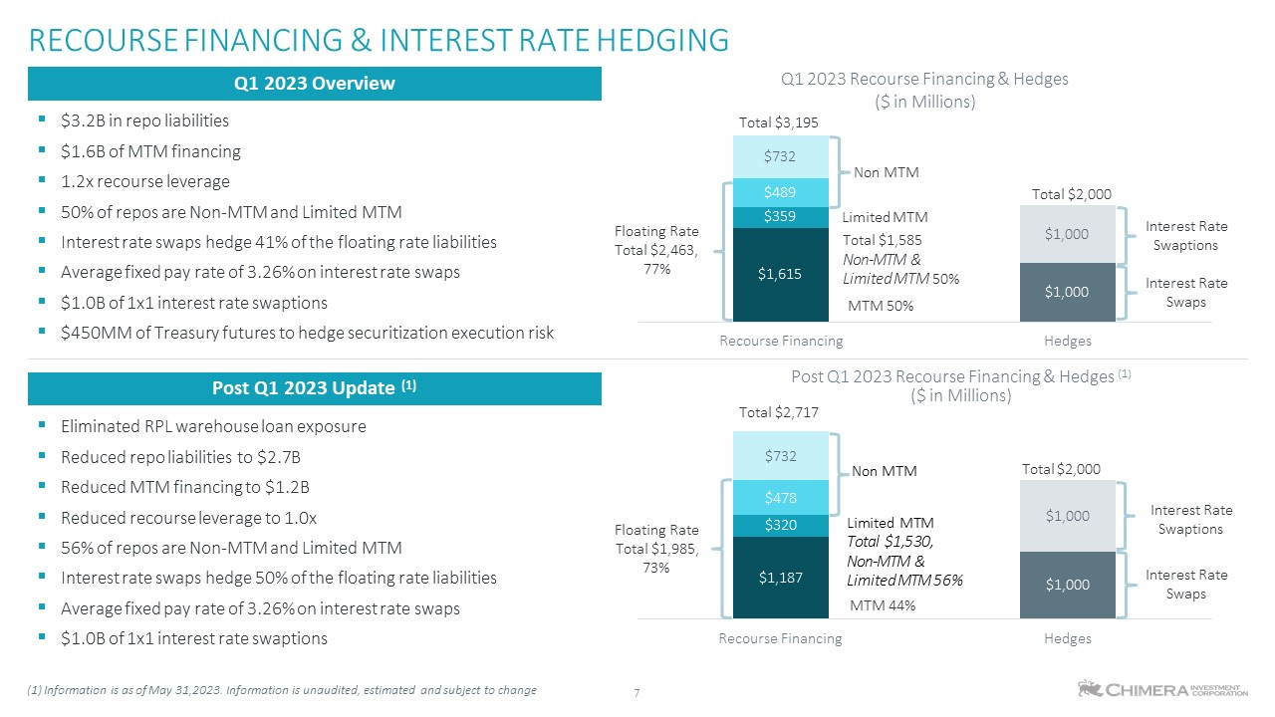
$3.2B in repo liabilities $1.6B of MTM financing 1.2x recourse leverage 50% of repos are Non-MTM and Limited MTM Interest rate swaps hedge 41% of the floating rate liabilities Average fixed pay rate of 3.26% on interest rate swaps $1.0B of 1x1 interest rate swaptions $450MM of Treasury futures to hedge securitization execution risk Eliminated RPL warehouse loan exposure Reduced repo liabilities to $2.7B Reduced MTM financing to $1.2B Reduced recourse leverage to 1.0x 56% of repos are Non-MTM and Limited MTM Interest rate swaps hedge 50% of the floating rate liabilities Average fixed pay rate of 3.26% on interest rate swaps $1.0B of 1x1 interest rate swaptions RECOURSE FINANCING & INTEREST RATE HEDGING (1) Information is as of May 31,2023. Information is unaudited, estimated and subject to change Q1 2023 Overview Post Q1 2023 Update (1) 7 $1,615 $359 $489 $732 $1,000 $1,000 Recourse Financing Hedges Post Q1 2023 Recourse Financing & Hedges (1) ($ in Millions) Total $2,717 Q1 2023 Recourse Financing & Hedges ($ in Millions) Total $3,195 Total $2,000 Non MTM Floating Rate Total $2,463, 77% Limited MTM Total $1,585 Non-MTM & Limited MTM 50% MTM 50% Interest Rate Swaptions Interest Rate Swaps $1,187 $320 $478 $732 $1,000 $1,000 Recourse Financing Hedges Non MTM Limited MTM Total $1,530, Non-MTM & Limited MTM 56% MTM 44% Total $2,000 Floating Rate Total $1,985, 73% Interest Rate Swaptions Interest Rate Swaps

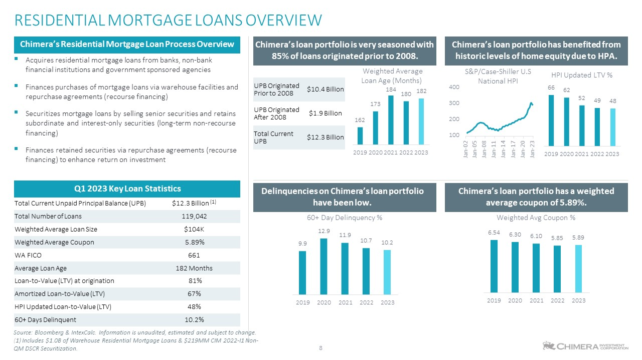
Chimera’s loan portfolio is very seasoned with 85% of loans originated prior to 2008. Acquires residential mortgage loans from banks, non-bank financial institutions and government sponsored agencies Finances purchases of mortgage loans via warehouse facilities and repurchase agreements (recourse financing) Securitizes mortgage loans by selling senior securities and retains subordinate and interest-only securities (long-term non-recourse financing) Finances retained securities via repurchase agreements (recourse financing) to enhance return on investment Chimera’s Residential Mortgage Loan Process Overview Q1 2023 Key Loan Statistics Total Current Unpaid Principal Balance (UPB) $12.3 Billion (1) Total Number of Loans 119,042 Weighted Average Loan Size $104K Weighted Average Coupon 5.89% WA FICO 661 Average Loan Age 182 Months Loan-to-Value (LTV) at origination 81% Amortized Loan-to-Value (LTV) 67% HPI Updated Loan-to-Value (LTV) 48% 60+ Days Delinquent 10.2% RESIDENTIAL MORTGAGE LOANS OVERVIEW UPB Originated Prior to 2008 $10.4 Billion UPB Originated After 2008 $1.9 Billion Total Current UPB $12.3 Billion Chimera’s loan portfolio has benefited from historic levels of home equity due to HPA. 8 Source: Bloomberg & IntexCalc. Information is unaudited, estimated and subject to change. (1) Includes $1.0B of Warehouse Residential Mortgage Loans & $219MM CIM 2022-I1 Non- QM DSCR Securitization. Chimera’s loan portfolio has a weighted average coupon of 5.89%. Delinquencies on Chimera’s loan portfolio have been low. 100 200 300 400 Jan-02 Jan-05 Jan-08 Jan-11 Jan-14 Jan-17 Jan-20 Jan-23 S&P/Case-Shiller U.S National HPI 162 173 184 180 182 2019 2020 2021 2022 2023 Weighted Average Loan Age (Months) 66 62 52 49 48 2019 2020 2021 2022 2023 HPI Updated LTV % 9.9 12.9 11.9 10.7 10.2 2019 2020 2021 2022 2023 60+ Day Delinquency % 6.54 6.30 6.10 5.85 5.89 2019 2020 2021 2022 2023 Weighted Avg Coupon %

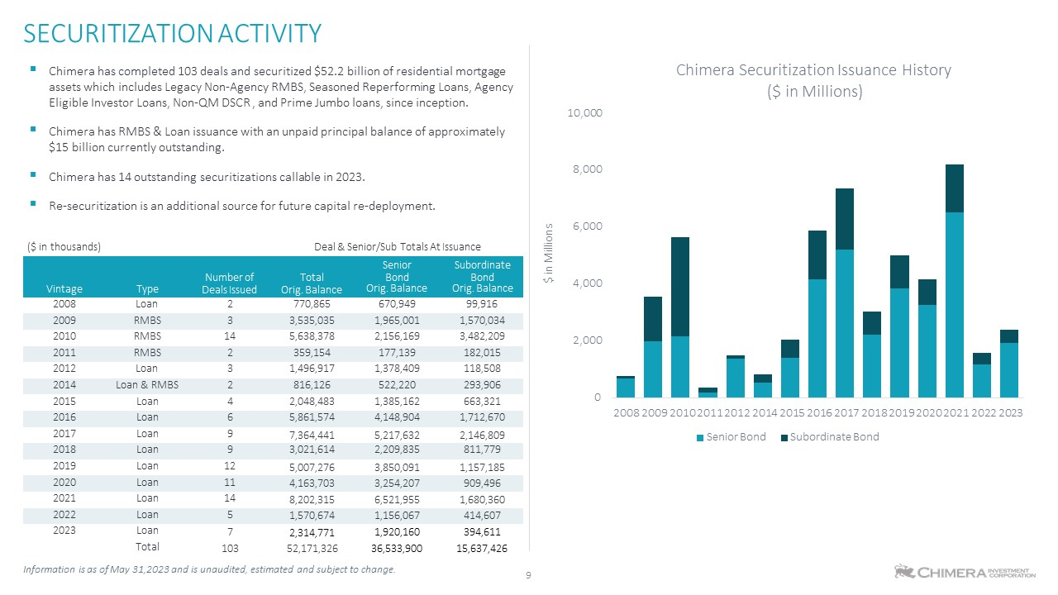
Chimera has completed 103 deals and securitized $52.2 billion of residential mortgage assets which includes Legacy Non-Agency RMBS, Seasoned Reperforming Loans, Agency Eligible Investor Loans, Non-QM DSCR , and Prime Jumbo loans, since inception. Chimera has RMBS & Loan issuance with an unpaid principal balance of approximately $15 billion currently outstanding. Chimera has 14 outstanding securitizations callable in 2023. Re-securitization is an additional source for future capital re-deployment. ($ in thousands) Deal & Senior/Sub Totals At Issuance Vintage Type Number of Deals Issued Total Orig. Balance Senior Bond Orig. Balance Subordinate Bond Orig. Balance 2008 Loan 2 770,865 670,949 99,916 2009 RMBS 3 3,535,035 1,965,001 1,570,034 2010 RMBS 14 5,638,378 2,156,169 3,482,209 2011 RMBS 2 359,154 177,139 182,015 2012 Loan 3 1,496,917 1,378,409 118,508 2014 Loan & RMBS 2 816,126 522,220 293,906 2015 Loan 4 2,048,483 1,385,162 663,321 2016 Loan 6 5,861,574 4,148,904 1,712,670 2017 Loan 9 7,364,441 5,217,632 2,146,809 2018 Loan 9 3,021,614 2,209,835 811,779 2019 Loan 12 5,007,276 3,850,091 1,157,185 2020 Loan 11 4,163,703 3,254,207 909,496 2021 Loan 14 8,202,315 6,521,955 1,680,360 2022 Loan 5 1,570,674 1,156,067 414,607 2023 Loan 7 2,314,771 1,920,160 394,611 Total 103 52,171,326 36,533,900 15,637,426 SECURITIZATION ACTIVITY 9 Information is as of May 31,2023 and is unaudited, estimated and subject to change. 0 2,000 4,000 6,000 8,000 10,000 $ in Millions Chimera Securitization Issuance History ($ in Millions) 2008 2009 2010 2011 2012 2014 2015 2016 2017 2018 2019 2020 2021 2022 2023 Senior Bond Subordinate Bond

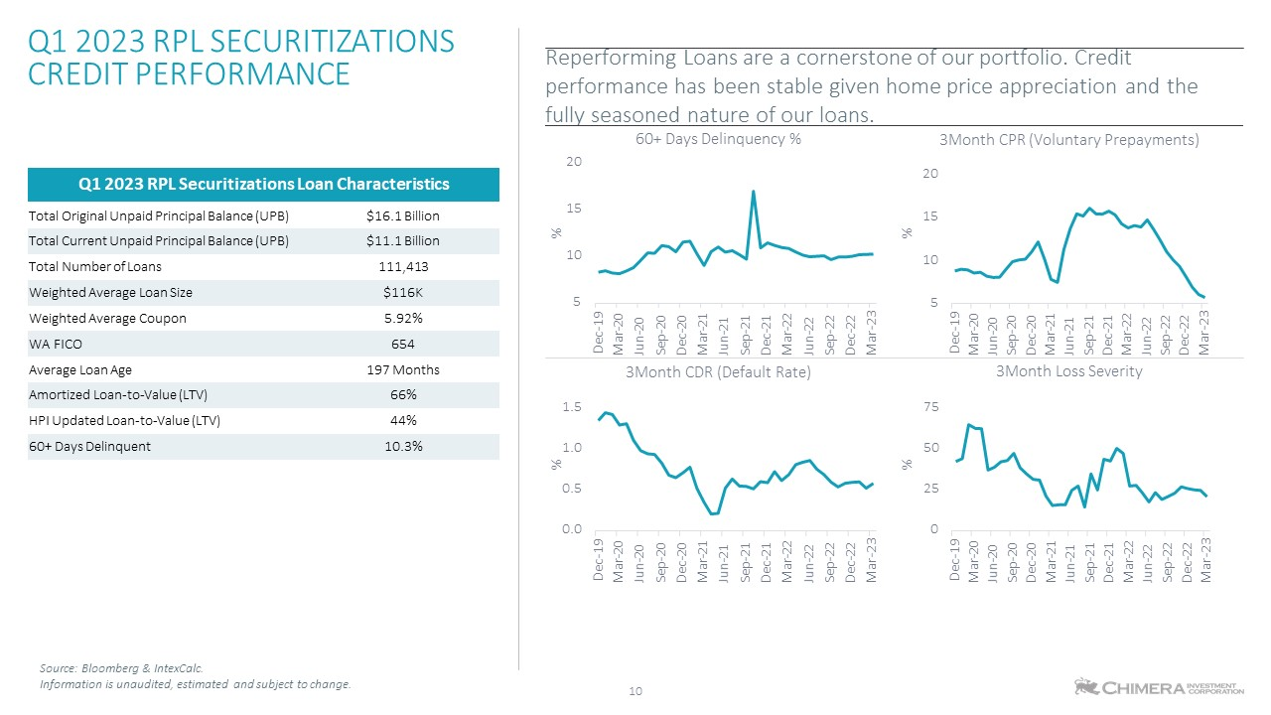
Reperforming Loans are a cornerstone of our portfolio. Credit performance has been stable given home price appreciation and the fully seasoned nature of our loans. 60+ Days Delinquency % 3Month CPR (Voluntary Prepayments) Q1 2023 RPL SECURITIZATIONS CREDIT PERFORMANCE 10 Q1 2023 RPL Securitizations Loan Characteristics Total Original Unpaid Principal Balance (UPB) $16.1 Billion Total Current Unpaid Principal Balance (UPB) $11.1 Billion Total Number of Loans 111,413 Weighted Average Loan Size $116K Weighted Average Coupon 5.92% WA FICO 654 Average Loan Age 197 Months Amortized Loan-to-Value (LTV) 66% HPI Updated Loan-to-Value (LTV) 44% 60+ Days Delinquent 10.3% Source: Bloomberg & IntexCalc. Information is unaudited, estimated and subject to change. 5 10 15 20 Dec-19 Mar-20 Jun-20 Sep-20 Dec-20 Mar-21 Jun-21 Sep-21 Dec-21 Mar-22 Jun-22 Sep-22 Dec-22 Mar-23 % 5 10 15 20 Dec-19 Mar-20 Jun-20 Sep-20 Dec-20 Mar-21 Jun-21 Sep-21 Dec-21 Mar-22 Jun-22 Sep-22 Dec-22 Mar-23 % 0.0 0.5 1.0 1.5 Dec-19 Mar-20 Jun-20 Sep-20 Dec-20 Mar-21 Jun-21 Sep-21 Dec-21 Mar-22 Jun-22 Sep-22 Dec-22 Mar-23 % 3Month CDR (Default Rate) 0 25 50 75 Dec-19 Mar-20 Jun-20 Sep-20 Dec-20 Mar-21 Jun-21 Sep-21 Dec-21 Mar-22 Jun-22 Sep-22 Dec-22 Mar-23 % 3Month Loss Severity

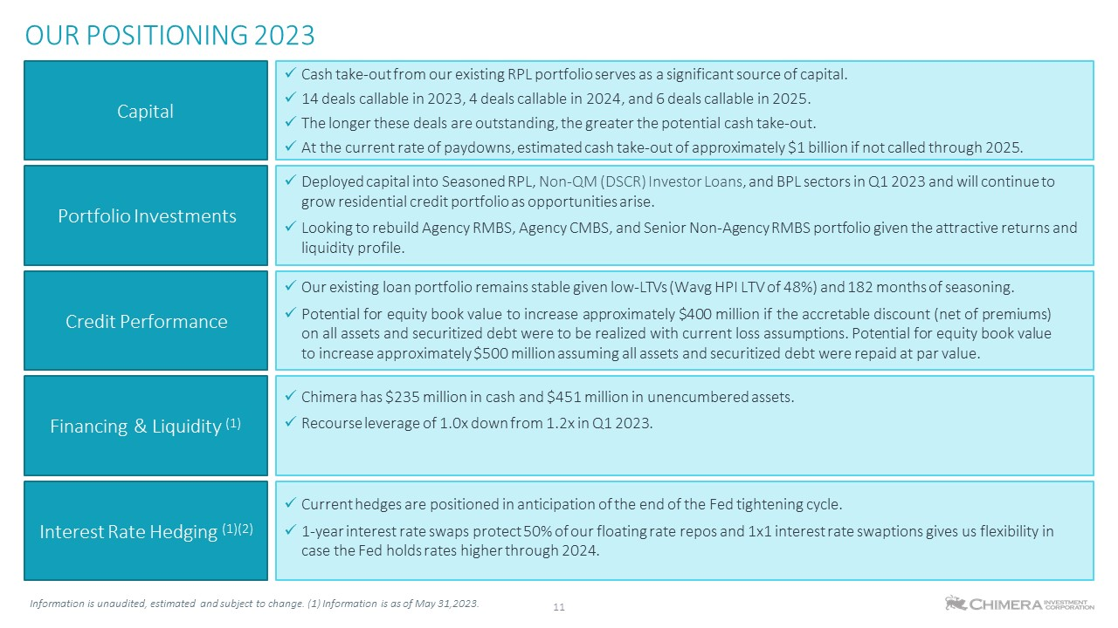
OUR POSITIONING 2023 11 Information is unaudited, estimated and subject to change. (1) Information is as of May 31,2023. Portfolio Investments Cash take-out from our existing RPL portfolio serves as a significant source of capital. 14 deals callable in 2023, 4 deals callable in 2024, and 6 deals callable in 2025. The longer these deals are outstanding, the greater the potential cash take-out. At the current rate of paydowns, estimated cash take-out of approximately $1 billion if not called through 2025. Capital Deployed capital into Seasoned RPL, Non-QM (DSCR) Investor Loans, and BPL sectors in Q1 2023 and will continue to grow residential credit portfolio as opportunities arise. Looking to rebuild Agency RMBS, Agency CMBS, and Senior Non-Agency RMBS portfolio given the attractive returns and liquidity profile. Credit Performance Our existing loan portfolio remains stable given low-LTVs (Wavg HPI LTV of 48%) and 182 months of seasoning. Potential for equity book value to increase approximately $400 million if the accretable discount (net of premiums) on all assets and securitized debt were to be realized with current loss assumptions. Potential for equity book value to increase approximately $500 million assuming all assets and securitized debt were repaid at par value. Financing & Liquidity (1) Chimera has $235 million in cash and $451 million in unencumbered assets. Recourse leverage of 1.0x down from 1.2x in Q1 2023. Interest Rate Hedging (1)(2) Current hedges are positioned in anticipation of the end of the Fed tightening cycle. 1-year interest rate swaps protect 50% of our floating rate repos and 1x1 interest rate swaptions gives us flexibility in case the Fed holds rates higher through 2024.


APPENDIX

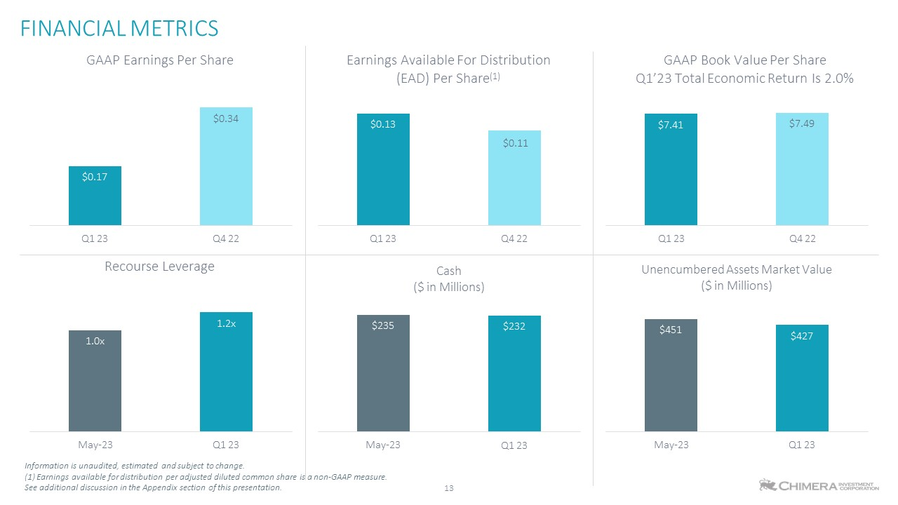
13 FINANCIAL METRICS See additional discussion in the Appendix section of this presentation. $0.17 $0.34 Q1 23 Q4 22 GAAP Earnings Per Share $0.13 $0.11 Q1 23 Q4 22 Earnings Available For Distribution (EAD) Per Share(1) $7.41 $7.49 GAAP Book Value Per Share Q1’23 Total Economic Return Is 2.0% 1.0x 1.2x Recourse Leverage $235 $232 May-23 Q1 23 May-23 Information is unaudited, estimated and subject to change. (1) Earnings available for distribution per adjusted diluted common share is a non-GAAP measure. Q1 23 Cash ($ in Millions) $451 $427 May-23 Q1 23 Q1 23 Q4 22 Unencumbered Assets Market Value ($ in Millions)

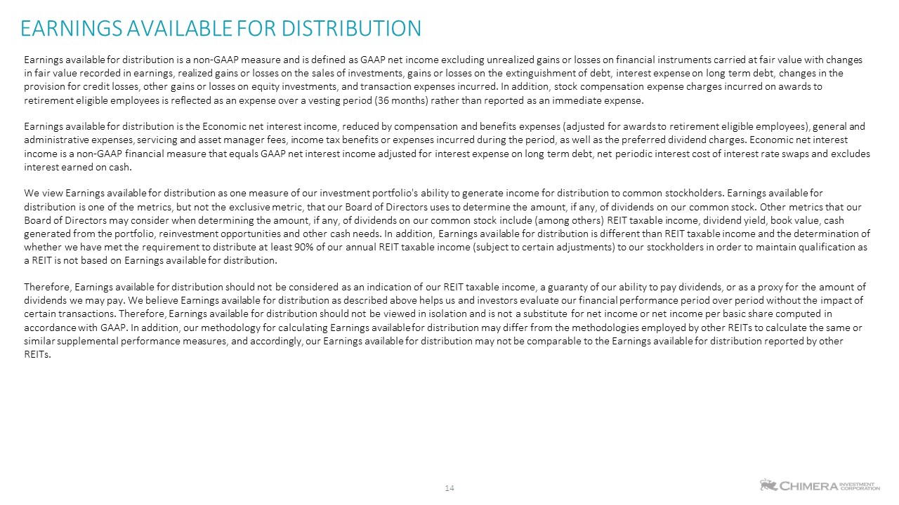
EARNINGS AVAILABLE FOR DISTRIBUTION Earnings available for distribution is a non-GAAP measure and is defined as GAAP net income excluding unrealized gains or losses on financial instruments carried at fair value with changes in fair value recorded in earnings, realized gains or losses on the sales of investments, gains or losses on the extinguishment of debt, interest expense on long term debt, changes in the provision for credit losses, other gains or losses on equity investments, and transaction expenses incurred. In addition, stock compensation expense charges incurred on awards to retirement eligible employees is reflected as an expense over a vesting period (36 months) rather than reported as an immediate expense. Earnings available for distribution is the Economic net interest income, reduced by compensation and benefits expenses (adjusted for awards to retirement eligible employees), general and administrative expenses, servicing and asset manager fees, income tax benefits or expenses incurred during the period, as well as the preferred dividend charges. Economic net interest income is a non-GAAP financial measure that equals GAAP net interest income adjusted for interest expense on long term debt, net periodic interest cost of interest rate swaps and excludes interest earned on cash. We view Earnings available for distribution as one measure of our investment portfolio's ability to generate income for distribution to common stockholders. Earnings available for distribution is one of the metrics, but not the exclusive metric, that our Board of Directors uses to determine the amount, if any, of dividends on our common stock. Other metrics that our Board of Directors may consider when determining the amount, if any, of dividends on our common stock include (among others) REIT taxable income, dividend yield, book value, cash generated from the portfolio, reinvestment opportunities and other cash needs. In addition, Earnings available for distribution is different than REIT taxable income and the determination of whether we have met the requirement to distribute at least 90% of our annual REIT taxable income (subject to certain adjustments) to our stockholders in order to maintain qualification as a REIT is not based on Earnings available for distribution. Therefore, Earnings available for distribution should not be considered as an indication of our REIT taxable income, a guaranty of our ability to pay dividends, or as a proxy for the amount of dividends we may pay. We believe Earnings available for distribution as described above helps us and investors evaluate our financial performance period over period without the impact of certain transactions. Therefore, Earnings available for distribution should not be viewed in isolation and is not a substitute for net income or net income per basic share computed in accordance with GAAP. In addition, our methodology for calculating Earnings available for distribution may differ from the methodologies employed by other REITs to calculate the same or similar supplemental performance measures, and accordingly, our Earnings available for distribution may not be comparable to the Earnings available for distribution reported by other REITs. 14

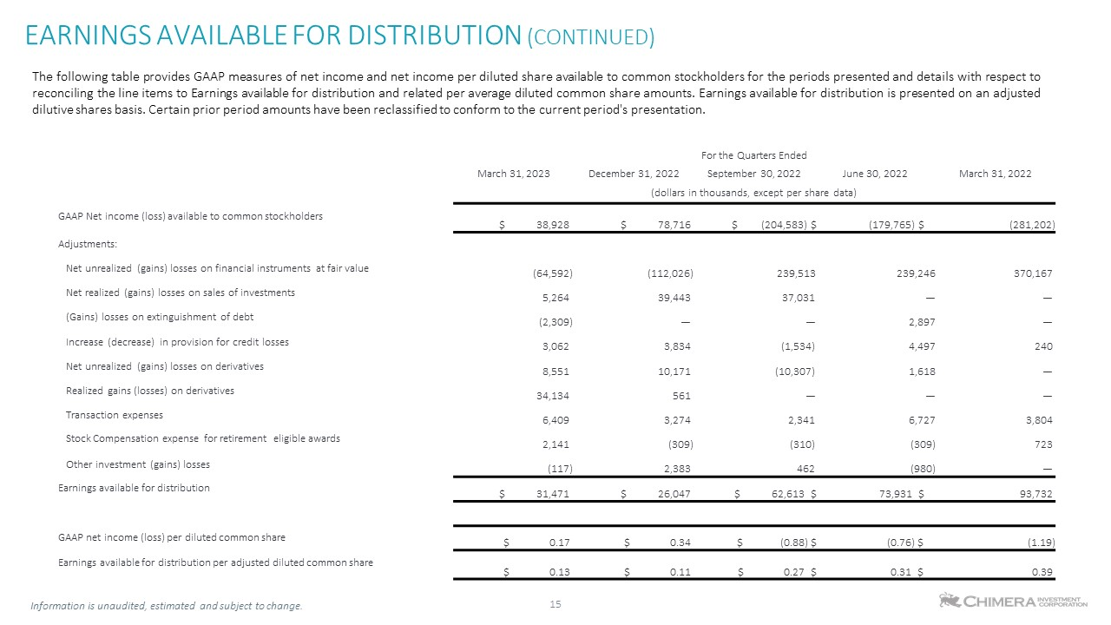
EARNINGS AVAILABLE FOR DISTRIBUTION (CONTINUED) 15 The following table provides GAAP measures of net income and net income per diluted share available to common stockholders for the periods presented and details with respect to reconciling the line items to Earnings available for distribution and related per average diluted common share amounts. Earnings available for distribution is presented on an adjusted dilutive shares basis. Certain prior period amounts have been reclassified to conform to the current period's presentation. For the Quarters Ended March 31, 2023 December 31, 2022 September 30, 2022 June 30, 2022 March 31, 2022 (dollars in thousands, except per share data) GAAP Net income (loss) available to common stockholders $ 38,928 $ 78,716 $ (204,583) $ (179,765) $ (281,202) Adjustments: Net unrealized (gains) losses on financial instruments at fair value (64,592) (112,026) 239,513 239,246 370,167 Net realized (gains) losses on sales of investments 5,264 39,443 37,031 — — (Gains) losses on extinguishment of debt (2,309) — — 2,897 — Increase (decrease) in provision for credit losses 3,062 3,834 (1,534) 4,497 240 Net unrealized (gains) losses on derivatives 8,551 10,171 (10,307) 1,618 — Realized gains (losses) on derivatives 34,134 561 — — — Transaction expenses 6,409 3,274 2,341 6,727 3,804 Stock Compensation expense for retirement eligible awards 2,141 (309) (310) (309) 723 Other investment (gains) losses (117) 2,383 462 (980) — Earnings available for distribution $ 31,471 $ 26,047 $ 62,613 $ 73,931 $ 93,732 GAAP net income (loss) per diluted common share $ 0.17 $ 0.34 $ (0.88) $ (0.76) $ (1.19) Earnings available for distribution per adjusted diluted common share $ 0.13 $ 0.11 $ 0.27 $ 0.31 $ 0.39 Information is unaudited, estimated and subject to change.

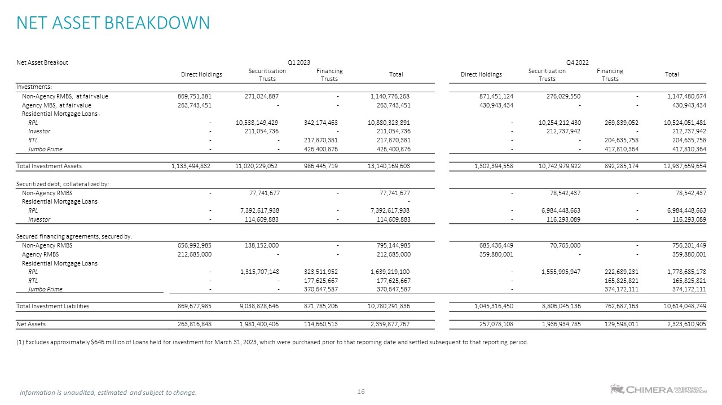
NET ASSET BREAKDOWN 16 Net Asset Breakout Q1 2023 Q4 2022 Direct Holdings Securitization Trusts Financing Trusts Total Direct Holdings Securitization Trusts Financing Trusts Total Investments: Non-Agency RMBS, at fair value 869,751,381 271,024,887 - 1,140,776,268 871,451,124 276,029,550 - 1,147,480,674 Agency MBS, at fair value 263,743,451 - - 263,743,451 430,943,434 - - 430,943,434 Residential Mortgage Loans(1) RPL - 10,538,149,429 342,174,463 10,880,323,891 - 10,254,212,430 269,839,052 10,524,051,481 Investor - 211,054,736 - 211,054,736 - 212,737,942 - 212,737,942 RTL - - 217,870,381 217,870,381 - - 204,635,758 204,635,758 Jumbo Prime - - 426,400,876 426,400,876 - - 417,810,364 417,810,364 Total Investment Assets 1,133,494,832 11,020,229,052 986,445,719 13,140,169,603 1,302,394,558 10,742,979,922 892,285,174 12,937,659,654 Securitized debt, collateralized by: Non-Agency RMBS - 77,741,677 - 77,741,677 - 78,542,437 - 78,542,437 Residential Mortgage Loans - RPL - 7,392,617,938 - 7,392,617,938 - 6,984,448,663 - 6,984,448,663 Investor - 114,609,883 - 114,609,883 - 116,293,089 - 116,293,089 Secured financing agreements, secured by: Non-Agency RMBS 656,992,985 138,152,000 - 795,144,985 685,436,449 70,765,000 - 756,201,449 Agency RMBS 212,685,000 - - 212,685,000 359,880,001 - - 359,880,001 Residential Mortgage Loans RPL - 1,315,707,148 323,511,952 1,639,219,100 - 1,555,995,947 222,689,231 1,778,685,178 RTL - - 177,625,667 177,625,667 - 165,825,821 165,825,821 Jumbo Prime - - 370,647,587 370,647,587 - 374,172,111 374,172,111 Total Investment Liabilities 869,677,985 9,038,828,646 871,785,206 10,780,291,836 1,045,316,450 8,806,045,136 762,687,163 10,614,048,749 Net Assets 263,816,848 1,981,400,406 114,660,513 2,359,877,767 257,078,108 1,936,934,785 129,598,011 2,323,610,905 (1) Excludes approximately $646 million of Loans held for investment for March 31, 2023, which were purchased prior to that reporting date and settled subsequent to that reporting period. Information is unaudited, estimated and subject to change.

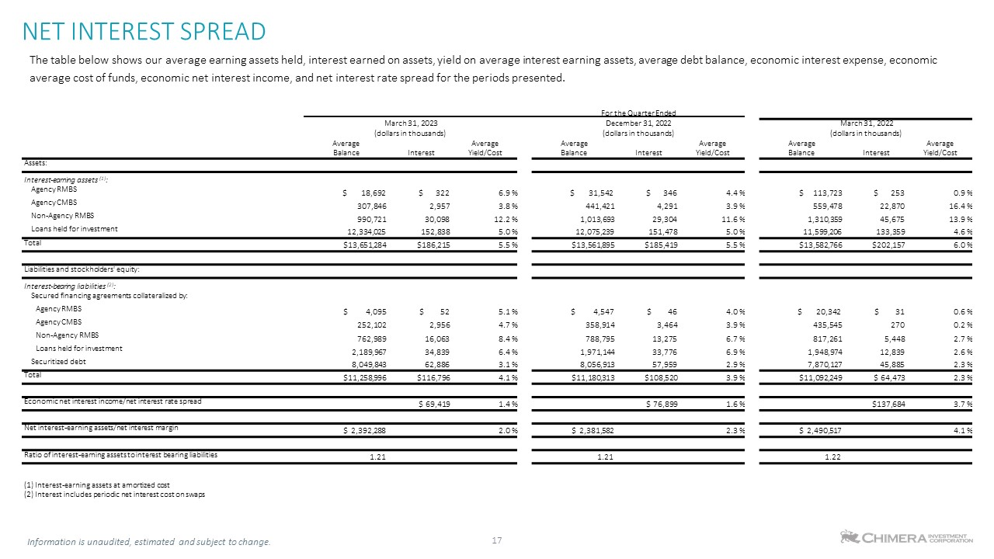
NET INTEREST SPREAD The table below shows our average earning assets held, interest earned on assets, yield on average interest earning assets, average debt balance, economic interest expense, economic average cost of funds, economic net interest income, and net interest rate spread for the periods presented. 17 For the Quarter Ended March 31, 2023 December 31, 2022 March 31, 2022 (dollars in thousands) (dollars in thousands) (dollars in thousands) Average Balance Interest Average Yield/Cost Average Balance Interest Average Yield/Cost Average Balance Interest Average Yield/Cost Assets: Interest-earning assets (1): Agency RMBS $ 18,692 $ 322 6.9 % $ 31,542 $ 346 4.4 % $ 113,723 $ 253 0.9 % Agency CMBS 307,846 2,957 3.8 % 441,421 4,291 3.9 % 559,478 22,870 16.4 % Non-Agency RMBS 990,721 30,098 12.2 % 1,013,693 29,304 11.6 % 1,310,359 45,675 13.9 % Loans held for investment 12,334,025 152,838 5.0 % 12,075,239 151,478 5.0 % 11,599,206 133,359 4.6 % Total $13,651,284 $186,215 5.5 % $13,561,895 $185,419 5.5 % $13,582,766 $202,157 6.0 % Liabilities and stockholders' equity: Interest-bearing liabilities (2): Secured financing agreements collateralized by: Agency RMBS $ 4,095 $ 52 5.1 % $ 4,547 $ 46 4.0 % $ 20,342 $ 31 0.6 % Agency CMBS 252,102 2,956 4.7 % 358,914 3,464 3.9 % 435,545 270 0.2 % Non-Agency RMBS 762,989 16,063 8.4 % 788,795 13,275 6.7 % 817,261 5,448 2.7 % Loans held for investment 2,189,967 34,839 6.4 % 1,971,144 33,776 6.9 % 1,948,974 12,839 2.6 % Securitized debt 8,049,843 62,886 3.1 % 8,056,913 57,959 2.9 % 7,870,127 45,885 2.3 % Total $11,258,996 $116,796 4.1 % $11,180,313 $108,520 3.9 % $11,092,249 $ 64,473 2.3 % Economic net interest income/net interest rate spread $ 69,419 1.4 % $ 76,899 1.6 % $137,684 3.7 % Net interest-earning assets/net interest margin $ 2,392,288 2.0 % $ 2,381,582 2.3 % $ 2,490,517 4.1 % Ratio of interest-earning assets to interest bearing liabilities 1.21 1.21 1.22 (1) Interest-earning assets at amortized cost (2) Interest includes periodic net interest cost on swaps Information is unaudited, estimated and subject to change.

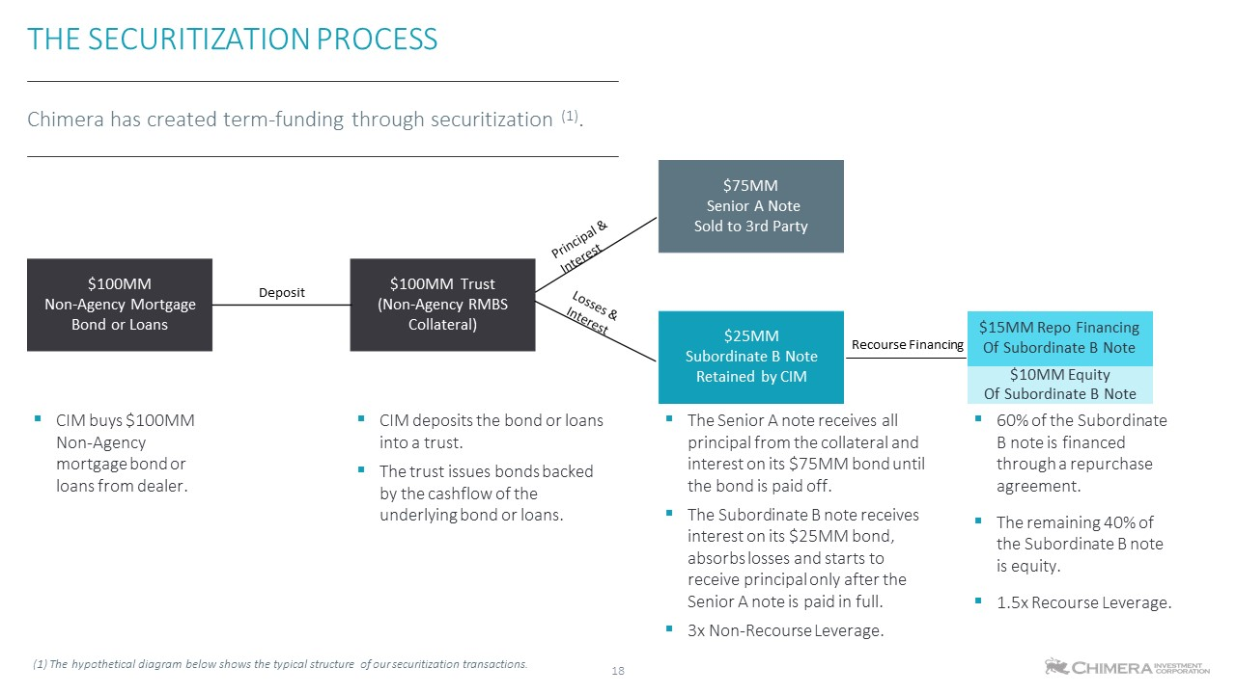
Chimera has created term-funding through securitization (1). THE SECURITIZATION PROCESS CIM buys $100MM Non-Agency mortgage bond or loans from dealer. CIM deposits the bond or loans into a trust. The trust issues bonds backed by the cashflow of the underlying bond or loans. The Senior A note receives all principal from the collateral and interest on its $75MM bond until the bond is paid off. The Subordinate B note receives interest on its $25MM bond, absorbs losses and starts to receive principal only after the Senior A note is paid in full. 3x Non-Recourse Leverage. $100MM Non-Agency Mortgage Bond or Loans $100MM Trust (Non-Agency RMBS Collateral) $75MM Senior A Note Sold to 3rd Party $25MM Subordinate B Note Retained by CIM Deposit 18 Recourse Financing $15MM Repo Financing Of Subordinate B Note $10MM Equity Of Subordinate B Note 60% of the Subordinate B note is financed through a repurchase agreement. The remaining 40% of the Subordinate B note is equity. 1.5x Recourse Leverage. (1) The hypothetical diagram below shows the typical structure of our securitization transactions.

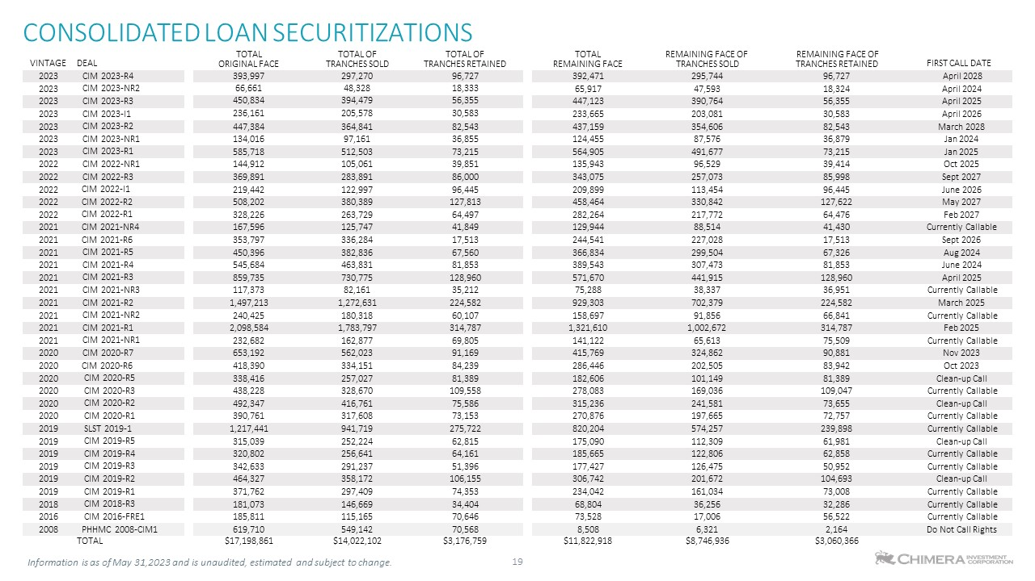
CONSOLIDATED LOAN SECURITIZATIONS 19 VINTAGE DEAL TOTAL ORIGINAL FACE TOTAL OF TRANCHES SOLD TOTAL OF TRANCHES RETAINED TOTAL REMAINING FACE REMAINING FACE OF TRANCHES SOLD REMAINING FACE OF TRANCHES RETAINED FIRST CALL DATE 2023 CIM 2023-R4 393,997 297,270 96,727 392,471 295,744 96,727 April 2028 2023 CIM 2023-NR2 66,661 48,328 18,333 65,917 47,593 18,324 April 2024 2023 CIM 2023-R3 450,834 394,479 56,355 447,123 390,764 56,355 April 2025 2023 CIM 2023-I1 236,161 205,578 30,583 233,665 203,081 30,583 April 2026 2023 CIM 2023-R2 447,384 364,841 82,543 437,159 354,606 82,543 March 2028 2023 CIM 2023-NR1 134,016 97,161 36,855 124,455 87,576 36,879 Jan 2024 2023 CIM 2023-R1 585,718 512,503 73,215 564,905 491,677 73,215 Jan 2025 2022 CIM 2022-NR1 144,912 105,061 39,851 135,943 96,529 39,414 Oct 2025 2022 CIM 2022-R3 369,891 283,891 86,000 343,075 257,073 85,998 Sept 2027 2022 CIM 2022-I1 219,442 122,997 96,445 209,899 113,454 96,445 June 2026 2022 CIM 2022-R2 508,202 380,389 127,813 458,464 330,842 127,622 May 2027 2022 CIM 2022-R1 328,226 263,729 64,497 282,264 217,772 64,476 Feb 2027 2021 CIM 2021-NR4 167,596 125,747 41,849 129,944 88,514 41,430 Currently Callable 2021 CIM 2021-R6 353,797 336,284 17,513 244,541 227,028 17,513 Sept 2026 2021 CIM 2021-R5 450,396 382,836 67,560 366,834 299,504 67,326 Aug 2024 2021 CIM 2021-R4 545,684 463,831 81,853 389,543 307,473 81,853 June 2024 2021 CIM 2021-R3 859,735 730,775 128,960 571,670 441,915 128,960 April 2025 2021 CIM 2021-NR3 117,373 82,161 35,212 75,288 38,337 36,951 Currently Callable 2021 CIM 2021-R2 1,497,213 1,272,631 224,582 929,303 702,379 224,582 March 2025 2021 CIM 2021-NR2 240,425 180,318 60,107 158,697 91,856 66,841 Currently Callable 2021 CIM 2021-R1 2,098,584 1,783,797 314,787 1,321,610 1,002,672 314,787 Feb 2025 2021 CIM 2021-NR1 232,682 162,877 69,805 141,122 65,613 75,509 Currently Callable 2020 CIM 2020-R7 653,192 562,023 91,169 415,769 324,862 90,881 Nov 2023 2020 CIM 2020-R6 418,390 334,151 84,239 286,446 202,505 83,942 Oct 2023 2020 CIM 2020-R5 338,416 257,027 81,389 182,606 101,149 81,389 Clean-up Call 2020 CIM 2020-R3 438,228 328,670 109,558 278,083 169,036 109,047 Currently Callable 2020 CIM 2020-R2 492,347 416,761 75,586 315,236 241,581 73,655 Clean-up Call 2020 CIM 2020-R1 390,761 317,608 73,153 270,876 197,665 72,757 Currently Callable 2019 SLST 2019-1 1,217,441 941,719 275,722 820,204 574,257 239,898 Currently Callable 2019 CIM 2019-R5 315,039 252,224 62,815 175,090 112,309 61,981 Clean-up Call 2019 CIM 2019-R4 320,802 256,641 64,161 185,665 122,806 62,858 Currently Callable 2019 CIM 2019-R3 342,633 291,237 51,396 177,427 126,475 50,952 Currently Callable 2019 CIM 2019-R2 464,327 358,172 106,155 306,742 201,672 104,693 Clean-up Call 2019 CIM 2019-R1 371,762 297,409 74,353 234,042 161,034 73,008 Currently Callable 2018 CIM 2018-R3 181,073 146,669 34,404 68,804 36,256 32,286 Currently Callable 2016 CIM 2016-FRE1 185,811 115,165 70,646 73,528 17,006 56,522 Currently Callable 2008 PHHMC 2008-CIM1 619,710 549,142 70,568 8,508 6,321 2,164 Do Not Call Rights TOTAL $17,198,861 $14,022,102 $3,176,759 $11,822,918 $8,746,936 $3,060,366 Information is as of May 31,2023 and is unaudited, estimated and subject to change.


Information is unaudited, estimated and subject to change. 20

