​
​
​
UNITED STATES
SECURITIES AND EXCHANGE COMMISSION
WASHINGTON, D.C. 20549
​
SCHEDULE TO
(Rule 13e-4)
​
TENDER OFFER STATEMENT PURSUANT TO SECTION 14(D)(1) OR 13(E)(1)
OF THE SECURITIES EXCHANGE ACT OF 1934
​
Ares Strategic Income Fund
(Name of Issuer)
Ares Strategic Income Fund
(Name of Person(s) Filing Statement)​
Class I Shares of Beneficial Interest
(Title of Class of Securities)​
04020E404, 04020E107 and U2225W101
(CUSIP Number of class of securities)​
Class D Shares of Beneficial Interest
(Title of Class of Securities)​
04020E305
(CUSIP Number of class of securities)​
Class S Shares of Beneficial Interest
(Title of Class of Securities)​
04020E206
(CUSIP Number of class of securities)​
​
Joshua M. Bloomstein
General Counsel
Ares Strategic Income Fund
245 Park Avenue, 44th Floor
New York, NY 10167
(212) 750-7300
(Name, Address and Telephone No. of Person Authorized to Receive
Notices and Communications on Behalf of the Person(s) Filing Statement)
​
COPIES TO:
​ | Monica J. Shilling, P.C.  Kirkland & Ellis LLP  2049 Century Park East, 37th Floor  Los Angeles, California 90067  (310) 552-4200 | ​ | ​ | Nicole M. Runyan, P.C.  Kirkland & Ellis LLP  601 Lexington Avenue  New York, New York 10022  (212) 446-4800 | ​
August 22, 2024
(Date Tender Offer First Published, Sent or Given to Security Holders)​
☐
Check the box if any part of the fee is offset as provided by Rule 0-11(a)(2) and identify the filing with which the offsetting fee was previously paid. Identify the previous filing by registration statement number, or the Form of Schedule and the date of its filing.
​
​ | Amount Previously Paid: | ​ | ​ | ​ | ​ | ​ | Filing Parties: | ​ | ​ | ​ | ​
​ | Form or Registration No.: | ​ | ​ | ​ | ​ | ​ | Date Filed: | ​ | ​ | ​ | ​
​
☐
Check the box if the filing relates solely to preliminary communications made before commencement of a tender offer.
​
Check the appropriate boxes below to designate any transactions to which the statement relates:
☐
third-party tender offer subject to Rule 14d-1.
​
☒
issuer tender offer subject to Rule 13e-4.
​
☐
going-private transaction subject to Rule 13e-3.
​
☐
amendment to Schedule 13D under Rule 13d-2.
​
Check the following box if the filing is a final amendment reporting the results of the tender offer: ☐
​
​

​

Item 1. Summary Term Sheet.
Reference is made to the Summary Term Sheet of the Offer to Purchase (as defined below) that is attached hereto as Exhibit (a)(1)(ii) and is hereby incorporated by reference.
Item 2. Subject Company Information.
(a)
The name of the issuer is Ares Strategic Income Fund (the “Fund”). The Fund is a closed-end management investment company that has elected to be regulated as a business development company under the Investment Company Act of 1940, as amended (the “1940 Act”). It is organized as a Delaware statutory trust. The principal executive office of the Fund is located at 245 Park Avenue, New York, New York 10167 and the telephone number is (212) 750-7300.
​
(b)
The title of the securities that are the subject of the offer to purchase and the related Letter of Transmittal (“Offer to Purchase” and the tender offer made thereby, the “Offer”) are Class I common shares of beneficial interest (the “Class I Shares”), Class D common shares of beneficial interest (the “Class D Shares”), and Class S common shares of beneficial interest (the “Class S Shares” and together with Class I Shares and Class D Shares, the “Shares”) or portions thereof. As of the close of business on July 31, 2024, there were 115,660,996 Class I Shares outstanding, 3,493,447 Class D Shares outstanding, and 22,933,784 Class S Shares outstanding. Subject to the conditions set forth in the Offer to Purchase, the Fund will purchase up to 5.0% of the Fund’s outstanding Shares that are tendered by holders of the Fund’s Shares (“Shareholders”) and not withdrawn as described in the Offer to Purchase (the “Offer Amount”). The Shares subject to the Offer represent approximately 5.0% of the Fund’s Shares outstanding as of July 31, 2024.
​
(c)
Shares are not traded in any market.
​
Item 3. Identity and Background of Filing Person.
(a)
The Fund is tendering for its own Shares. The information required by this Item is set forth in Item 2(a) above. Ares Capital Management LLC (the “Adviser”) serves as the investment adviser for the Fund. The Adviser is located at 1800 Avenue of the Stars, Suite 1400, Los Angeles, California 90067 and its telephone number is (310) 201-4100. The members of the Fund’s Board of Trustees (the “Board”) are R. Kipp deVeer, Mitchell Goldstein, Michael L. Smith, Sandra R. Anceleitz, Ann Torre Bates, Steven B. McKeever and Eric B. Siegel (each, a “Trustee”). The Co-Chief Executive Officers are Mitchell Goldstein and Michael L. Smith, the President is Jim Miller, the Chief Financial Officer and Treasurer is Scott C. Lem, the Chief Accounting Officer is Paul Cho, the Chief Operating Officer is Jana Markowicz, and the General Counsel and Secretary is Joshua M. Bloomstein. The Trustees and the executive officers of the Fund may be reached at the Fund’s business address and phone number set forth in Item 2(a) above.
​
(b) – (c)
Not applicable.
​
Item 4. Terms of the Transaction.
(a)(1)(i)
Subject to the conditions set forth in the Offer to Purchase, the Fund will purchase up to 7,104,411 Shares that are tendered by Shareholders by 11:59 p.m., Eastern Time, on September 20, 2024 and not withdrawn as described in Item 4(a)(1)(vi).
​
(ii)
The purchase price of a Share (or portion thereof) tendered will be its net asset value as of August 31, 2024 or a later date determined by the Fund if the Offer is extended (in each case, the “Valuation Date”), upon the terms and subject to the conditions set forth in the Offer to Purchase. Reference is made to the Cover Page, Section 2 “Offer to Purchase and Price” and Section 6 “Purchases and Payment” of the Offer to Purchase, which are incorporated herein by reference.
​
Each Shareholder that tenders Shares that are accepted for purchase will be sent a written notice (the “Acceptance Notice”) notifying the Shareholder that the Fund has received and accepted their tender. Such Shareholder will receive cash in an amount equal to the value of the Shareholder’s

1

​

Shares accepted for purchase by the Fund determined as of the Valuation Date. The Form of the Acceptance Notice is attached hereto as Exhibit (a)(1)(iv) and incorporated herein by reference.
(iii)
The Offer is scheduled to expire on September 20, 2024 unless extended. Reference is made to the Cover Page, Summary Term Sheet, Section 2 “Offer to Purchase and Price” and Section 5 “Withdrawal Rights” of the Offer to Purchase, which are incorporated herein by reference.
​
(iv)
Not applicable.
​
(v)
Reference is made to the Cover Page, Summary Term Sheet and Section 7 “Certain Conditions of the Offer” of the Offer to Purchase, which are incorporated herein by reference.
​
(vi)
Reference is made to Section 5 “Withdrawal Rights” of the Offer to Purchase, which is incorporated herein by reference.
​
(vii)
Reference is made to the Cover Page, Section 4 “Procedure for Tenders” and Section 5 “Withdrawal Rights” of the Offer to Purchase, which are incorporated herein by reference. Note that certain Shareholders may be required to deliver their Letter of Transmittal to their Financial Advisor (instead of directly to the Fund’s transfer agent, SS&C GIDS, Inc.). All Shareholders tendering Shares should carefully review their Letter of Transmittal and follow the delivery instructions therein.
​
(viii)
Reference is made to Section 4 “Procedure for Tenders” and Section 6 “Purchases and Payment” of the Offer to Purchase, which are incorporated herein by reference.
​
(ix)
Reference is made to the Cover Page, Section 3 “Amount of Tender,” and Section 6 “Purchases and Payment” of the Offer to Purchase, which are incorporated herein by reference.
​
(x)
Reference is made to Section 2 “Offer to Purchase and Price” of the Offer to Purchase, which is incorporated herein by reference.
​
(xi)
Not applicable.
​
(xii)
Reference is made to Section 10 “Certain Federal Income Tax Consequences” of the Offer to Purchase, which is incorporated herein by reference.
​
(a)(2)
Not applicable.
​
(b)
Any Shares to be purchased from any officer, Trustee or affiliate of the Fund will be on the same terms and conditions as any other purchase of Shares. To the Fund’s knowledge, none of the officers, Trustees, or affiliates of the Fund intends to tender Shares in the Offer.
​
Item 5. Past Contracts, Transactions, Negotiations and Agreements with Respect to the Issuer’s Securities.
(a)
Not applicable.
​
(b)
Not applicable.
​
(c)
Not applicable.
​
(d)
Not applicable.
​
(e)
The Fund’s prospectus, dated April 26, 2024, as amended and/or supplemented from time to time (the “Prospectus”), provides that the Board has the discretion to determine whether the Fund will purchase Shares from Shareholders from time to time pursuant to written tenders. The Adviser expects that it will recommend to the Board that the Fund purchase Shares from Shareholders quarterly. However, the Fund is not required to conduct tender offers.
​
Except as described below, the Fund is not aware of any other agreement, arrangement, or understanding relating, directly or indirectly, to the Offer, whether or not legally enforceable, between: (i) the Fund, the Adviser, the Fund’s officers or members of the Board or any person controlling the Fund, the Adviser, the Fund’s officers or the Board; and (ii) any other person, with respect to the Shares. Certain investors that purchased the Fund’s Class I Shares through a

2

​

private placement conducted pursuant to Section 4(a)(2) of the Securities Act of 1933, as amended (the “Securities Act”), and Rule 506(b) of Regulation D promulgated under the Securities Act entered into an agreement with the Adviser, pursuant to which each such investor agreed to not tender its Shares in any anticipated quarterly tender offer by the Fund until 2024, subject to certain agreed-upon terms and limitations.
Item 6. Purposes Of This Tender Offer and Plans or Proposals.
(a) – (b)
Reference is made to Section 1 “Background and Purpose of the Offer” of the Offer to Purchase, which is incorporated herein by reference.
​
(c)
Reference is made to Section 8 “Certain Information About the Fund” of the Offer to Purchase, which is incorporated herein by reference. Because Shares are not traded in any market, subsections (6), (7), and (8) of Regulation M-A Item 1006(c) are not applicable to the Fund.
​
Item 7. Source and Amount of Funds or Other Consideration.
(a) – (d)
Reference is made to Section 6 “Purchases and Payment” of the Offer to Purchase, which is incorporated herein by reference.
​
Item 8. Interest in Securities of the Issuer.
(a)
Based on the number of Shares outstanding as of July 31, 2024, the following persons own the number of Shares indicated in the below table.
​
Person | ​ | ​ | Shares |  |  |  | ​ | ​ | Percentage of the Fund’s  Outstanding Shares |  |  |  | ​
Sandra R. Anceleitz | ​ | ​ | ​ | ​ | — | ​ | ​ | ​ | ​ | ​ | — | ​ | ​
Ann Torre Bates | ​ | ​ | ​ | ​ | 19,539 | ​ | ​ | ​ | ​ | ​ | * | ​ | ​
Steven B. McKeever | ​ | ​ | ​ | ​ | — | ​ | ​ | ​ | ​ | ​ | — | ​ | ​
Eric B. Siegel | ​ | ​ | ​ | ​ | — | ​ | ​ | ​ | ​ | ​ | — | ​ | ​
R. Kipp deVeer | ​ | ​ | ​ | ​ | — | ​ | ​ | ​ | ​ | ​ | — | ​ | ​
Mitchell Goldstein | ​ | ​ | ​ | ​ | 184,638 | ​ | ​ | ​ | ​ | ​ | * | ​ | ​
Michael L. Smith | ​ | ​ | ​ | ​ | — | ​ | ​ | ​ | ​ | ​ | — | ​ | ​
Scott C. Lem | ​ | ​ | ​ | ​ | — | ​ | ​ | ​ | ​ | ​ | — | ​ | ​
Paul Cho | ​ | ​ | ​ | ​ | — | ​ | ​ | ​ | ​ | ​ | — | ​ | ​
Joshua M. Bloomstein | ​ | ​ | ​ | ​ | — | ​ | ​ | ​ | ​ | ​ | — | ​ | ​
Jana Markowicz | ​ | ​ | ​ | ​ | — | ​ | ​ | ​ | ​ | ​ | — | ​ | ​
Jim Miller | ​ | ​ | ​ | ​ | — | ​ | ​ | ​ | ​ | ​ | — | ​ | ​
Ares Management LLC | ​ | ​ | ​ | ​ | 1,000 | ​ | ​ | ​ | ​ | ​ | * | ​ | ​
​
*
Less than 1%.
​
None of the persons listed above intends to tender any of his or her Shares in the Offer. Addresses for each of the persons listed above are provided in Item 3.
(b)
Reference is made to Section 8 “Certain Information About the Fund” of the Offer to Purchase, which is incorporated herein by reference. During the past 60 days, the Fund has issued to the Adviser, Trustees and officers of the Fund an aggregate of approximately 452 shares, including the net impact of shares issued pursuant to the Fund’s dividend reinvestment plan, for net proceeds of approximately $12,367.80 from the Adviser, any Trustee or executive officer of the Fund, or any person controlling the Fund or the Adviser.
​
Item 9. Persons/Assets Retained, Employed, Compensated or Used.
(a)
No persons have been employed, retained, or are to be compensated by the Fund to make solicitations or recommendations in connection with the Offer to Purchase.
​

3

​

Item 10. Financial Statements.
(a)
Not applicable. The consideration offered to security holders consists solely of cash. The Offer is not subject to any financing condition, and the Fund is a public reporting company under Sections 13(a) or 15(d) of the Securities Exchange Act of 1934, as amended, that files reports electronically on EDGAR.
​
(b)
Not applicable.
​
Item 11. Additional Information.
(a)(1) None.
(2) None.
(3) Not applicable.
(4) None.
(5) None.
(c)
The Offer to Purchase, attached hereto as Exhibit (a)(1)(ii), is incorporated herein by reference in its entirety.
​
Item 12. Exhibits.
​ | (a)(1)(i) | ​ | ​ | Cover Letter to Offer to Purchase and Letter of Transmittal. | ​
​ | (a)(1)(ii) | ​ | ​ | Offer to Purchase. | ​
​ | (a)(1)(iii) | ​ | ​ | Forms of Letter of Transmittal. | ​
​ | (a)(1)(iv) | ​ | ​ | Form of Notice from the Fund to Shareholders in Connection with the Fund’s Acceptance of Shares. | ​
​ | (a)(1)(v) | ​ | ​ | Forms of Notice of Withdrawal of Tender. | ​
​ | (a)(2) – (4) | ​ | ​ | Not applicable. | ​
​ | (b) | ​ | ​ | None. | ​
​ | (d) | ​ | ​ | Not applicable. | ​
​ | (g) | ​ | ​ | Not applicable. | ​
​ | (h) | ​ | ​ | Not applicable. | ​
​ | EX-FILING FEES | ​ | ​ | Filing Fee Table. | ​

4

​

SIGNATURE
After due inquiry and to the best of my knowledge and belief, I certify that the information set forth in this statement is true, complete and correct.
ARES STRATEGIC INCOME FUND
By:
/s/ Joshua M. Bloomstein
​
​
Name:
Joshua M. Bloomstein
​
Title:
General Counsel and Secretary
​
Dated: August 22, 2024

5

​

EXHIBIT INDEX
​ | Exhibit | ​ | ​ | ​ | ​
​ | (a)(1)(i) | ​ | ​ | Cover Letter to Offer to Purchase and Letter of Transmittal. | ​
​ | (a)(1)(ii) | ​ | ​ | Offer to Purchase. | ​
​ | (a)(1)(iii) | ​ | ​ | Forms of Letter of Transmittal. | ​
​ | (a)(1)(iv) | ​ | ​ | Form of Notice from the Fund to Shareholders in Connection with the Fund’s Acceptance of Shares. | ​
​ | (a)(1)(v) | ​ | ​ | Forms of Notice of Withdrawal of Tender. | ​
​ | EX-FILING FEES | ​ | ​ | Filing Fee Table. | ​

6

​

Exhibit (a)(1)(i)​
ARES STRATEGIC INCOME FUND
If you do not want to sell your shares of beneficial
interest at this time, please disregard this notice.
This is simply a notification of the Fund’s repurchase offer.
August 22, 2024
Dear Shareholder:
This letter serves to inform you of important dates relating to a repurchase offer by Ares Strategic Income Fund (the “Fund”). If you are not interested in selling your shares of beneficial interest in the Fund (“Shares”) for repurchase at this time, please disregard this notice and take no action.
Please note that, except as described below and unless the Offer is extended, all Shares that have been issued on or after October 1, 2023 will be subject to an “early repurchase deduction”, which will reduce your proceeds by 2.0%. Shares that are issued pursuant to the Fund’s distribution reinvestment plan will not be subject to the early repurchase deduction. Further, the Early Repurchase Deduction may be waived in the case of repurchase requests (i) arising from the death or qualified disability of a shareholder; (ii) submitted by discretionary model portfolio management programs (and similar arrangements); (iii) from feeder funds (or similar vehicles) primarily created to hold the Fund’s Shares, which are offered to non-U.S. persons, where such funds seek to avoid imposing such a deduction because of administrative or systems limitations; and (iv) in the event that a shareholder’s Shares are repurchased because the shareholder has failed to maintain the $500 minimum account balance. The Fund currently is waiving the Early Repurchase Deduction for each category of shareholder above, and will notify shareholders prior to the termination of this tender offer if it no longer intends to continue such waiver for one or more of those categories. In addition, the repurchase of Shares may also be subject to income and transfer taxes.
The tender offer period will begin on August 22, 2024 and end at 11:59 p.m., Eastern Time, on September 20, 2024. The purpose of the tender offer is to provide liquidity to shareholders of the Fund. Shares may be presented to the Fund for repurchase only by tendering them during one of the Fund’s announced tender offers.
If you do not wish to sell your Shares for any reason, simply disregard this notice. No action is required if you do not wish to sell any portion of your Shares at this time.
Should you wish to tender all or some of your Shares during this tender offer period, please complete the enclosed Letter of Transmittal and return it by mail or fax to the Fund’s Transfer Agent, SS&C GIDS, Inc., Attention: Ares Strategic Income Fund, using one of the below options or to your financial advisor as instructed in the Letter of Transmittal:
Regular Mail — P.O. Box 219270, Kansas City, MO 64121
Overnight Mail — 430 W 7th Street, Suite 219270, Kansas City, MO 64105
Fax: 816-374-7420
All Shareholders tendering Shares should carefully review their Letter of Transmittal and follow the delivery instructions therein.
All tenders of Shares must be received in good order by the Fund’s Transfer Agent by 11:59 p.m., Eastern Time, on September 20, 2024.
If you have any questions, please refer to the attached Offer to Purchase document, which contains additional important information about the repurchase offer, or call 888-310-9352.
Sincerely,
Ares Strategic Income Fund

TABLE OF CONTENTS

Exhibit (a)(1)(ii)​
ARES STRATEGIC INCOME FUND
c/o Ares Capital Management LLC
Offer to Purchase Up to 7,104,411
Shares of Beneficial Interest
Dated August 22, 2024
The Offer and Withdrawal Rights Will Expire at
11:59 p.m., Eastern Time, on September 20, 2024,
Unless the Offer is Extended
To the Shareholders of Ares Strategic Income Fund:
Subject to the terms and conditions set forth in this offer to purchase (“Offer to Purchase”) and the related Letter of Transmittal (which together with the Offer to Purchase constitutes the “Offer”), Ares Strategic Income Fund, a closed-end management investment company that has elected to be regulated as a business development company under the Investment Company Act of 1940, as amended (the “1940 Act”), and is organized as a Delaware statutory trust (the “Fund”), is offering to purchase up to 7,104,411 of its outstanding shares of beneficial interest (including Class I common shares of beneficial interest, Class D common shares of beneficial interest, and Class S common shares of beneficial interest, the “Shares”) pursuant to tenders by shareholders of the Fund (“Shareholders”) at a price equal to the net asset value per Share as of August 31, 2024 or a later date determined by the Fund if the Offer is extended (the “Valuation Date”). This Offer is currently scheduled to expire at 11:59 p.m., Eastern Time, on September 20, 2024 (the “Expiration Date”), but the Fund may extend this date; if it does, the Valuation Date may be changed. This Offer is being made to all Shareholders of the Fund and is not conditioned on any minimum amount of Shares being tendered, but is subject to certain conditions described below. Shares are not traded on any established trading market.
Shareholders should realize that the value of the Shares tendered in this Offer will likely change between the most recent time net asset value was calculated and communicated to them and the Valuation Date (the relevant date for determining the value of the Shares tendered to the Fund for purposes of calculating the purchase price of such Shares) and such change could be material. The Fund generally determines the net asset value of the Shares as of the last calendar day of each month within 20 business days after the last calendar day of each month. The most recently calculated net asset value for each class of the Shares can be found by going to https://www.areswms.com/ares-wealth-management-solutions/solutions/asif. Shareholders should keep in mind that, if they tender Shares in a tender offer with a prospective repurchase date that is within the one-year period following the initial subscription closing date of the Shares being tendered, such Shares will be subject to an “early repurchase deduction” ​(described further below) of 2.0% of the aggregate net asset value of the Shares repurchased, except as described below. The early repurchase deduction will reduce the repurchase proceeds payable to Shareholders for the repurchased Shares. For illustrative purposes, if a Shareholder purchased Shares as of a September 1 subscription closing date, and such Shareholder tendered those Shares on September 20 of the following year for repurchase, the one-year holding period would be deemed satisfied and such Shares would not incur an early repurchase deduction. However, if a Shareholder purchased Shares as of an October 1 subscription closing date, and such Shareholder tendered those Shares on September 20 of the following year for repurchase, the one-year holding period would not be deemed satisfied and such Shares would incur an early repurchase deduction. Shares that are issued pursuant to the Fund’s distribution reinvestment plan and tendered shall not be subject to the early repurchase deduction.
Shareholders desiring to tender all or any portion of their Shares in accordance with the terms of the Offer should complete and sign the attached Letter of Transmittal and deliver it to either the Fund’s transfer agent, SS&C GIDS, Inc. (the “Transfer Agent”) or the Shareholder’s financial advisor, as applicable, in the manner provided for in the Letter of Transmittal and set forth in Section 4 “Procedure for Tenders” below.
IMPORTANT
The Fund makes no recommendation to any Shareholder as to whether to tender or refrain from tendering Shares. Shareholders must make their own decisions whether to tender Shares and, if so, the portion of their Shares to tender.

TABLE OF CONTENTS

Because each Shareholder’s investment decision is a personal one, based on its financial circumstances, no person has been authorized to make any recommendation on behalf of the Fund as to whether Shareholders should tender Shares pursuant to the Offer. No person has been authorized to give any information or to make any representations in connection with the Offer other than those contained herein or in the Letter of Transmittal. If given or made, such recommendation and such information and representations must not be relied on as having been authorized by the Fund.
This transaction has not been approved or disapproved by the Securities and Exchange Commission or the Commodity Futures Trading Commission nor has the Securities and Exchange Commission, the Commodity Futures Trading Commission, or any state securities commission passed on the fairness or merits of such transaction or on the accuracy or adequacy of the information contained in this document. Any representation to the contrary is unlawful.
Questions and requests for assistance and requests for additional copies of the Offer may be directed to the Transfer Agent:
Overnight Mail:
Ares Strategic Income Fund
c/o SS&C GIDS, Inc.
430 W 7th Street, Suite 219270
Kansas City, MO 64105
Regular Mail:
Ares Strategic Income Fund
c/o SS&C GIDS, Inc.
P.O. Box 219270
Kansas City, MO 64105

TABLE OF CONTENTS​

TABLE OF CONTENTS
​ | SUMMARY TERM SHEET | ​ | ​ | ​ | ​ | 1 | ​ | ​
​ | 1. Background and Purpose of the Offer | ​ | ​ | ​ | ​ | 2 | ​ | ​
​ | 2. Offer to Purchase and Price | ​ | ​ | ​ | ​ | 2 | ​ | ​
​ | 3. Amount of Tender | ​ | ​ | ​ | ​ | 2 | ​ | ​
​ | 4. Procedure for Tenders | ​ | ​ | ​ | ​ | 3 | ​ | ​
​ | 5. Withdrawal Rights | ​ | ​ | ​ | ​ | 3 | ​ | ​
​ | 6. Purchases and Payment | ​ | ​ | ​ | ​ | 3 | ​ | ​
​ | 7. Certain Conditions of the Offer | ​ | ​ | ​ | ​ | 4 | ​ | ​
​ | 8. Certain Information About the Fund | ​ | ​ | ​ | ​ | 5 | ​ | ​
​ | 9. Full Tender by DRIP Participants | ​ | ​ | ​ | ​ | 6 | ​ | ​
​ | 10. Certain Federal Income Tax Consequences | ​ | ​ | ​ | ​ | 6 | ​ | ​
​ | 11. Miscellaneous | ​ | ​ | ​ | ​ | 10 | ​ | ​

i

TABLE OF CONTENTS​

SUMMARY TERM SHEET
This is a summary of the features of the Offer. To understand the Offer fully and for a more complete discussion of the terms and conditions of the Offer, you should read carefully this entire Offer to Purchase and the related Letter of Transmittal.
•
As disclosed in the Fund’s prospectus, dated April 26, 2024, as amended and/or supplemented from time to time (the “Prospectus”), the Fund may from time to time offer to repurchase a portion of its outstanding Shares pursuant to written tenders by Shareholders. Accordingly, the Fund is offering to purchase up to 7,104,411 Shares at a price equal to their net asset value (that is, the value of the Fund’s total assets minus its total liabilities, divided by outstanding Shares) determined as of August 31, 2024 or such later date as may be determined by the Fund if the Offer is extended (the “Valuation Date”). The Shares subject to the Offer represent approximately 5% of the outstanding Shares as of July 31, 2024. The Offer, which begins on August 22, 2024, will remain open until 11:59 p.m., Eastern Time, on September 20, 2024 (the “Expiration Date”). The Fund reserves the right to adjust the Valuation Date to correspond to any extension of the Offer.
​
•
Unless the Offer is extended, all Shares issued on or after October 1, 2023, except for Shares issued pursuant to the Fund’s distribution reinvestment plan (“DRIP”), that are tendered and purchased in this Offer will be subject to a 2.0% “early repurchase deduction.” See Section 6 “Purchases and Payment”.
​
•
Shareholders may tender all or a portion of their Shares.
​
•
If a Shareholder tenders Shares and the Fund purchases those Shares, the Fund will effect payment for those Shares in cash promptly after the determination of the relevant net asset value per share is finalized.
​
•
There is no assurance that the Board of Trustees of the Fund (the “Board”) will exercise its discretion to offer to repurchase Shares or that there will be sufficient funds available to accommodate all of the Shareholders’ requests for repurchase. As a result, the Fund may repurchase less than the full amount of shares that you request to have repurchased. If the Fund does not repurchase the full amount of your Shares that you have requested to be repurchased, or the Fund determines not to make repurchases of its Shares, you will likely not be able to dispose of your Shares, even if the Fund under-performs. Any periodic repurchase offers will be subject in part to the Fund’s available cash and compliance with the regulated investment company (“RIC”) qualification and diversification rules and the 1940 Act.
​
•
Other than the early repurchase deduction described below (if applicable), the Fund does not expect to impose any charges on repurchases of Shares in the Fund.
​
•
If you tender only a portion of your Shares, you must maintain a minimum account balance of at least $500 as of the Valuation Date. The Fund reserves the right to purchase all your Shares in the Fund if you tender less than all of your Shares and the number of Shares you tender would cause your account in the Fund to have a value lower than the required minimum balance. Minimum account repurchases are not subject to the early repurchase deduction. The Offer is being made to all Shareholders and is not conditioned on any minimum amount of Shares being tendered.
​
•
If you are a participant in the DRIP, if you elect to tender your Shares in full, and such full tender is accepted by the Fund, any shares issued to you under the DRIP subsequent to the expiration of the tender offer will be considered part of your prior tender. Your participation in the DRIP will be automatically terminated as of the applicable Expiration Date and any distributions due but not yet paid as of such date will be paid in cash on the scheduled distribution payment date.
​
•
If the Fund accepts the tender of any of your Shares, your proceeds will be funded from one or more of the following sources: cash on hand (including cash received from investments in the Fund), borrowings and/or proceeds from the sale of portfolio holdings.
​
•
Additional repurchases will be made at such times and on such terms as may be determined by the Board. Ares Capital Management LLC, the Fund’s investment adviser (the “Adviser”), expects that it will generally recommend to the Board that the Fund offer to repurchase a portion of its outstanding Shares each quarter, but the Fund is not required to make any such offer.
​

1

TABLE OF CONTENTS​​​

•
Following this summary is a formal notice of the Offer, which remains open until the Expiration Date, unless extended. If you elect to tender your Shares, you have the right to change your mind and withdraw your tendered Shares at any time until the Expiration Date or, if such tendered Shares have not been accepted by the Fund, at any time on or after October 21, 2024. If you would like to tender your Shares, you must complete the Letter of Transmittal enclosed with the Offer to Purchase, and return it as instructed in the Letter of Transmittal to the Transfer Agent, Ares Strategic Income Fund, c/o SS&C GIDS, Inc., or to your financial advisor. Your properly completed Letter of Transmittal must be received prior to the Expiration Date. All Shareholders tendering Shares should carefully review their Letter of Transmittal and follow the delivery instructions therein.
​
•
The value of your Shares will likely change between the most recent time the net asset value was calculated and communicated to you and the Valuation Date (the date when the value of your investment will be determined for purposes of calculating the purchase price of your Shares). If you would like to obtain the estimated net asset value of your Shares, visit the Fund’s website at https://www.areswms.com/ares-wealth-management-solutions/investors/asif.
​
•
Please note that just as you have the right to withdraw your tender of Shares, the Fund has the right to cancel, amend or postpone this offer at any time on or before the Expiration Date.
​
1. Background and Purpose of the Offer. The purpose of the Offer is to provide liquidity to Shareholders. Because there is no secondary trading market for Shares, the Board has determined, after consideration of various matters, that the Offer is in the best interests of Shareholders in order to provide liquidity for Shares as contemplated in the Prospectus. The Board intends to consider the continued desirability of the Fund making an offer to purchase Shares quarterly, but the Fund is not required to make any such offer.
The purchase of Shares pursuant to the Offer will have the effect of increasing the proportionate interest in the Fund of Shareholders who do not tender Shares. Shareholders who retain their Shares may be subject to increased risks that may possibly result from the reduction in the Fund’s aggregate assets resulting from payment for the Shares tendered. These risks include the potential for greater volatility due to decreased diversification. A reduction in the aggregate assets of the Fund may result in Shareholders who do not tender Shares bearing higher costs to the extent that certain expenses borne by the Fund are relatively fixed and may not decrease if assets decline. These effects may be reduced or eliminated to the extent that additional purchases of Shares are made by new and existing investors from time to time, although there can be no assurances that such new or additional purchases will occur.
Shares that are tendered to the Fund in connection with the Offer, if accepted for repurchase, will be repurchased, resulting in a change in the income ratio and an increase in the expense ratios of Shares owned by Shareholders remaining in the Fund (assuming no further issuances of Shares).
2. Offer to Purchase and Price. The Fund will purchase, upon the terms and subject to the conditions of the Offer, up to 7,104,411 of those outstanding Shares that are properly tendered by, and not withdrawn (in accordance with Section 5 “Withdrawal Rights” below) before, the Expiration Date.
The Fund reserves the right to extend, amend or cancel the Offer as described in Sections 3 and 7 below. The purchase price of a Share tendered will be its net asset value as of the Valuation Date, payable as set forth in Section 6. The Fund reserves the right to adjust the Valuation Date to correspond with any extension of the Offer.
As of the close of business on July 31, 2024, there were approximately 115,660,996 Class I Shares, 3,493,447 Class D Shares and 22,933,784 Class S Shares issued and outstanding, with a net asset value per share of $27.44 for Class I Shares, $27.44 for Class D Shares and $27.44 for Class S Shares. Shareholders may obtain monthly estimated net asset value information until the Expiration Date of the Offer at https://www.areswms.com/ares-wealth-management-solutions/solutions/asif. The value of the Shares tendered by Shareholders likely will change between the most recent time net asset value was calculated and communicated to you and the Valuation Date.
3. Amount of Tender. Subject to the limitations set forth below, Shareholders may tender all or a portion of their Shares. If you tender only a portion of your Shares, you must maintain a minimum account

2

TABLE OF CONTENTS​​​

balance of at least $500 as of the Valuation Date. The Fund reserves the right to purchase all your Shares in the Fund if you tender less than all of your Shares and the number of Shares you tender would cause your account in the Fund to have a value lower than the required minimum balance. Minimum account repurchases are not subject to the early repurchase deduction. The Offer is being made to all Shareholders and is not conditioned on any minimum amount of Shares being tendered.
If less than 7,104,411 Shares are properly tendered pursuant to the Offer and not withdrawn, the Fund will, on the terms and subject to the conditions of the Offer, purchase all of the Shares so tendered unless the Fund elects to cancel or amend the Offer, or postpone acceptance of tenders made pursuant to the Offer, as provided in Section 7 “Certain Conditions of the Offer” below. If more than 7,104,411 Shares are duly tendered to the Fund before the expiration of the Offer and not withdrawn, pursuant to Section 5 “Withdrawal Rights” below, the Fund will accept Shares tendered on or before the Expiration Date for payment on a pro rata basis based on the number of tendered Shares, and there is no repurchase priority for repurchase requests in the case of the death or disability of a shareholder; provided that the Fund reserves the right in its sole discretion to purchase additional outstanding Shares representing up to 2.0% of the Fund’s outstanding Shares without amending or extending the Offer as permitted by Rule 13e-4(f)(1) of the Securities Exchange Act of 1934, as amended (the “1934 Act”). The unaccepted portion of any tender of Shares made by a Shareholder pursuant to this Offer shall not be automatically carried forward or given priority in connection with any future tender offer made by the Fund, but any Shareholder that wishes to have the Fund repurchase Shares that were not accepted for repurchase in connection with this Offer may again tender those Shares in connection with, and subject to the terms and conditions of, any future tender offer made by the Fund.
4. Procedure for Tenders. Shareholders wishing to tender Shares pursuant to the Offer must complete and execute the Letter of Transmittal in accordance with the instructions on the first page of such Shareholder’s Letter of Transmittal. The completed and executed Letter of Transmittal must be received by the specified agent by 11:59 p.m., Eastern Time, on the Expiration Date.
Shareholders wishing to confirm receipt of a Letter of Transmittal may contact the agent specified in the instructions therein. The method of delivery of any documents is at the election and complete risk of the Shareholder tendering Shares, including, but not limited to, the failure to receive any Letter of Transmittal or other document submitted by facsimile transmission. All questions as to the validity, form, eligibility (including time of receipt) and acceptance of tenders will be determined by the Fund, in its sole discretion, and its determination shall be final and binding. The Fund reserves the absolute right to reject any or all tenders (i) determined by it not to be in appropriate form or (ii) for which the acceptance of, or payment for, would, in the opinion of counsel for the Fund, be unlawful. The Fund also reserves the absolute right to waive any of the conditions of the Offer or any defect in any tender with respect to any particular Shares or any particular Shareholder (including, without limitation, the conditions relating to the dates on which Shares must be tendered or withdrawn), and the Fund’s interpretation of the terms and conditions of the Offer will be final and binding. Unless waived, any defects or irregularities in connection with tenders must be cured within such time as the Fund shall determine. Tenders will not be deemed to have been made until the defects or irregularities have been cured or waived. None of the Fund, the Board, the Adviser, or any of their agents is obligated to give notice of any defects or irregularities in tenders, nor shall any of them incur any liability for failure to give such notice.
5. Withdrawal Rights. Any Shareholder tendering Shares pursuant to this Offer may withdraw tendered Shares at any time before the Expiration Date or, if the Fund has not accepted such tendered Shares, on or after October 21, 2024. A form to use to give notice of withdrawal is enclosed with the Offer to Purchase. To be effective, any notice of withdrawal must be timely received by the agent specified in the instructions to the Notice of Withdrawal. All questions as to the form and validity (including time of receipt) of notices of withdrawal will be determined by the Fund, in its sole discretion, and such determination shall be final and binding. Shares properly withdrawn shall not thereafter be deemed to be tendered for purposes of the Offer. However, withdrawn Shares may be re-tendered prior to the Expiration Date by following the procedures for tenders described above.
6. Purchases and Payment. For purposes of the Offer, the Fund will be deemed to have accepted Shares that are tendered if and when it gives written notice to the tendering Shareholder of its election to purchase such Shares (the “Repurchase Date”).

3

TABLE OF CONTENTS​

If a Shareholder tenders Shares and the Fund purchases those Shares, the Fund will effect payment for those Shares in cash promptly after the determination of the relevant net asset value per share is finalized.
There is no assurance that the Board will exercise its discretion to offer to repurchase Shares or that there will be sufficient funds available to accommodate all Shareholders’ requests for repurchase. As a result, the Fund may repurchase less than the full amount of Shares that you request to have repurchased. If the Fund does not repurchase the full amount of your Shares that you have requested to be repurchased, or the Fund determines not to make repurchases of its Shares, you will likely not be able to dispose of your Shares, even if the Fund under-performs. Any periodic repurchase offers will be subject in part to the Fund’s available cash and compliance with the RIC qualification and diversification rules and the 1940 Act.
Other than the early repurchase deduction described below (if applicable), the Fund does not expect to impose any charges on repurchases of Shares in the Fund.
Each Shareholder whose Shares (or portion thereof) have been accepted for repurchase will continue to be a Shareholder of the Fund until the Repurchase Date (and thereafter if not all of its Shares are repurchased) and may exercise his or her voting rights with respect to the repurchased Shares (or portion thereof) until the Repurchase Date.
As described in the Prospectus and except as described below, the amount to which any Shareholder that sells Shares to the Fund in a repurchase offer that has a Repurchase Date within the one-year period following the initial subscription closing date of the Shares is entitled to be paid for the tendered Shares will be reduced by 2.0% of the aggregate net asset value of the Shares repurchased by the Fund; this reduction is referred to herein as an “early repurchase deduction.” Payment of the early repurchase deduction will be made by reducing the repurchase proceeds. The early repurchase deduction will be retained by the Fund for the benefit of remaining Shareholders. Shares that are issued pursuant to the Fund’s DRIP and tendered, including any portion of Shares repurchased that are issued pursuant to the Fund’s DRIP, shall not be subject to the early repurchase deduction. Shares repurchased will be treated as having been repurchased on a “first-in-first-out” basis for purposes of determining whether and to what extent the early repurchase deduction is applicable. Therefore, the portion of Shares repurchased will be deemed to have been taken from the earliest Shares purchased by such Shareholder for purposes of determining whether and to what extent the early repurchase deduction is applicable, except that in all cases Shares issued pursuant to the Fund’s DRIP will be treated as having been repurchased first. In addition, the Fund may waive the early repurchase deduction in respect of any repurchase request: (i) arising from the death or qualified disability of the holder; (ii) submitted by discretionary model portfolio management programs (and similar arrangements); (iii) from feeder funds (or similar vehicles) primarily created to hold the Fund’s Shares, which are offered to non-U.S. persons, where such funds seek to avoid imposing such a deduction because of administrative or systems limitations; and (iv) in the event that a Shareholder’s Shares are repurchased because the Shareholder has failed to maintain the $500 minimum account balance. The Fund currently is waiving the Early Repurchase Deduction for each category of shareholder above, and will notify shareholders prior to the termination of this tender offer if it no longer intends to continue such waiver for one or more of those categories.
A Shareholder who tenders some but not all of such Shareholder’s Shares for repurchase will be required to maintain a minimum account balance of $500 in the Fund. Such minimum account balance requirement may be waived by the Fund, in its sole discretion. The Fund reserves the right to reduce the number of Shares to be repurchased from a Shareholder so that the required account balance is maintained.
The Fund expects that the purchase price for Shares acquired pursuant to the Offer to Purchase will be derived from cash on hand (including cash received from investments in the Fund), borrowings and/or proceeds from the sale of portfolio holdings. Payment for repurchased shares may require the Fund to liquidate portfolio holdings earlier than our Adviser would otherwise have caused these holdings to be liquidated, potentially resulting in losses, and may increase our investment-related expenses as a result of higher portfolio turnover rates. Our Adviser intends to take measures, subject to policies as may be established by our Board, to attempt to avoid or minimize potential losses and expenses resulting from the repurchase of shares.
7. Certain Conditions of the Offer. The Fund reserves the right, at any time and from time to time, to extend the period of time during which the Offer is pending by notifying Shareholders of such extension.

4

TABLE OF CONTENTS​

If the Fund elects to extend the tender period, the Valuation Date may occur after August 31, 2024. During any such extension, all Shares previously tendered and not withdrawn will remain subject to the Offer. The Fund also reserves the right, at any time and from time to time, up to and including acceptance of tenders pursuant to the Offer, to: (a) cancel the Offer and in the event of such cancellation, not to purchase or pay for any Shares tendered pursuant to the Offer; (b) amend the Offer; or (c) postpone the acceptance of Shares tendered. If the Fund determines to amend the Offer or to postpone the acceptance of Shares tendered, it will, to the extent necessary, extend the period of time during which the Offer is open as provided above and will promptly notify Shareholders.
Please note that just as you have the opportunity to withdraw shares that you have tendered under certain circumstances, the Fund has the right to cancel, amend or postpone the Offer at any time before accepting tendered Shares. At the discretion of our Board, the Fund may cancel the Offer, amend the Offer or postpone the acceptance of tenders made pursuant to the Offer if, among other reasons: (a) the Fund would not be able to liquidate portfolio securities in a manner that is orderly and consistent with the Fund’s investment objectives and policies in order to purchase Shares tendered pursuant to the Offer; (b) there is, in the Board’s judgment, any (i) legal action or proceeding instituted or threatened challenging the Offer or that otherwise would have a material adverse effect on the Fund, (ii) declaration of a banking moratorium by Federal or state authorities or any suspension of payment by banks in the United States or New York State that is material to the Fund, (iii) limitation imposed by Federal or state authorities on the extension of credit by lending institutions, (iv) suspension of trading on any organized exchange or over-the-counter market where the Fund has a material investment, (v) commencement of war, armed hostilities or other international or national calamity directly or indirectly involving the United States that is material to the Fund, (vi) material decrease in the estimated net asset value of the Fund from the estimated net asset value of the Fund as of the commencement of the Offer, or (vii) other event or condition that would have a material adverse effect on the Fund or its Shareholders if Shares tendered pursuant to the Offer were purchased; or (c) the Board determines that it is not in the best interest of the Fund to purchase Shares pursuant to the Offer. However, there can be no assurance that the Fund will exercise its right to extend, amend or cancel the Offer or to postpone acceptance of tenders pursuant to the Offer.
8. Certain Information About the Fund. The Fund is a closed-end management investment company that has elected to be regulated as a business development company under the 1940 Act and is organized as a Delaware statutory trust. The principal executive office of the Fund is located at 245 Park Avenue, 44th Floor, New York, New York 10167 and the telephone number is (212) 750-7300. Shares are not traded on any established trading market.
The Fund does not have any other plans or proposals that relate to or would result in: (a) the acquisition by any person of additional Shares (other than the Fund’s intention to accept purchases for Shares from time to time, the DRIP or otherwise in the discretion of the Fund) or the disposition of Shares (except for periodic discretionary solicitations of tender offers); (b) an extraordinary transaction, such as a merger, reorganization or liquidation, involving the Fund; (c) any material change in the present distribution policy or indebtedness or capitalization of the Fund; (d) any change in the identity of the investment adviser or Trustees of the Fund, or in the management of the Fund including, but not limited to, any plans or proposals to change the number or the term of the Trustees or to change any material term of the investment advisory arrangements with the Adviser; (e) a sale or transfer of a material amount of assets of the Fund (other than as the Trustees determine may be necessary or appropriate to fund any portion of the purchase price for Shares acquired pursuant to this Offer to Purchase or in connection with the ordinary portfolio transactions of the Fund); (f) any other material change in the Fund’s structure or business, including any plans or proposals to make any changes in its fundamental investment policy for which a vote would be required by Section 13 of the 1940 Act; or (g) any changes in the Fund’s Fourth Amended and Restated Declaration of Trust, Second Amended and Restated Bylaws, or Prospectus or other actions that may impede the acquisition of control of the Fund by any person.
Based on the number of Shares outstanding as of July 31, 2024, the following persons (the named individuals being the Trustees, officers and persons deemed to have a controlling interest in the Adviser) own the number of Shares indicated in the below table:

5

TABLE OF CONTENTS​​

Person | ​ | ​ | Shares |  |  |  | ​ | ​ | Percentage of  the Fund’s  Outstanding Shares |  |  |  | ​
Sandra R. Anceleitz | ​ | ​ | ​ | ​ | — | ​ | ​ | ​ | ​ | ​ | — | ​ | ​
Ann Torre Bates | ​ | ​ | ​ | ​ | 19,539 | ​ | ​ | ​ | ​ | ​ | * | ​ | ​
Steven B. McKeever | ​ | ​ | ​ | ​ | — | ​ | ​ | ​ | ​ | ​ | — | ​ | ​
Eric B. Siegel | ​ | ​ | ​ | ​ | — | ​ | ​ | ​ | ​ | ​ | — | ​ | ​
R. Kipp deVeer | ​ | ​ | ​ | ​ | — | ​ | ​ | ​ | ​ | ​ | — | ​ | ​
Mitchell Goldstein | ​ | ​ | ​ | ​ | 184,638 | ​ | ​ | ​ | ​ | ​ | * | ​ | ​
Michael L. Smith | ​ | ​ | ​ | ​ | — | ​ | ​ | ​ | ​ | ​ | — | ​ | ​
Scott C. Lem | ​ | ​ | ​ | ​ | — | ​ | ​ | ​ | ​ | ​ | — | ​ | ​
Paul Cho | ​ | ​ | ​ | ​ | — | ​ | ​ | ​ | ​ | ​ | — | ​ | ​
Joshua M. Bloomstein | ​ | ​ | ​ | ​ | — | ​ | ​ | ​ | ​ | ​ | — | ​ | ​
Jana Markowicz | ​ | ​ | ​ | ​ | — | ​ | ​ | ​ | ​ | ​ | — | ​ | ​
Jim Miller | ​ | ​ | ​ | ​ | — | ​ | ​ | ​ | ​ | ​ | — | ​ | ​
Ares Management LLC | ​ | ​ | ​ | ​ | 1,000 | ​ | ​ | ​ | ​ | ​ | * | ​ | ​
​
*
Less than 1%.
​
Based on information available to the Fund, none of the persons listed above intends to tender any of his or her Shares in the Offer.
During the past 60 days, the Fund has issued to the Adviser, Trustees and officers of the Fund an aggregate of approximately 452 shares, including the net impact of shares issued pursuant to the Fund’s dividend reinvestment plan, for net proceeds of approximately $12,367.80 from the Adviser, any Trustee or executive officer of the Fund, or any person controlling the Fund or the Adviser.
9. Full Tender by DRIP Participants. If you are a participant in the DRIP, if you elect to tender your Shares in full and such full tender is accepted by the Fund, any Shares issued to you under the DRIP subsequent to the expiration of the tender offer will be considered part of your prior tender and your participation in the DRIP will be automatically terminated as of the applicable Expiration Date. Any distributions due but not yet paid as of such date will be paid in cash on the scheduled distribution payment date.
10. Certain Federal Income Tax Consequences. The following discussion is a general summary of certain material U.S. federal income tax consequences of the purchase of Shares by the Fund from Shareholders pursuant to the Offer. This discussion does not purport to be a complete description of all of the tax considerations relating thereto. In particular, we have not described certain considerations that may be relevant to certain types of Shareholders subject to special treatment under U.S. federal income tax laws, including Shareholders subject to the alternative minimum tax, tax-exempt organizations, insurance companies, Shareholders that are treated as partnerships for U.S. federal income tax purposes, dealers in securities, traders in securities that elect to use a mark-to-market method of accounting for securities holdings, pension plans and trusts, financial institutions, a person that holds shares in our Common Shares as part of a straddle or a hedging or conversion transaction, real estate investment trusts, RICs, U.S. Shareholders (as defined below) whose functional currency is not the U.S. dollar, Non-U.S. Shareholders (as defined below) engaged in a trade or business in the United States, persons who have ceased to be U.S. citizens or to be taxed as residents of the United States, “controlled foreign corporations,” and passive foreign investment companies. This summary is limited to Shareholders that hold the Shares as capital assets (within the meaning of the Code), and does not address owners of a Shareholder.
This summary is based on U.S. federal income tax law as of the date hereof, including the Internal Revenue Code of 1986, as amended (the “Code”), its legislative history, existing and proposed U.S. Treasury regulations, published rulings and court decisions, each as of the date of this prospectus and all of which are subject to change, possibly retroactively, which could affect the continuing validity of this discussion. We

6

TABLE OF CONTENTS

have not sought and will not seek any ruling from the Internal Revenue Service (“IRS”) regarding the offerings pursuant to this prospectus or pursuant to the accompanying prospectus supplement unless expressly stated therein. This summary does not discuss any aspects of U.S. estate or gift tax or foreign, state or local tax. For more detailed information regarding tax considerations applicable to a purchase of Shares by the Fund pursuant to the Offer, and ownership of Shares of the Fund in general, see the Fund’s Prospectus. Shareholders are urged to consult their tax advisers regarding their particular situation and the potential tax consequences to them of a purchase of their Shares by the Fund pursuant to the Offer, including potential state, local and non-U.S. taxation, as well as any applicable transfer taxes.
A “U.S. Shareholder” is a beneficial owner of shares of our Shares that is for U.S. federal income tax purposes:
•
an individual who is a citizen or resident of the United States;
​
•
a corporation, or other entity treated as a corporation for U.S. federal income tax purposes, created or organized in or under the laws of the United States or any state thereof or the District of Columbia;
​
•
a trust if a court within the United States is able to exercise primary supervision over its administration and one or more U.S. persons (as defined in the Code) have the authority to control all of its substantial decisions, or if the trust has a valid election in effect under applicable U.S. Treasury regulations to be treated as a domestic trust for U.S. federal income tax purposes; or
​
•
an estate, the income of which is subject to U.S. federal income taxation regardless of its source.
​
A “Non-U.S. Shareholder” is a beneficial owner of our Common Shares that is not a U.S. Shareholder or an entity that is treated as a partnership for U.S. federal income tax purposes.
If a partnership (or any entity or arrangement so characterized for U.S. federal income tax purposes) holds Shares, the tax treatment of such partnership and a person treated as a partner of such partnership will generally depend on the status of the partner, the activities of the partner and the partnership and certain determinations made at the partner level. Partnerships holding any Shares and persons that are treated as partners of such partnerships are urged to consult their tax advisors as to the particular U.S. federal income tax consequences of the Offer.
Tax matters are very complicated and the tax consequences to each Shareholder of the ownership and disposition of our Shares will depend on the facts of his, her, or its particular situation. Investors are urged to consult their tax advisors regarding the specific consequences of the repurchase, including tax reporting requirements, the applicability of U.S. federal, state, local and non-U.S. tax laws, eligibility for the benefits of any applicable tax treaty, and the effect of any possible changes in the tax laws.
Sale or Exchange of Shares. Under Section 302(b) of the Code, a Shareholder (other than a tax-exempt Shareholder) whose Shares are repurchased pursuant to the Offer generally will be treated as having sold the Shares and will recognize gain or loss for U.S. federal income tax purposes, so long as either (a) such Shareholder tenders, and the Fund repurchases, all of such Shareholder’s Shares (i.e., reduces such Shareholder’s percentage ownership of the Fund to 0%), (b) such Shareholder meets numerical safe harbors with respect to percentage voting interest and reduction in ownership of the Fund following the completion of the Offer for the distribution to be “substantially disproportionate” with respect to such Shareholder, or (c) the tender otherwise results in a distribution that is “not essentially equivalent to a dividend,” which determination depends on a Shareholder’s particular facts and circumstances, including the initial size of and extent to which a Shareholder’s ownership percentage interest in the Fund is reduced. The IRS has indicated in published rulings that a relatively minor reduction of the proportionate equity interest of a Shareholder whose relative equity interest is minimal and who does not exercise any control over or participate in the management of the Fund’s affairs should be treated as “not essentially equivalent to a dividend”. For these purposes, a shareholder’s ownership of the Fund is determined after applying the ownership attribution rules under Section 318 of the Code. The gain or loss recognized by a Shareholder in such case generally will equal the difference between the price paid by the Fund for the Shares pursuant to the Offer and the Shareholder’s adjusted tax basis in the Shares sold. A tendering Shareholder’s gain or loss will generally be capital gain or loss, and will generally be treated as long-term capital gain or loss if the Shares have been held for more than one year or as short-term capital gain or loss if the Shares have been held for one year or less. For these purposes, a Shareholder’s holding period in Shares repurchased pursuant to the Offer

7

TABLE OF CONTENTS

should terminate as of the Repurchase Date. If a Shareholder realizes a gain upon the sale of its Shares and payment for the Shares is received after the close of the taxable year of the Shareholder in which the Repurchase Date occurs, it is expected that, unless the Shareholder elects otherwise, the Shareholder will generally recognize such gain in the taxable year in which the proceeds are received. The maximum U.S. federal income tax rate applicable to short-term capital gains recognized by a non-corporate Shareholder is currently the same as the applicable ordinary income rate. In addition, the Code generally imposes a 3.8% Medicare contribution tax on the net investment income of certain individuals, estates and trusts to the extent their income exceeds certain threshold amounts. For these purposes, “net investment income” generally includes, among other things, (i) distributions paid by the Fund of net investment income and capital gains, and (ii) any net gain from the sale, exchange or other taxable disposition of the Shares.
If a tendering Shareholder’s ownership (taking into account deemed ownership under Section 318 of the Code) of Shares of the Fund is not reduced to the extent required under the tests described above, such Shareholder would be deemed to receive a distribution from the Fund under Section 301 of the Code with respect to the Shares held by the Shareholder after the tender (a “Section 301 distribution”). Such distribution, which would equal the price paid by the Fund to such Shareholder for the Shares sold, would be taxable as a dividend to the extent of the Fund’s current or accumulated earnings and profits allocable to such Shareholder, with the excess treated as a return of capital reducing the Shareholder’s tax basis in the Shares, and thereafter as capital gain. If any amounts received by a Shareholder are treated as a dividend, the tax basis (after any adjustment for a return of capital) in the Shares sold pursuant to the Offer will generally be transferred to any remaining Shares held by the Shareholder. It is not expected that any amount treated as a dividend will be eligible for the dividends received deduction allowed to corporations or for the reduced U.S. federal income tax rates that are currently imposed on certain “qualified dividend income” received by non-corporate Shareholders.
Provided that no tendering Shareholder is treated as receiving a Section 301 distribution as a result of the Offer, Shareholders whose percentage ownership of the Fund increases as a result of the Offer will not be treated as realizing constructive distributions by virtue of that increase. If any tendering Shareholder is deemed to receive a Section 301 distribution as a result of the Offer, it is possible that Shareholders whose percentage ownership of the Fund increases as a result of the Offer, including Shareholders who do not tender any Shares pursuant to the Offer, will be deemed to receive a constructive distribution under Section 305(c) of the Code in an amount determined by the increase in their percentage ownership of the Fund as a result of the Offer. Such constructive distribution will be treated as a dividend to the extent of the Fund’s current or accumulated earnings and profits allocable to it.
Under the “wash sale” rules under the Code, provided the tender of Shares pursuant to the Offer is treated as a sale or exchange (and not a distribution as described above), loss recognized on Shares sold pursuant to the Offer will ordinarily be disallowed to the extent the Shareholder acquires other Shares of the Fund (whether through automatic reinvestment of dividends or otherwise) or substantially identical stock or securities within 30 days before or after the date the tendered Shares are purchased pursuant to the Offer. In that event, the basis and holding period of the Shares (or substantially identical stock or securities) acquired will be adjusted to reflect the disallowed loss. Any loss realized by a Shareholder on the sale of Shares held by the Shareholder for six months or less will be treated for U.S. federal income tax purposes as a long-term capital loss to the extent of any distributions or deemed distributions of long-term capital gains received by the Shareholder with respect to such Shares. A Shareholder’s ability to utilize capital losses may be limited under the Code.
Non-U.S. Shareholders. Generally, if a Non-U.S. Shareholder’s sale of Shares pursuant to the Offer is respected as a sale or exchange for U.S. federal income tax purposes pursuant to Section 302(b) of the Code (as discussed above), any gain realized by the Non-U.S. Shareholder will not be subject to U.S. federal income tax or to any U.S. tax withholding, provided that such gain is not effectively connected with a trade or business carried on in the United States by the Non-U.S. Shareholder. If, however, all or a portion of the proceeds received by a tendering Non-U.S. Shareholder is treated for U.S. federal income tax purposes as a distribution by the Fund that is a dividend, or if a Non-U.S. Shareholder is otherwise treated as receiving a deemed distribution that is a dividend by reason of the Shareholder’s increase in its percentage ownership of the Fund resulting from other Shareholders’ sale of Shares pursuant to the Offer, and, as discussed in greater detail in the Fund’s Prospectus, absent a statutory exemption, the dividend received or deemed received

8

TABLE OF CONTENTS

by the Non-U.S. Shareholder will be subject to a U.S. withholding tax of 30% (or a lower treaty rate). If any gain or dividend income realized in connection with the tender of Shares by a Non-U.S. Shareholder is effectively connected with a trade or business carried on in the United States by the Non-U.S. Shareholder, such gain or dividend will generally be taxed at the regular rates applicable to U.S. Shareholders. In addition, if the Non-U.S. Shareholder is a non-U.S. corporation, it may be subject to a branch profits tax of 30% (or a lower treaty rate) on its effectively connected income. In order to qualify for an exemption from withholding for effectively connected income or for lower withholding tax rates under income tax treaties, or to establish an exemption from backup withholding, a Non-U.S. Shareholder must comply with special certification and filing requirements relating to its non-U.S. status (including, in general, furnishing an IRS Form W-8ECI, W-8BEN or W-8BEN-E, as applicable, or any substitute form). Because an applicable withholding agent may not be able to determine if a particular Non-U.S. Shareholder qualifies for sale or exchange treatment pursuant to Section 302(b) of the Code, such agent may withhold U.S. federal income tax equal to 30% of the gross payments payable to a Non-U.S. Shareholder unless the agent determines that an exemption or a reduced rate of withholding is available as discussed above. However, a Non-U.S. Shareholder may be eligible to obtain a refund of all or a portion of any tax withheld if such Non-U.S. Shareholder establishes that it qualifies for sale or exchange treatment pursuant to Section 302(b) of the Code or is otherwise able to establish that no tax or a reduced amount of tax is due. See the section of the Fund’s Prospectus entitled “Certain U.S. Federal Income Tax Considerations — Non-U.S. Shareholders” for further information concerning the taxation of Non-U.S. Shareholders. Non-U.S. Shareholders are urged to consult their tax advisors regarding the application of U.S. federal income tax rules, including withholding, to their tender of Shares.
FATCA. Pursuant to Sections 1471 to 1474 of the Code and the U.S. Treasury regulations thereunder, the relevant withholding agent generally will be required to withhold 30% of any dividends paid on our Common Shares to: (i) a foreign financial institution unless such foreign financial institution agrees to verify, report and disclose its U.S. accountholders and meets certain other specified requirements or (ii) a non-financial foreign entity that is the beneficial owner of the payment unless such entity certifies that it does not have any substantial U.S. owners or provides the name, address and taxpayer identification number of each substantial U.S. owner and such entity meets certain other specified requirements or is subject to an applicable “intergovernmental agreement.” If payment of this withholding tax is made, Non-U.S. Shareholders that are otherwise eligible for an exemption from, or reduction of, U.S. federal withholding taxes with respect to such dividends will be required to seek a credit or refund from the IRS to obtain the benefit of such exemption or reduction. In certain cases, the relevant foreign financial institution or non-financial foreign entity may qualify for an exemption from, or be deemed to be in compliance with, these rules. Certain jurisdictions have entered into agreements with the United States that may supplement or modify these rules. Non-U.S. Shareholders should consult their own tax advisors regarding the particular consequences to them of this legislation and guidance. We will not pay any additional amounts in respect of any amounts withheld.
Backup Withholding. The Fund generally is required to withhold and remit to the U.S. Treasury a percentage of the taxable distributions and redemption proceeds paid to any U.S. Shareholder who fails to properly furnish the Fund with a correct taxpayer identification number and a certification that such Shareholder is not subject to backup withholding (generally, through the provision of a properly executed IRS Form W-9). A Non-U.S. Shareholder generally can establish an exemption from backup withholding by certifying as to its foreign status (generally, through the provision of a properly executed IRS Form W-8BEN, W-8BEN-E or other applicable Form W-8).
Shareholders should provide the Fund with a completed IRS Form W-9, W-8BEN or W-8BEN-E, as applicable, or other appropriate form in order to avoid backup withholding on the payment they receive from the Fund regardless of how they are taxed with respect to their tendered Shares. Backup withholding is not an additional tax and any amount withheld may be credited against a Shareholder’s U.S. federal income tax liability, and may entitle the Shareholder to a refund, provided in each case that the appropriate information is furnished to the IRS.
Other Tax Consequences. The Fund’s purchase of Shares in the Offer may directly result in, or contribute to a subsequent, limitation on the Fund’s ability to use capital loss carryforwards to offset future gains. Therefore, in certain circumstances, Shareholders who remain Shareholders following completion of the Offer may pay taxes sooner, or pay more taxes, than they would have had the Offer not occurred.

9

TABLE OF CONTENTS​

Payments for repurchased Shares may require the Fund to liquidate all or a portion of its portfolio holdings. Such action could give rise to increased taxable distributions to Shareholders, including distributions of ordinary income or short-term capital gains taxable to individuals as ordinary income.
Under Treasury regulations directed at tax shelter activity, if a Shareholder recognizes a loss of $2 million or more for an individual Shareholder or $10 million or more for a corporate Shareholder, such Shareholder must file with the IRS a disclosure statement on Form 8886. Direct holders of portfolio securities are in many cases excepted from this reporting requirement, but under current guidance, shareholders of a RIC, such as the Fund, are not excepted. Future guidance may extend the current exception from this reporting requirement to shareholders of most or all RICs. The fact that a loss is reportable under these regulations does not affect the legal determination of whether the taxpayer’s treatment of the loss is proper. Shareholders should consult their own tax advisers concerning any possible disclosure obligation with respect to their disposition of Shares pursuant to the Offer.
11. Miscellaneous. The Offer is not being made to, nor will tenders be accepted from, Shareholders in any jurisdiction in which the Offer or its acceptance would not comply with the securities or Blue Sky laws of such jurisdiction. The Fund is not aware of any jurisdiction in which the Offer or tenders pursuant thereto would not be in compliance with the laws of such jurisdiction. However, the Fund reserves the right to exclude Shareholders from the Offer in any jurisdiction in which it is asserted that the Offer cannot lawfully be made. The Fund believes such exclusion is permissible under applicable laws and regulations, provided the Fund makes a good faith effort to comply with any state law deemed applicable to the Offer.
The Fund has filed an Issuer Tender Offer Statement on Schedule TO with the Securities and Exchange Commission (the “SEC”), which includes certain information relating to the Offer summarized herein. A free copy of such statement may be obtained from the Fund at https://www.areswms.com/ares-wealth-management-solutions/solutions/asif, by contacting the Transfer Agent at 1-866-324-7348, or from the SEC’s internet web site, http://www.sec.gov.

10

​

Exhibit (a)(1)(iii)​
Letter of Transmittal
Regarding Shares in Ares Strategic Income Fund
Tendered Pursuant to the Offer to Purchase
Dated August 22, 2024
The Offer and withdrawal rights will expire on September 20, 2024 and
this Letter of Transmittal must be received by
the Fund’s Transfer Agent, either by mail or by fax, by 11:59 p.m.,
Eastern Time, on September 20, 2024, unless the Offer is extended
Complete this Letter of Transmittal and follow the Transmittal
Instructions included herein
Dear Shareholder:
The undersigned hereby tenders to Ares Strategic Income Fund, a closed-end management investment company that has elected to be regulated as a business development company under the Investment Company Act of 1940, as amended (the “1940 Act”), and is organized as a Delaware statutory trust (the “Fund”), the shares of beneficial interest in the Fund or portion thereof held by the undersigned, described and specified below, on the terms and conditions set forth in the Offer to Purchase dated August 22, 2024 (the “Offer to Purchase”), receipt of which is hereby acknowledged, and in this Letter of Transmittal (which together with the Offer to Purchase constitute the “Offer”). The Tender and this Letter of Transmittal are subject to all the terms and conditions set forth in the Offer to Purchase, including, but not limited to, the absolute right of the Fund to reject any and all tenders determined by it, in its sole discretion, not to be in the appropriate form.
The undersigned hereby sells to the Fund the shares of beneficial interest in the Fund or portion thereof tendered hereby pursuant to the Offer.
The undersigned hereby warrants that the undersigned has full authority to sell the shares of beneficial interest in the Fund or portion thereof tendered hereby and that the Fund will acquire good title thereto, free and clear of all liens, charges, encumbrances, conditional sales agreements or other obligations relating to the sale thereof, and not subject to any adverse claim, when and to the extent the same are purchased by it. Upon request, the undersigned will execute and deliver any additional documents necessary to complete the sale in accordance with the terms of the Offer. The undersigned recognizes that under certain circumstances set forth in the Offer, the Fund may not be required to purchase any of the beneficial shares of interest in the Fund or portions thereof tendered hereby.
If the Fund accepts for purchase the shares tendered hereby, the purchase price will be paid in cash to the undersigned. The cash payment(s) of the purchase price for the shares of beneficial interest in the Fund or portion thereof of the undersigned, as described in Section 6 “Purchases and Payment” of the Offer to Purchase, shall be wired to the account from which your subscription funds were debited.
All authority herein conferred or agreed to be conferred shall survive the death or incapacity of the undersigned and the obligation of the undersigned hereunder shall be binding on the heirs, personal representatives, successors and assigns of the undersigned. Except as stated in Section 5 “Withdrawal Rights” of the Offer to Purchase, this tender is irrevocable.

​

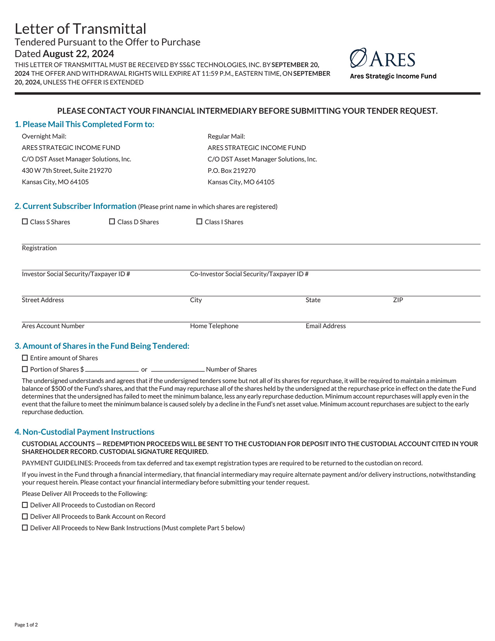

​

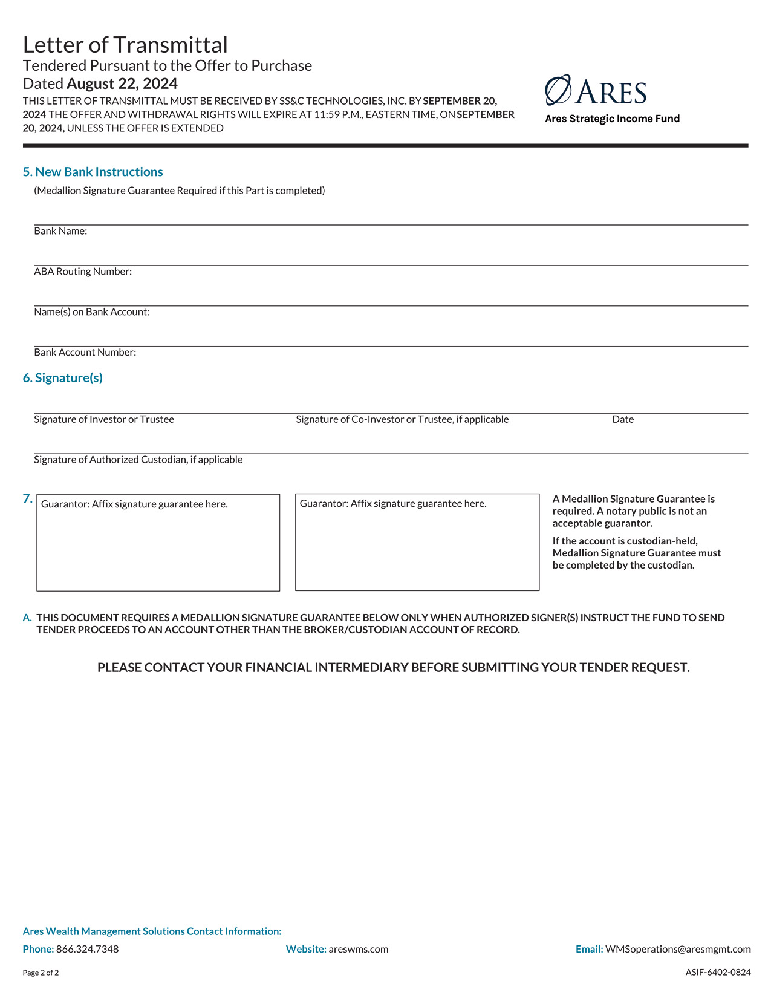

​

Letter of Transmittal
Regarding Shares in Ares Strategic Income Fund
For Clients of Merrill Lynch, Pierce, Fenner & Smith Incorporated
Tendered Pursuant to the Offer to Purchase
Dated August 22, 2024
Your Merrill Lynch Financial Advisor/Portfolio Manager must submit
this Letter of Transmittal for processing by
11:59 p.m., Eastern Time, on September 20, 2024, unless the Offer is extended
Should you wish to participate in the Offer, please contact your Merrill Lynch Financial Advisor/Portfolio Manager who will enter the order and provide you with a customized Letter of Transmittal for your account. The Letter of Transmittal generated for your account will need to be signed and returned or delivered to your Merrill Lynch Financial Advisor/Portfolio Manager.
For additional information call your Merrill Lynch Financial Advisor/Portfolio Manager.
Dear Shareholder:
The undersigned hereby tenders to Ares Strategic Income Fund, a closed-end management investment company that has elected to be regulated as a business development company under the Investment Company Act of 1940, as amended (the “1940 Act”) and is organized as a Delaware statutory trust (the “Fund”), the shares of beneficial interest in the Fund or portion thereof held by the undersigned, described and specified below, on the terms and conditions set forth in the Offer to Purchase dated August 22, 2024 (the “Offer to Purchase”), receipt of which is hereby acknowledged, and in this Letter of Transmittal (which together with the Offer to Purchase constitute the “Offer”). The Tender and this Letter of Transmittal are subject to all the terms and conditions set forth in the Offer to Purchase, including, but not limited to, the absolute right of the Fund to reject any and all tenders determined by it, in its sole discretion, not to be in the appropriate form.
The undersigned hereby sells to the Fund the shares of beneficial interest in the Fund or portion thereof tendered hereby pursuant to the Offer.
The undersigned hereby warrants that the undersigned has full authority to sell the shares of beneficial interest in the Fund or portion thereof tendered hereby and that the Fund will acquire good title thereto, free and clear of all liens, charges, encumbrances, conditional sales agreements or other obligations relating to the sale thereof, and not subject to any adverse claim, when and to the extent the same are purchased by it. Upon request, the undersigned will execute and deliver any additional documents necessary to complete the sale in accordance with the terms of the Offer. The undersigned recognizes that under certain circumstances set forth in the Offer, the Fund may not be required to purchase any of the beneficial shares of interest in the Fund or portions thereof tendered hereby.
If the Fund accepts for purchase the shares tendered hereby, the purchase price will be paid in cash to the undersigned. The cash payment(s) of the purchase price for the shares of beneficial interest in the Fund or portion thereof of the undersigned, as described in Section 6 “Purchases and Payment” of the Offer to Purchase, shall be wired to the account from which your subscription funds were debited.
All authority herein conferred or agreed to be conferred shall survive the death or incapacity of the undersigned and the obligation of the undersigned hereunder shall be binding on the heirs, personal representatives, successors and assigns of the undersigned. Except as stated in Section 5 “Withdrawal Rights” of the Offer to Purchase, this tender is irrevocable.
Instructions to Tendering Shareholder:
Please contact your Merrill Lynch Financial Advisor/Portfolio Manager who will enter the tender order and provide you with a customized Letter of Transmittal for your account. The Letter of Transmittal generated for your account will need to be signed and returned or delivered to your Merrill Lynch Financial Advisor/Portfolio Manager. For additional information, call your Merrill Lynch Financial Advisor/Portfolio Manager. If the shareholder chooses to fax the signed Letter of Transmittal (or otherwise deliver not in original form), it should mail the original Letter of Transmittal to its Merrill Lynch Financial Advisor/​Portfolio Manager promptly after it is initially delivered (although the original does not have to be received before 11:59 p.m., Eastern Time, on September 20, 2024).

​

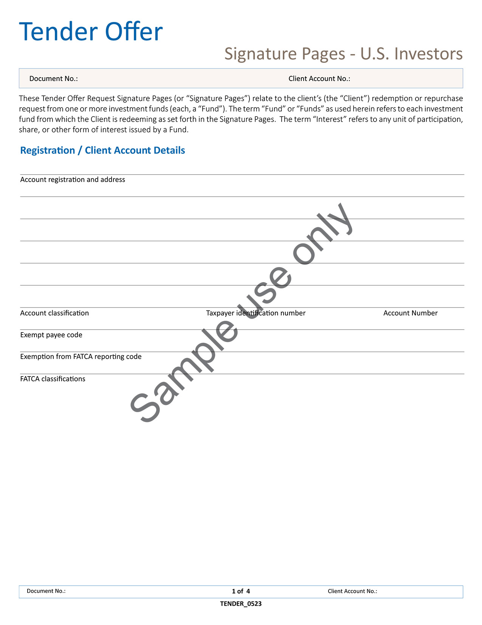

​

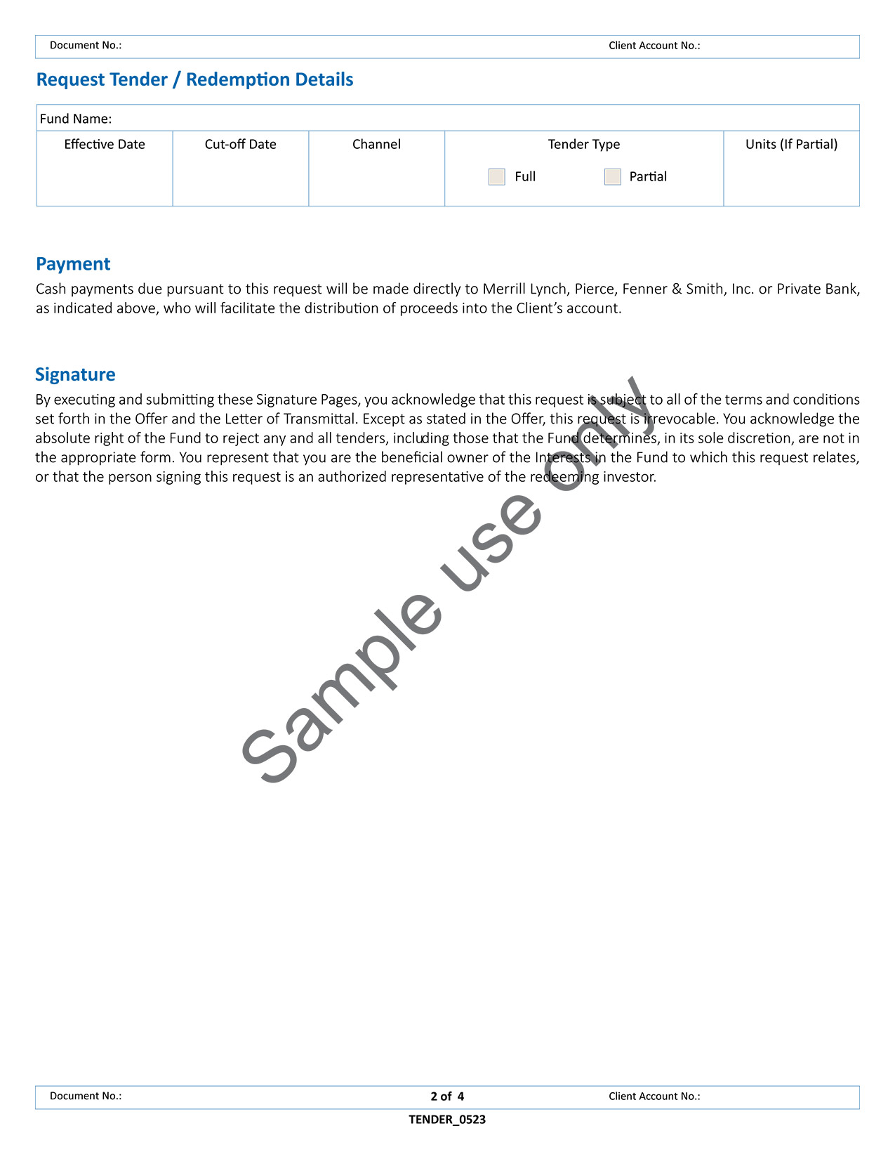

​

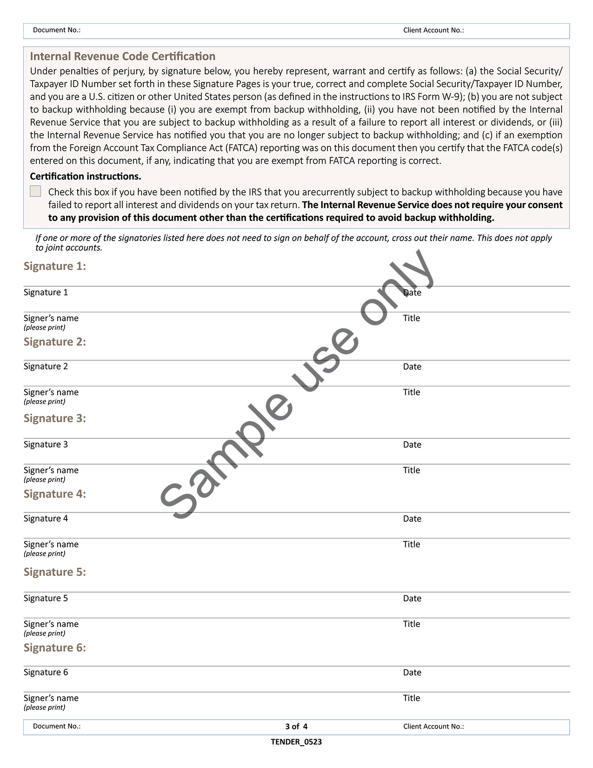

​

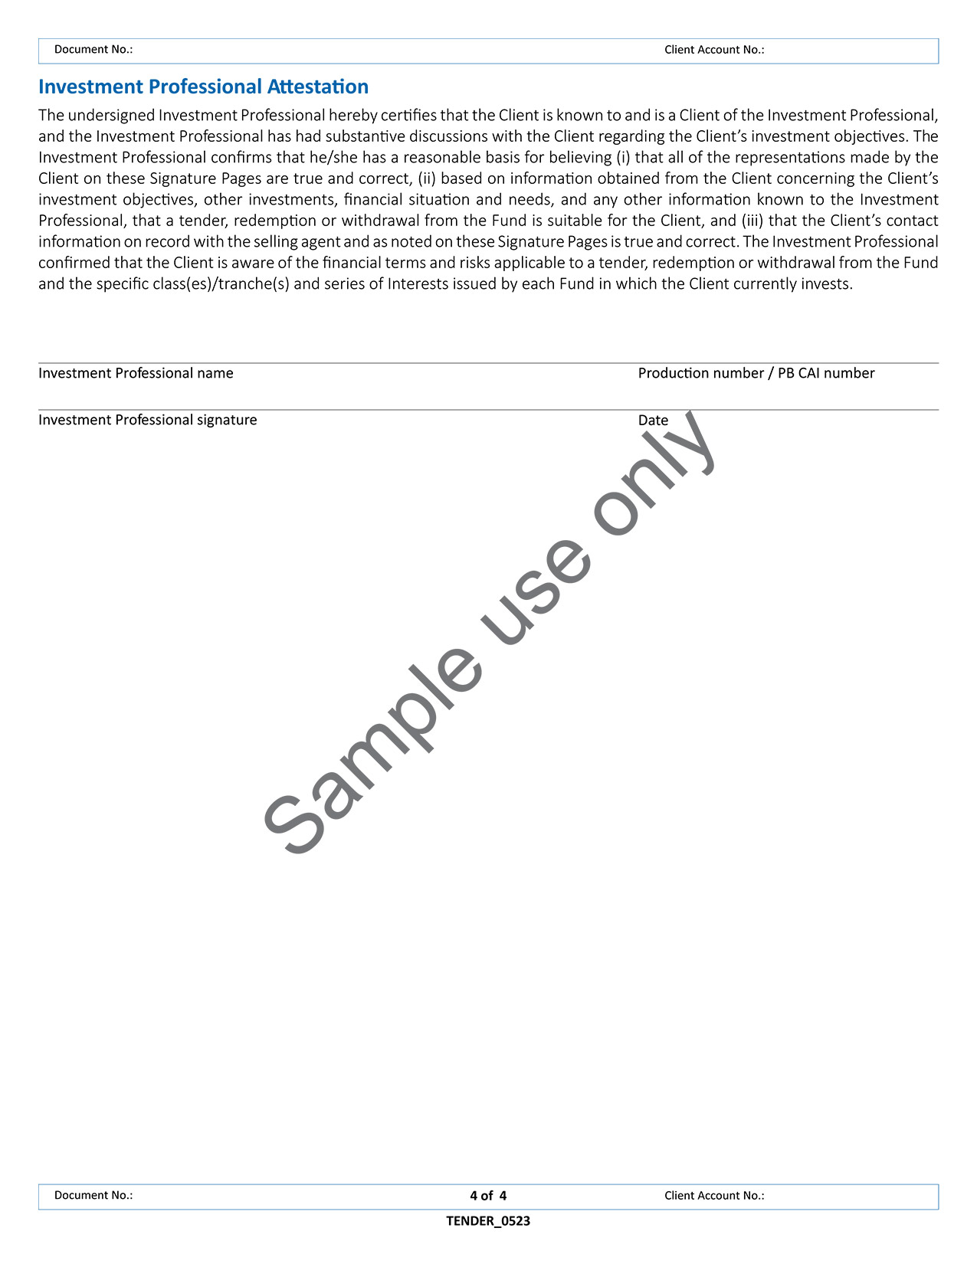

​

Exhibit (a)(1)(iv)​
Form of Notice from the Fund to Shareholders
in Connection with the Fund’s Acceptance of Shares
Ares Strategic Income Fund
c/o Ares Capital Management LLC
245 Park Avenue, 44th Floor
New York, New York 10167
[DATE]
[SHAREHOLDER NAME/EMAIL ADDRESS]
Dear Shareholder:
This notice serves to inform you that Ares Strategic Income Fund (the “Fund”) has received and accepted for purchase your tender of shares of beneficial interest in the Fund.
In accordance with the terms of the tender offer, you will be issued payment in cash in an aggregate amount equal to the net asset value of the tendered shares as of August 31, 2024 (or such later date as may be determined by the Fund if the tender offer is extended, the “Valuation Date”) less the 2.0% “early repurchase deduction” ​(if applicable).
If you have any questions, please contact the Fund’s Transfer Agent, SS&C GIDS, Inc., at 1-866-324-7348.
Sincerely,
Ares Strategic Income Fund

​

Exhibit (a)(1)(v)​
Notice of Withdrawal of Tender
Regarding Shares in Ares Strategic Income Fund
Tendered Pursuant to the Offer to Purchase
Dated August 22, 2024
The Offer and withdrawal rights will expire on September 20, 2024
and this Notice of Withdrawal must be received by
the Fund’s Transfer Agent or Custodian by 11:59 p.m.,
Eastern Time, on September 20, 2024, unless the Offer is extended.
Complete this Notice of Withdrawal and follow the transmittal
instructions included herein
PLEASE SEND COMPLETED FORMS TO YOUR FINANCIAL REPRESENTATIVE.
You are responsible for confirming that this Notice is received timely. If you fail to confirm receipt of this Notice, there can be no assurance that your withdrawal will be honored by the Fund.
Please withdraw the tender previously submitted by the undersigned in a Letter of Transmittal.
​ | Fund Name: | ​ | ​ | ​ | ​
​ | Fund Account #: | ​ | ​ | ​ | ​
​ | Account Name/Registration: | ​ | ​ | ​ | ​
​ | Social Security Number: | ​ | ​ | ​ | ​
​ | Email Address: | ​ | ​ | ​ | ​
The undersigned represents that the undersigned is the beneficial owner of the shares in the Fund to which this withdrawal request relates, or that the person signing this request is an authorized representative of the withdrawing shareholder.
In the case of joint accounts, each joint holder must sign this withdrawal request. Requests on behalf of a foundation, partnership or any other entity should be accompanied by evidence of the authority of the person(s) signing.
​ | ​  Signature | ​ | ​ | ​  Print Name of Authorized Signatory (and Title if applicable) | ​ | ​ | ​  Date | ​
​ | ​  Signature | ​ | ​ | ​  Print Name of Authorized Signatory (and Title if applicable) | ​ | ​ | ​  Date | ​

​

Notice of Withdrawal of Tender
Regarding Shares in Ares Strategic Income Fund
For Clients of Merrill Lynch, Pierce, Fenner & Smith Incorporated
Tendered Pursuant to the Offer to Purchase
Dated August 22, 2024
The Offer and withdrawal rights will expire on September 20, 2024
and your Merrill Lynch Financial Advisor/Portfolio Manager must submit
this Notice of Withdrawal for processing by 11:59 p.m.,
Eastern Time, on September 20, 2024, unless the Offer is extended
Complete this Notice of Withdrawal and deliver to your Merrill Lynch Financial Advisor/Portfolio Manager.
For additional information call your Merrill Lynch Financial Advisor/Portfolio Manager.
You are responsible for confirming that this Notice is submitted for processing timely by your Merrill Lynch Financial Advisor/Portfolio Manager. If you fail to confirm timely submission of this Notice, there can be no assurance that your withdrawal will be honored by the Fund.
Dear Shareholder:
Please withdraw the tender previously submitted by the undersigned in a Letter of Transmittal.
​ | Fund Name: | ​ | ​ | ​ | ​
​ | Fund Account #: | ​ | ​ | ​ | ​
​ | Account Name/Registration: | ​ | ​ | ​ | ​
​ | Address: | ​ | ​ | ​ | ​
​ | City, State, Zip Telephone Number: | ​ | ​ | ​ | ​
​ | Email Address: | ​ | ​ | ​ | ​
​ | Financial Intermediary Finn Name: | ​ | ​ | ​ | ​
​ | Financial Intermediary Account #: | ​ | ​ | ​ | ​
​ | Financial Advisor Name: | ​ | ​ | ​ | ​
​ | Financial Advisor Telephone #: | ​ | ​ | ​ | ​
The undersigned represents that the undersigned is the beneficial owner of the shares in the Fund to which this withdrawal request relates, or that the person signing this request is an authorized representative of the withdrawing shareholder.
In the case of joint accounts, each joint holder must sign this withdrawal request. Requests on behalf of a foundation, partnership or any other entity should be accompanied by evidence of the authority of the person(s) signing.
​ | ​  Signature | ​ | ​ | ​  Print Name of Authorized Signatory (and Title if applicable) | ​ | ​ | ​  Date | ​
​ | ​  Signature | ​ | ​ | ​  Print Name of Authorized Signatory (and Title if applicable) | ​ | ​ | ​  Date | ​

EX-FILING FEES

Calculation of Filing Fee Tables

SC TO-I
(Form Type)

Ares Strategic Income Fund
(Name of Issuer)

Ares Strategic Income Fund
(Name of Person(s) Filing Statement)

Table 1: Transaction Valuation

 | Transaction Valuation | Fee rate | Amount of
 |  |  | Filing Fee
Fees to Be Paid | $194,945,037.84 ⁽¹⁾ | 0.01476% | $28,773.89 ⁽²⁾
Fees Previously Paid
Total Transaction Valuation | $194,945,037.84 ⁽¹⁾
Total Fees Due for Filing |  |  | $28,773.89 ⁽²⁾
Total Fees Previously Paid
Total Fee Offsets
Net Fee Due |  |  | $28,773.89 ⁽²⁾

 | (1) | Calculated as the aggregate maximum purchase price for shares of beneficial interest, based upon the net asset value per share as of July 31, 2024, of $27.44. This amount is based upon the offer to purchase up to 7,104,411 common shares of beneficial interest, par value $0.01 per share, of Ares Strategic Income Fund.
 | (2) | Calculated at $147.60 per $1,000,000.00 of the Transaction Valuation in accordance with Rule 0-11 under the Securities Exchange Act of 1934, as amended, as modified by Fee Rate Advisory No. 1 for fiscal year 2024.

