UNITED STATES
SECURITIES AND EXCHANGE COMMISSION
WASHINGTON, DC 20549

FORM 8-K

CURRENT REPORT
Pursuant to Section 13 or 15(d) of the
Securities Exchange Act of 1934

Date of report (Date of earliest event reported): June 9, 2020

ANNOVIS BIO, INC.
(Exact Name of Registrant as Specified in Charter)

Delaware |  | 001-39202 |  | 26-2540421
(State or Other Jurisdiction  of Incorporation) |  | (Commission  File Number) |  | (I.R.S. Employer  Identification No.)

1055 Westlakes Drive, Suite 300
Berwyn, PA 19312
(Address of Principal Executive Offices, and Zip Code)

(610) 727-3913
Registrant’s Telephone Number, Including Area Code

Not Applicable

(Former Name or Former Address, if Changed Since Last Report)

Securities registered pursuant to Section 12(b) of the Act:

Title of each class | Trading Symbol(s) | Name of each exchange on which registered
Common Stock, par value $0.0001 per share | ANVS | NYSE American

Check the appropriate box below if the Form 8-K filing is intended to simultaneously satisfy the filing obligation of the registrant under any of the following provisions (see General Instruction A.2. below):

 | ¨ | Written communication pursuant to Rule 425 under the Securities Act (17 CFR 230.425)

 | ¨ | Soliciting material pursuant to Rule 14a-12 under the Exchange Act (17 CFR 240.14a-12)

 | ¨ | Pre-commencement communication pursuant to Rule 14d-2(b) under the Exchange Act (17 CFR 240.14d-2(b))

 | ¨ | Pre-commencement communication pursuant to Rule 13e-4(c) under the Exchange Act (17 CFR 240.13e-4(c))
Indicate by check mark whether the registrant is an emerging growth company as defined in Rule 405 of the Securities Act of 1933 (17 CFR §230.405) or Rule 12b-2 of the Securities Exchange Act of 1934 (17 CFR §240.12b-2).

Emerging growth company x

If an emerging growth company, indicate by check mark if the registrant has elected not to use the extended transition period for complying with any new or revised financial accounting standards provided pursuant to Section 13(a) of the Exchange Act. x

Item 7.01 | Regulation FD Disclosure.

On June 9, 2020, Annovis Bio Inc. (the “Company”) issued a press release announcing that CEO Maria Maccecchini, Ph.D. and CFO Jeff McGroarty, MBA, CPA, will give a virtual corporate presentation at the June 2020 Virtual Summer Investor Summit taking place online from June 9 to 12, 2020. A copy of the Press Release is attached to this Current Report on Form 8-K as Exhibit 99.1.

Dr. Maccecchini and Mr. McGroarty will give a presentation via webcast on Wednesday, June 10, 2020 at 10:55 a.m. ET, followed by a live Q&A session. A copy of the written presentation is attached as Exhibit 99.2 to this Current Report on Form 8-K. A copy of the presentation will also be available on the Company’s website at www.annovisbio.com under “Investors & Media.” Investors can register for and access the live webcast at: https://www.webcaster4.com/Webcast/Page/2038/35035.

The information in this Item 7.01, Item 9.01, Exhibit 99.1 and Exhibit 99.2 attached hereto shall not be deemed “filed” for purposes of Section 18 of the Securities Exchange Act of 1934, or otherwise subject to the liability of such section, nor shall it be deemed incorporated by reference in any filing of the Company under the Securities Act of 1933 or the Securities Exchange Act of 1934, regardless of any general incorporation language in such filing, unless expressly incorporated by specific reference in such filing.

Item 9.01 |  |  | Financial Statements and Exhibits.
(d) | Exhibits.
Exhibit  Number |  |  | Description
99.1 |  |  | Press release, dated June 9, 2020.
99.2 |  |  | Investor Presentation.

SIGNATURES

Pursuant to the requirements of the Securities Exchange Act of 1934, the registrant has duly caused this report to be signed on its behalf by the undersigned hereunto duly authorized.

 | ANNOVIS BIO, INC.
Date: June 9, 2020 | By: | /s/ Jeffrey McGroarty
 |  | Name: Jeffrey McGroarty
 |  | Title: Chief Financial Officer

Exhibit 99.1

Annovis Bio to Present at the June 2020 Virtual Summer Investor Summit

BERWYN, PA. – June 9, 2020 – Annovis Bio Inc. (NYSE American: ANVS), a clinical-stage drug platform company addressing Alzheimer’s disease (AD), Parkinson’s disease (PD) and other neurodegenerative diseases, today announced that CEO Maria Maccecchini, Ph.D. and CFO Jeff McGroarty, MBA, CPA, will give a virtual corporate presentation at the June 2020 Virtual Summer Investor Summit taking place online from June 9 to 12, 2020.

Annovis Bio’s presentation will be held on Wednesday, June 10, 2020 at 10:55 a.m. ET, followed by a live Q&A session. Investors can register for and access the live webcast at: https://www.webcaster4.com/Webcast/Page/2038/35035.

Dr. Maccecchini and Mr. McGroarty will also be available for one-on-one meetings online. To register for the Virtual Investor Summit, visit: https://virtual-summer-summit.events.issuerdirect.com/signup.

About Annovis Bio

Headquartered in Berwyn, Pennsylvania, Annovis Bio, Inc. (Annovis) is a clinical-stage, drug platform company addressing neurodegeneration, such as Alzheimer’s disease (AD), Parkinson’s disease (PD) and Alzheimer’s in Down Syndrome (AD-DS). We believe that we are the only company developing a drug for AD, PD and AD-DS that inhibits more than one neurotoxic protein and, thereby, improves the information highway of the nerve cell, known as axonal transport. When this information flow is impaired, the nerve cell gets sick and dies. We expect our treatment to improve memory loss and dementia associated with AD and AD-DS, as well as body and brain function in PD. We have an ongoing Phase 2a study in AD patients and plan to commence a second Phase 2a study in PD and AD patients. For more information on Annovis, please visit the company’s website: www.annovisbio.com.

Forward-Looking Statements

Statements in this press release contain “forward-looking statements” that are subject to substantial risks and uncertainties. Forward-looking statements contained in this press release may be identified by the use of words such as “anticipate,” “expect,” “believe,” “will,” “may,” “should,” “estimate,” “project,” “outlook,” “forecast” or other similar words, and include, without limitation, statements regarding the timing, effectiveness and anticipated results of ANVS401 clinical trials and the approval of any allowances or additional patents. Forward-looking statements are based on Annovis Bio, Inc.’s current expectations and are subject to inherent uncertainties, risks and assumptions that are difficult to predict. Further, certain forward-looking statements are based on assumptions as to future events that may not prove to be accurate. These and other risks and uncertainties are described more fully in the section titled “Risk Factors” in the Annual Report on Form 10-K for the year ended December 31, 2019 filed with the Securities and Exchange Commission. Forward-looking statements contained in this announcement are made as of this date, and Annovis Bio, Inc. undertakes no duty to update such information except as required under applicable law.

Investor Relations:

Dave Gentry, CEO
RedChip Companies Inc.

407-491-4498
Dave@redchip.com

SOURCE: Annovis Bio Inc.

Exhibit 99.2
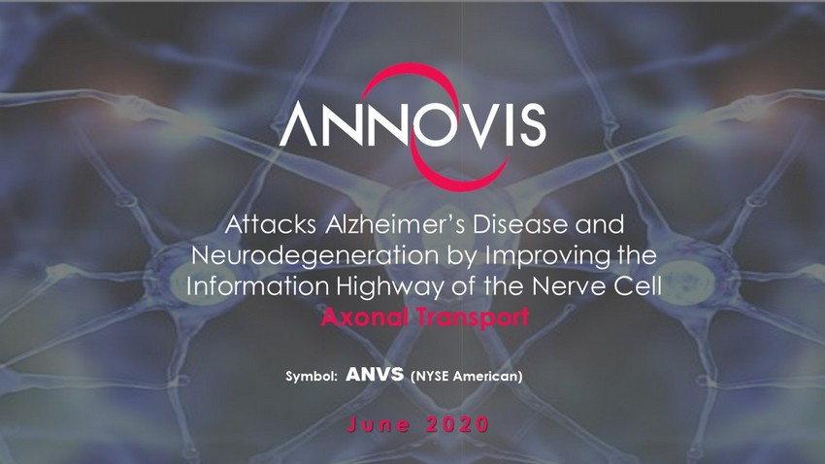
Attacks Alzheimer’s Disease and Neurodegeneration by Improving the Information Highway of the Nerve Cell Axonal Transport June 2020 Symbol: ANVS (NYSE American)

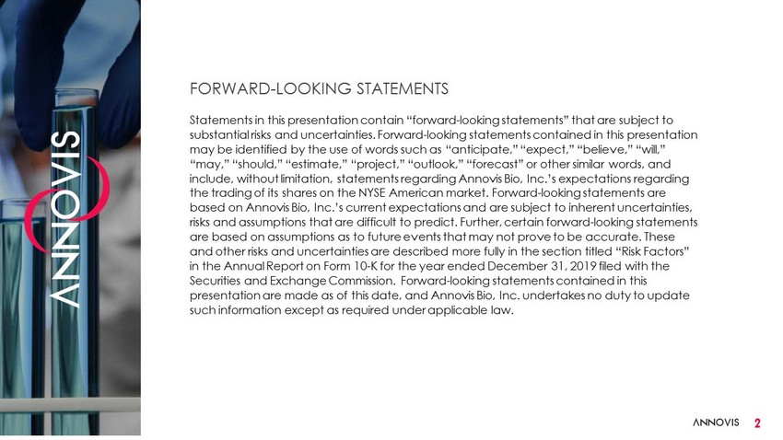
FORWARD - LOOKING STATEMENTS Statements in this presentation contain “forward - looking statements” that are subject to substantial risks and uncertainties. Forward - looking statements contained in this presentation may be identified by the use of words such as “anticipate,” “expect,” “believe,” “will,” “may,” “should,” “estimate,” “project,” “outlook,” “forecast” or other similar words, and include, without limitation, statements regarding Annovis Bio, Inc.’s expectations regarding the trading of its shares on the NYSE American market. Forward - looking statements are based on Annovis Bio, Inc.’s current expectations and are subject to inherent uncertainties, risks and assumptions that are difficult to predict. Further, certain forward - looking statements are based on assumptions as to future events that may not prove to be accurate. These and other risks and uncertainties are described more fully in the section titled “Risk Factors” in the Annual Report on Form 10 - K for the year ended December 31, 2019 filed with the Securities and Exchange Commission. Forward - looking statements contained in this presentation are made as of this date, and Annovis Bio, Inc. undertakes no duty to update such information except as required under applicable law. 2

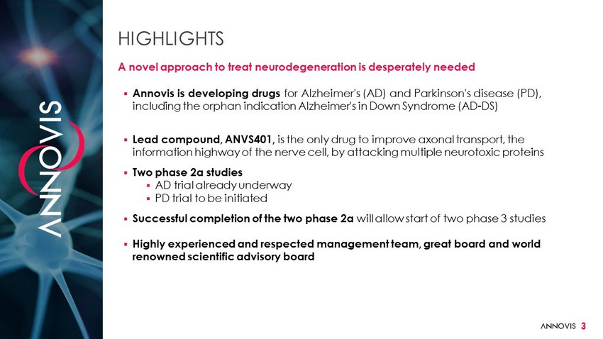
3 ▪ Annovis is developing drugs for Alzheimer's (AD) and Parkinson's disease (PD), including the orphan indication Alzheimer's in Down Syndrome (AD - DS) ▪ Lead compound, ANVS401, is the only drug to improve axonal transport, the information highway of the nerve cell, by attacking multiple neurotoxic proteins ▪ Two phase 2a studies ▪ AD trial already underway ▪ PD trial to be initiated ▪ Successful completion of the two phase 2a will allow start of two phase 3 studies ▪ Highly experienced and respected management team, great board and world renowned scientific advisory board HIGHLIGHTS A novel approach to treat neurodegeneration is desperately needed

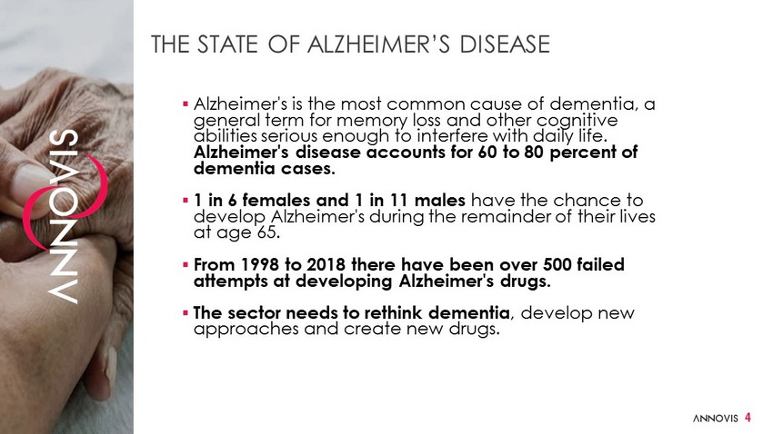
THE STATE OF ALZHEIMER’S DISEASE ▪ Alzheimer's is the most common cause of dementia, a general term for memory loss and other cognitive abilities serious enough to interfere with daily life. Alzheimer's disease accounts for 60 to 80 percent of dementia cases. ▪ 1 in 6 females and 1 in 11 males have the chance to develop Alzheimer's during the remainder of their lives at age 65. ▪ From 1998 to 2018 there have been over 500 failed attempts at developing Alzheimer's drugs. ▪ The sector needs to rethink dementia , develop new approaches and create new drugs. 4

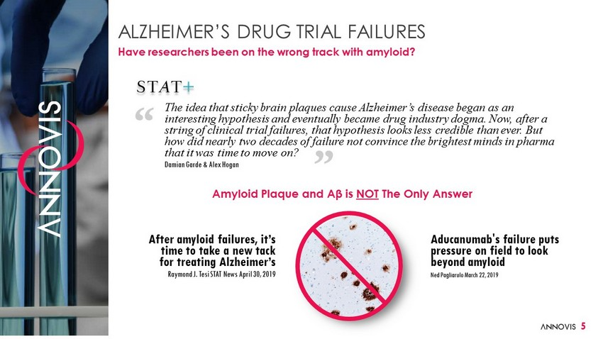
ALZHEIMER’S DRUG TRIAL FAILURES Have researchers been on the wrong track with amyloid? 5 The idea that sticky brain plaques cause Alzheimer’s disease began as an interesting hypothesis and eventually became drug industry dogma. Now, after a string of clinical trial failures, that hypothesis looks less credible than ever. But how did nearly two decades of failure not convince the brightest minds in pharma that it was time to move on? Damian Garde & Alex Hogan After amyloid failures, it’s time to take a new tack for treating Alzheimer’s Raymond J. Tesi STAT News April 30, 2019 Aducanumab's failure puts pressure on field to look beyond amyloid Ned Pagliarulo March 22, 2019 Amyloid Plaque and Aβ is NOT The Only Answer

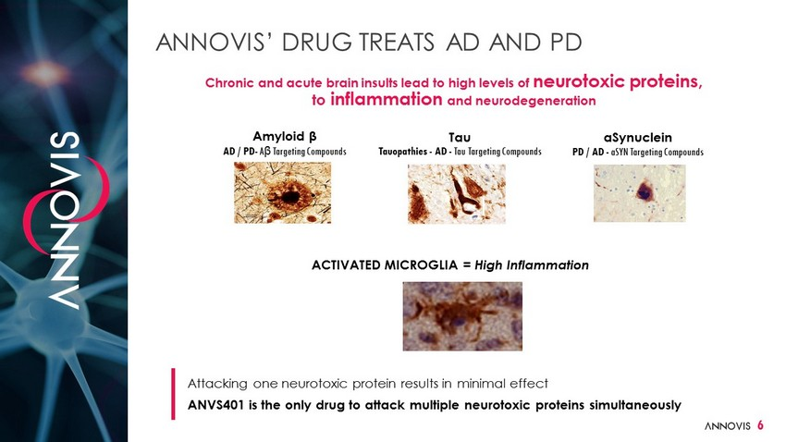
Chronic and acute brain insults lead to high levels of neurotoxic proteins, to inflammation and neurodegeneration Attacking one neurotoxic protein results in minimal effect ANVS401 is the only drug to attack multiple neurotoxic proteins simultaneously Amyloid β AD / PD - A β Targeting Compounds ANNOVIS’ DRUG TREATS AD AND PD Tau Tauopathies - AD - Tau Targeting Compounds aSynuclein PD / AD - aSYN Targeting Compounds 6 ACTIVATED MICROGLIA = High Inflammation

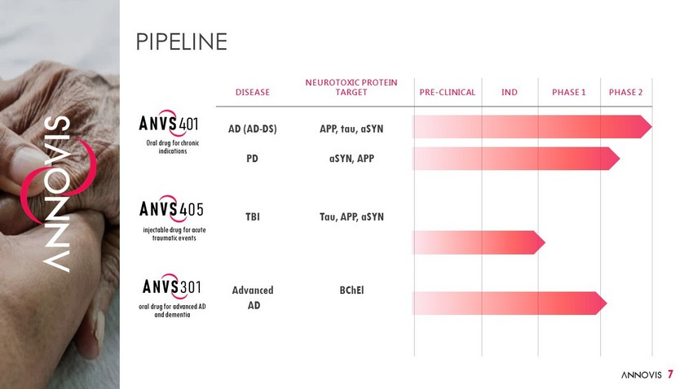
DISEASE NEUROTOXIC PROTEIN TARGET PRE - CLINICAL IND PHASE 1 PHASE 2 AD (AD - DS) PD TBI Advanced AD APP, tau, aSYN aSYN , APP Tau, APP, aSYN BChEl PIPELINE Oral drug for chronic indications injectable drug for acute traumatic events oral drug for advanced AD and dementia 7

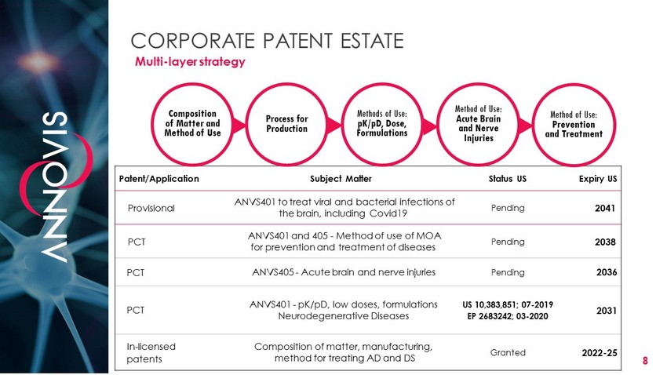
8 CORPORATE PATENT ESTATE Patent/Application Subject Matter Status US Expiry US Provisional ANVS401 to treat viral and bacterial infections of the brain, including Covid19 Pending 2041 PCT ANVS401 and 405 - Method of use of MOA for prevention and treatment of diseases Pending 2038 PCT ANVS405 - Acute brain and nerve injuries Pending 2036 PCT ANVS401 - pK/pD, low doses , formulations Neurodegenerative Diseases US 10,383,851; 07 - 2019 EP 2683242; 03 - 2020 2031 In - licensed patents Composition of matter, manufacturing, method for treating AD and DS Granted 2022 - 25 Composition of Matter and Method of Use  Process for Production  Methods of Use: pK/pD, Dose, Formulations  Method of Use: Acute Brain and Nerve Injuries  Method of Use: Prevention and Treatment Multi - layer strategy

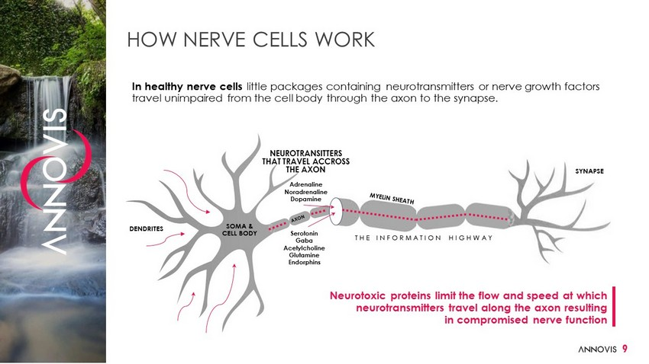
NEUROTRANSITTERS THAT TRAVEL ACCROSS THE AXON Adrenaline Noradrenaline Dopamine HOW NERVE CELLS WORK In healthy nerve cells little packages containing neurotransmitters or nerve growth factors travel unimpaired from the cell body through the axon to the synapse. SOMA & CELL BODY DENDRITES Serotonin Gaba Acetylcholine Glutamine Endorphins SYNAPSE 9 Neurotoxic proteins limit the flow and speed at which neurotransmitters travel along the axon resulting in compromised nerve function THE INFORMATION HIGHWAY

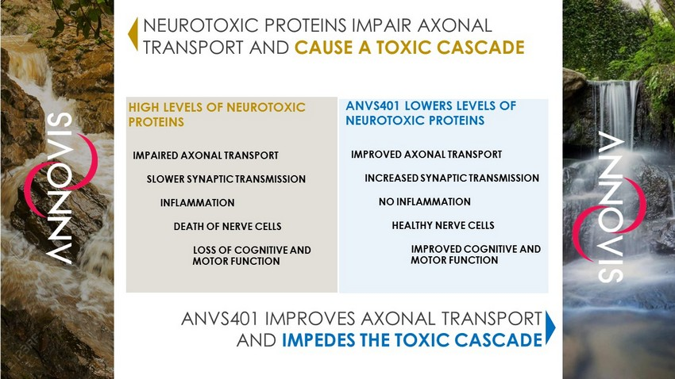
NEUROTOXIC PROTEINS IMPAIR AXONAL TRANSPORT AND CAUSE A TOXIC CASCADE ANVS401 IMPROVES AXONAL TRANSPORT AND IMPEDES THE TOXIC CASCADE IMPAIRED AXONAL TRANSPORT SLOWER SYNAPTIC TRANSMISSION INFLAMMATION DEATH OF NERVE CELLS LOSS OF COGNITIVE AND MOTOR FUNCTION IMPROVED AXONAL TRANSPORT INCREASED SYNAPTIC TRANSMISSION NO INFLAMMATION HEALTHY NERVE CELLS IMPROVED COGNITIVE AND MOTOR FUNCTION HIGH LEVELS OF NEUROTOXIC PROTEINS ANVS401 LOWERS LEVELS OF NEUROTOXIC PROTEINS

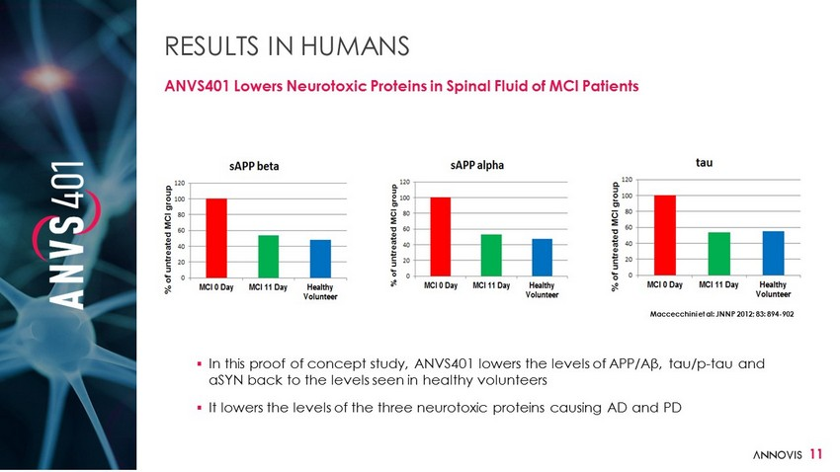
11 RESULTS IN HUMANS ANVS401 Lowers Neurotoxic Proteins in Spinal Fluid of MCI Patients ▪ In this proof of concept study, ANVS401 lowers the levels of APP/Aβ, tau/p - tau and αSYN back to the levels seen in healthy volunteers ▪ It lowers the levels of the three neurotoxic proteins causing AD and PD Maccecchini et al: JNNP 2012; 83: 894 - 902

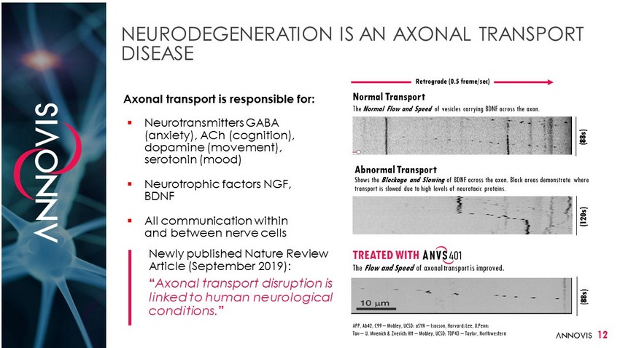
NEURODEGENERATION IS AN AXONAL TRANSPORT DISEASE Axonal transport is responsible for: Normal Transport The Normal Flow and Speed of vesicles carrying BDNF across the axon. ▪ Neurotransmitters GABA (anxiety), ACh (cognition), dopamine (movement), serotonin (mood) ▪ Neurotrophic factors NGF, BDNF ▪ All communication within and between nerve cells Newly published Nature Review Article (September 2019): “ Axonal transport disruption is linked to human neurological conditions. ” Abnormal Transport Shows the Blockage and Slowing of BDNF across the axon. Black areas demonstrate where transport is slowed due to high levels of neurotoxic proteins. TREATED WITH The Flow and Speed of axonal transport is improved. (120s) (88s) (88s) APP, Ab42, C99 – Mobley, UCSD; aSYN – Isacson, Harvard; Lee, U.Penn; Tau – U. Muenich & Zuerich; Htt – Mobley, UCSD; TDP43 – Taylor, Northwestern Retrograde (0.5 frame/sec) 12

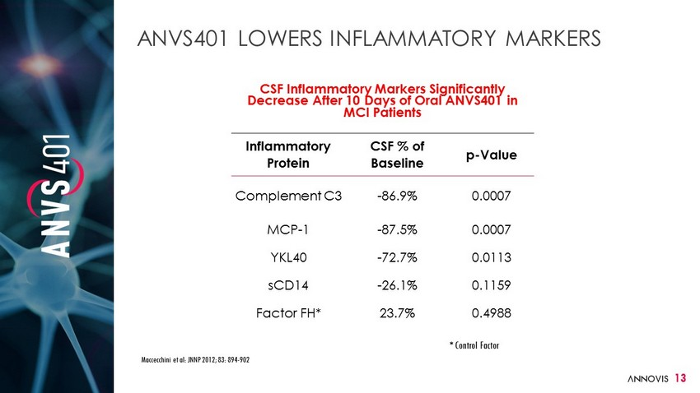
13 ANVS401 LOWERS INFLAMMATORY MARKERS Maccecchini et al: JNNP 2012; 83: 894 - 902 CSF Inflammatory Markers Significantly Decrease After 10 Days of Oral ANVS401 in MCI Patients Inflammatory Protein CSF % of Baseline p - Value Complement C3 - 86.9% 0.0007 MCP - 1 - 87.5% 0.0007 YKL40 - 72.7% 0.0113 sCD14 - 26.1% 0.1159 Factor FH* 23.7% 0.4988 * Control Factor

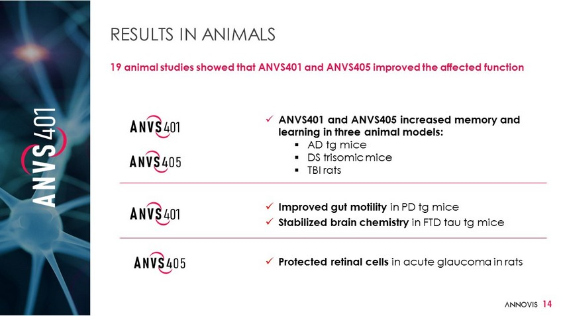
14 RESULTS IN ANIMALS 19 animal studies showed that ANVS401 and ANVS405 improved the affected function x ANVS401 and ANVS405 increased memory and learning in three animal models: ▪ AD tg mice ▪ DS trisomic mice ▪ TBI rats x Improved gut motility in PD tg mice x Stabilized brain chemistry in FTD tau tg mice x Protected retinal cells in acute glaucoma in rats

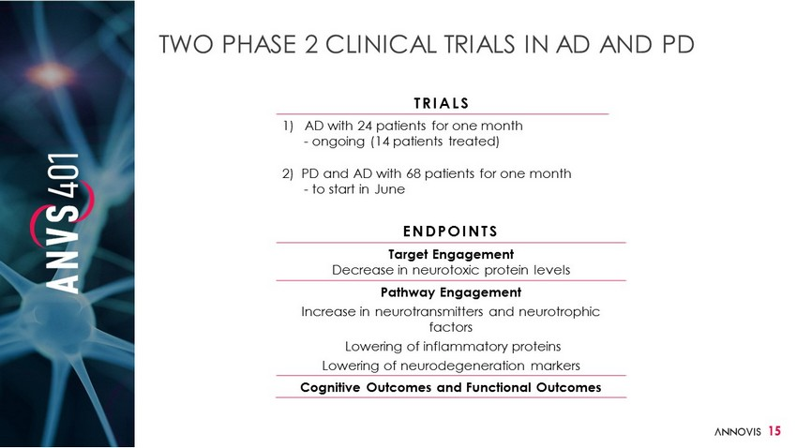
15 TWO PHASE 2 CLINICAL TRIALS IN AD AND PD TRIALS 1) AD with 24 patients for one month - ongoing (14 patients treated) 2) PD and AD with 68 patients for one month - to start in June ENDPOINTS Target Engagement Decrease in neurotoxic protein levels Pathway Engagement Increase in neurotransmitters and neurotrophic factors Lowering of inflammatory proteins Lowering of neurodegeneration markers Cognitive Outcomes and Functional Outcomes

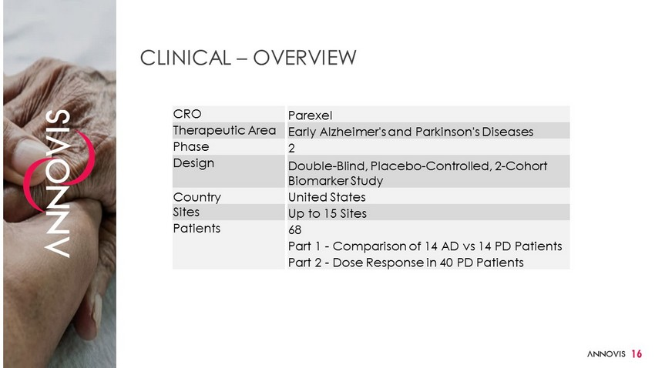
16 CLINICAL – OVERVIEW CRO Parexel Therapeutic Area Early Alzheimer's and Parkinson's Diseases Phase 2 Design Double - Blind, Placebo - Controlled, 2 - Cohort Biomarker Study Country United States Sites Up to 15 Sites Patients 68 Part 1 - Comparison of 14 AD vs 14 PD Patients Part 2 - Dose Response in 40 PD Patients

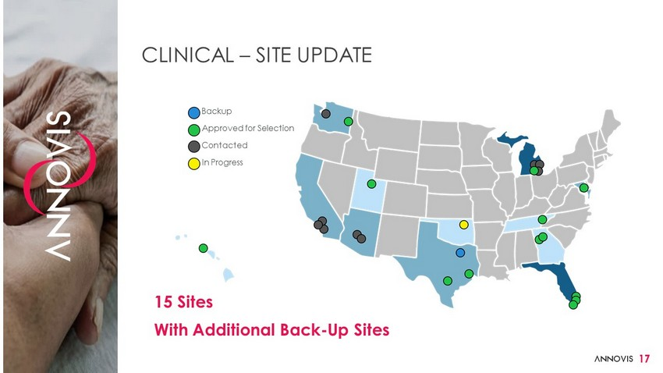
17 CLINICAL – SITE UPDATE Backup Approved for Selection Contacted In Progress 15 Sites With Additional Back - Up Sites

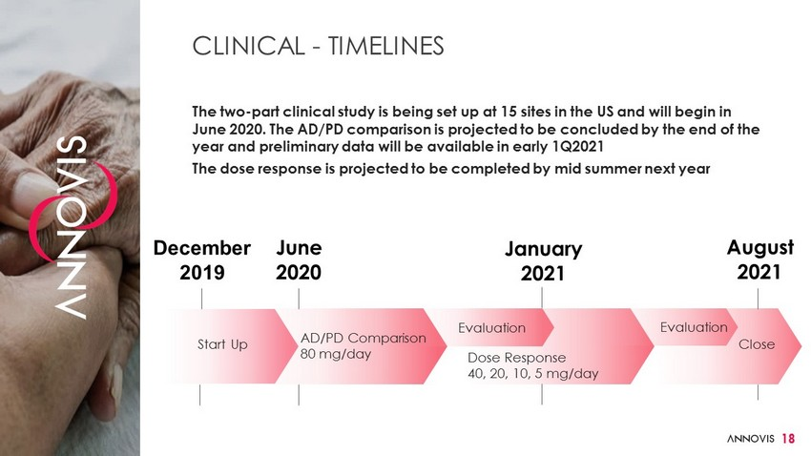
CLINICAL - TIMELINES The two - part clinical study is being set up at 15 sites in the US and will begin in June 2020. The AD/PD comparison is projected to be concluded by the end of the year and preliminary data will be available in early 1Q2021 The dose response is projected to be completed by mid summer next year Start Up AD/PD Comparison 80 mg/day Evaluation Evaluation Dose Response 40, 20, 10, 5 mg/day Close December 2019 June 2020 January 2021 August 2021 18

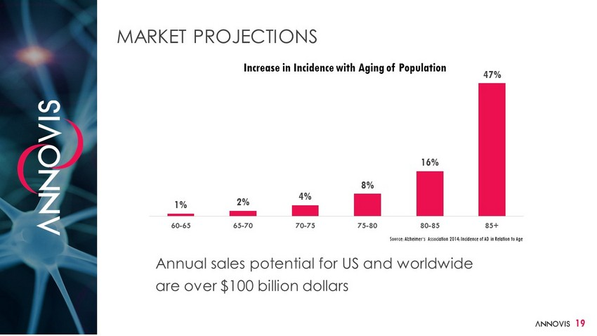
1% 2% 4% 8% 16% 47% 60-65 65-70 70-75 75-80 80-85 85+ 19 MARKET PROJECTIONS Source: Alzheimer‘s Association 2014; Incidence of AD in Relation to Age Increase in Incidence with Aging of Population Annual sales potential for US and worldwide are over $100 billion dollars

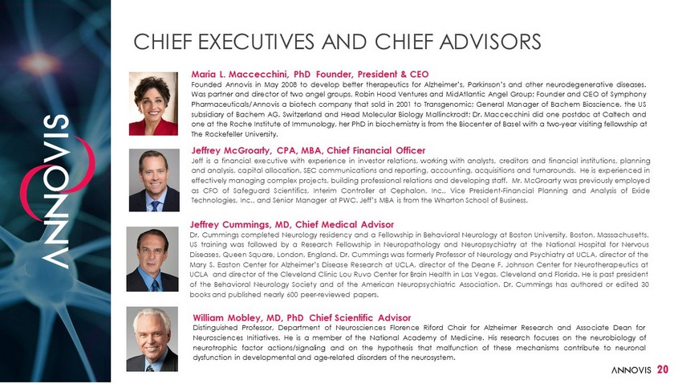
CHIEF EXECUTIVES AND CHIEF ADVISORS Jeffrey Cummings, MD, Chief Medical Advisor Dr . Cummings completed Neurology residency and a Fellowship in Behavioral Neurology at Boston University, Boston, Massachusetts . US training was followed by a Research Fellowship in Neuropathology and Neuropsychiatry at the National Hospital for Nervous Diseases, Queen Square, London, England . Dr . Cummings was formerly Professor of Neurology and Psychiatry at UCLA, director of the Mary S . Easton Center for Alzheimer’s Disease Research at UCLA, director of the Deane F . Johnson Center for Neurotherapeutics at UCLA and director of the Cleveland Clinic Lou Ruvo Center for Brain Health in Las Vegas, Cleveland and Florida . He is past president of the Behavioral Neurology Society and of the American Neuropsychiatric Association . Dr . Cummings has authored or edited 30 books and published nearly 600 peer - reviewed papers . 20 Maria L . Maccecchini, PhD Founder, President & CEO Founded Annovis in May 2008 to develop better therapeutics for Alzheimer’s, Parkinson’s and other neurodegenerative diseases . Was partner and director of two angel groups, Robin Hood Ventures and MidAtlantic Angel Group ; Founder and CEO of Symphony Pharmaceuticals/Annovis a biotech company that sold in 2001 to Transgenomic ; General Manager of Bachem Bioscience, the US subsidiary of Bachem AG, Switzerland and Head Molecular Biology Mallinckrodt ; Dr . Maccecchini did one postdoc at Caltech and one at the Roche Institute of Immunology, her PhD in biochemistry is from the Biocenter of Basel with a two - year visiting fellowship at The Rockefeller University . Jeffrey McGroarty, CPA, MBA, Chief Financial Officer Jeff is a financial executive with experience in investor relations, working with analysts, creditors and financial institutions, planning and analysis, capital allocation, SEC communications and reporting, accounting, acquisitions and turnarounds . He is experienced in effectively managing complex projects, building professional relations and developing staff . Mr . McGroarty was previously employed as CFO of Safeguard Scientifics, Interim Controller at Cephalon, Inc . , Vice President - Financial Planning and Analysis of Exide Technologies, Inc . , and Senior Manager at PWC . Jeff’s MBA is from the Wharton School of Business . William Mobley, MD, PhD Chief Scientific Advisor Distinguished Professor, Department of Neurosciences Florence Riford Chair for Alzheimer Research and Associate Dean for Neurosciences Initiatives . He is a member of the National Academy of Medicine . His research focuses on the neurobiology of neurotrophic factor actions/signaling and on the hypothesis that malfunction of these mechanisms contribute to neuronal dysfunction in developmental and age - related disorders of the neurosystem .

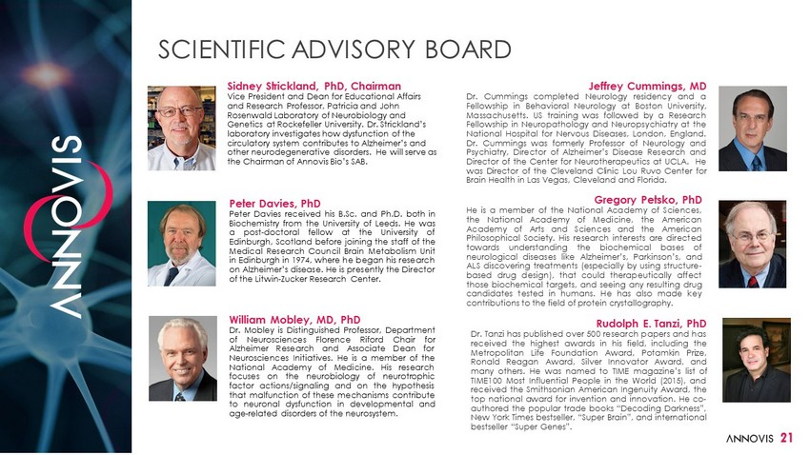
SCIENTIFIC ADVISORY BOARD 21 Sidney Strickland, PhD, Chairman Vice President and Dean for Educational Affairs and Research Professor, Patricia and John Rosenwald Laboratory of Neurobiology and Genetics at Rockefeller University. Dr. Strickland’s laboratory investigates how dysfunction of the circulatory system contributes to Alzheimer’s and other neurodegenerative disorders. He will serve as the Chairman of Annovis Bio’s SAB. Peter Davies, PhD Peter Davies received his B . Sc . and Ph . D . both in Biochemistry from the University of Leeds . He was a post - doctoral fellow at the University of Edinburgh, Scotland before joining the staff of the Medical Research Council Brain Metabolism Unit in Edinburgh in 1974 , where he began his research on Alzheimer’s disease . He is presently the Director of the Litwin - Zucker Research Center . Jeffrey Cummings, MD Dr . Cummings completed Neurology residency and a Fellowship in Behavioral Neurology at Boston University, Massachusetts . US training was followed by a Research Fellowship in Neuropathology and Neuropsychiatry at the National Hospital for Nervous Diseases, London, England . Dr . Cummings was formerly Professor of Neurology and Psychiatry, Director of Alzheimer’s Disease Research and Director of the Center for Neurotherapeutics at UCLA . He was Director of the Cleveland Clinic Lou Ruvo Center for Brain Health in Las Vegas, Cleveland and Florida . William Mobley, MD, PhD Dr . Mobley is Distinguished Professor, Department of Neurosciences Florence Riford Chair for Alzheimer Research and Associate Dean for Neurosciences Initiatives . He is a member of the National Academy of Medicine . His research focuses on the neurobiology of neurotrophic factor actions/signaling and on the hypothesis that malfunction of these mechanisms contribute to neuronal dysfunction in developmental and age - related disorders of the neurosystem . Gregory Petsko, PhD He is a member of the National Academy of Sciences, the National Academy of Medicine, the American Academy of Arts and Sciences and the American Philosophical Society . His research interests are directed towards understanding the biochemical bases of neurological diseases like Alzheimer’s, Parkinson’s, and ALS discovering treatments (especially by using structure - based drug design), that could therapeutically affect those biochemical targets, and seeing any resulting drug candidates tested in humans . He has also made key contributions to the field of protein crystallography . Rudolph E. Tanzi, PhD Dr . Tanzi has published over 500 research papers and has received the highest awards in his field, including the Metropolitan Life Foundation Award, Potamkin Prize, Ronald Reagan Award, Silver Innovator Award, and many others . He was named to TIME magazine’s list of TIME 100 Most Influential People in the World ( 2015 ), and received the Smithsonian American Ingenuity Award, the top national award for invention and innovation . He co - authored the popular trade books “Decoding Darkness”, New York Times bestseller, “Super Brain”, and international bestseller “Super Genes” .

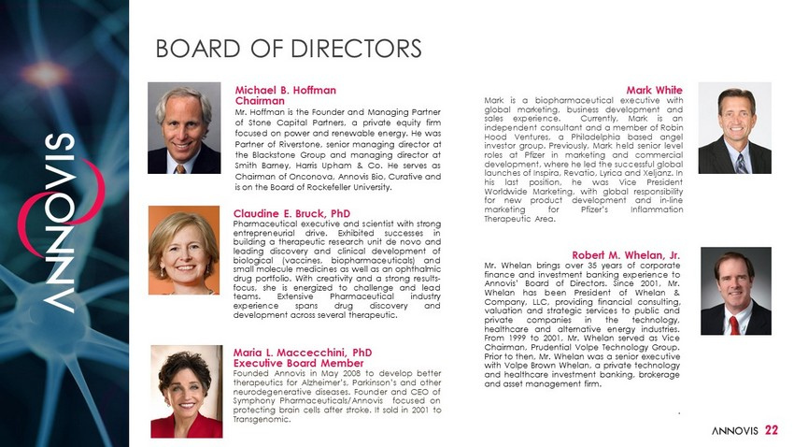
22 Michael B . Hoffman Chairman Mr . Hoffman is the Founder and Managing Partner of Stone Capital Partners, a private equity firm focused on power and renewable energy . He was Partner of Riverstone, senior managing director at the Blackstone Group and managing director at Smith Barney, Harris Upham & Co . He serves as Chairman of Onconova, Annovis Bio, Curative and is on the Board of Rockefeller University . Claudine E . Bruck, PhD Pharmaceutical executive and scientist with strong entrepreneurial drive . Exhibited successes in building a therapeutic research unit de novo and leading discovery and clinical development of biological (vaccines, biopharmaceuticals) and small molecule medicines as well as an ophthalmic drug portfolio . With creativity and a strong results - focus, she is energized to challenge and lead teams . Extensive Pharmaceutical industry experience spans drug discovery and development across several therapeutic . Mark White Mark is a biopharmaceutical executive with global marketing, business development and sales experience . Currently, Mark is an independent consultant and a member of Robin Hood Ventures, a Philadelphia based angel investor group . Previously, Mark held senior level roles at Pfizer in marketing and commercial development, where he led the successful global launches of Inspira, Revatio, Lyrica and Xeljanz . In his last position, he was Vice President Worldwide Marketing, with global responsibility for new product development and in - line marketing for Pfizer’s Inflammation Therapeutic Area . Robert M. Whelan, Jr. Mr . Whelan brings over 35 years of corporate finance and investment banking experience to Annovis’ Board of Directors . Since 2001 , Mr . Whelan has been President of Whelan & Company, LLC, providing financial consulting, valuation and strategic services to public and private companies in the technology, healthcare and alternative energy industries . From 1999 to 2001 , Mr . Whelan served as Vice Chairman, Prudential Volpe Technology Group . Prior to then, Mr . Whelan was a senior executive with Volpe Brown Whelan, a private technology and healthcare investment banking, brokerage and asset management firm . . Maria L. Maccecchini, PhD Executive Board Member Founded Annovis in May 2008 to develop better therapeutics for Alzheimer’s, Parkinson’s and other neurodegenerative diseases . Founder and CEO of Symphony Pharmaceuticals/Annovis focused on protecting brain cells after stroke . It sold in 2001 to Transgenomic . BOARD OF DIRECTORS

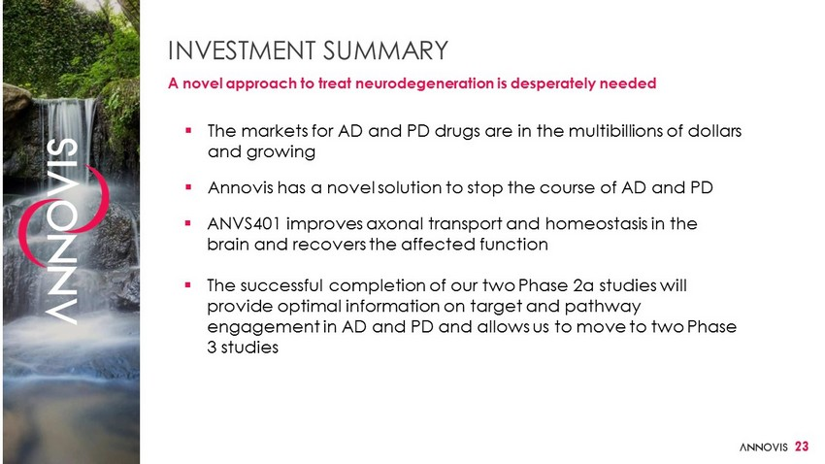
INVESTMENT SUMMARY A novel approach to treat neurodegeneration is desperately needed ▪ The markets for AD and PD drugs are in the multibillions of dollars and growing ▪ Annovis has a novel solution to stop the course of AD and PD ▪ ANVS401 improves axonal transport and homeostasis in the brain and recovers the affected function ▪ The successful completion of our two Phase 2a studies will provide optimal information on target and pathway engagement in AD and PD and allows us to move to two Phase 3 studies 23

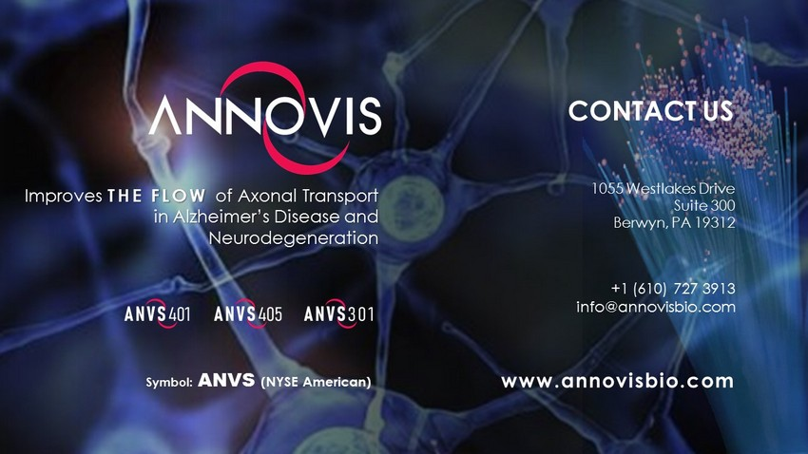
Improves THE FLOW of Axonal Transport in Alzheimer’s Disease and Neurodegeneration CONTACT US 1055 Westlakes Drive Suite 300 Berwyn, PA 19312 +1 (610) 727 3913 info@annovisbio.com www.annovisbio.com Symbol: ANVS (NYSE American)

