UNITED STATES
SECURITIES AND EXCHANGE COMMISSION
WASHINGTON, DC 20549

FORM 8-K

CURRENT REPORT
Pursuant to Section 13 or 15(d) of the
Securities Exchange Act of 1934

Date of report (Date of earliest event reported): November 12, 2021

ANNOVIS BIO, INC.
(Exact Name of Registrant as Specified in Charter)

Delaware |  | 001-39202 |  | 26-2540421
(State or Other Jurisdiction  of Incorporation) |  | (Commission  File Number) |  | (I.R.S. Employer  Identification No.)

1055 Westlakes Drive, Suite 300
Berwyn, PA 19312
(Address of Principal Executive Offices, and Zip Code)

(610) 727-3913
Registrant’s Telephone Number, Including Area Code

Not Applicable
(Former Name or Former Address, if Changed Since Last Report)

Securities registered pursuant to Section 12(b) of the Act:

Title of each class | Trading Symbol(s) | Name of each exchange on which  registered
Common Stock, par value $0.0001 per share | ANVS | NYSE American

Check the appropriate box below if the Form 8-K filing is intended to simultaneously satisfy the filing obligation of the registrant under any of the following provisions (see General Instruction A.2. below):

 | ¨ | Written communication pursuant to Rule 425 under the Securities Act (17 CFR 230.425)

 | ¨ | Soliciting material pursuant to Rule 14a-12 under the Exchange Act (17 CFR 240.14a-12)

 | ¨ | Pre-commencement communication pursuant to Rule 14d-2(b) under the Exchange Act (17 CFR 240.14d-2(b))

 | ¨ | Pre-commencement communication pursuant to Rule 13e-4(c) under the Exchange Act (17 CFR 240.13e-4(c))

Indicate by check mark whether the registrant is an emerging growth company as defined in Rule 405 of the Securities Act of 1933 (17 CFR §230.405) or Rule 12b-2 of the Securities Exchange Act of 1934 (17 CFR §240.12b-2).

Emerging growth company x

If an emerging growth company, indicate by check mark if the registrant has elected not to use the extended transition period for complying with any new or revised financial accounting standards provided pursuant to Section 13(a) of the Exchange Act. x

Item 7.01 | Regulation FD Disclosure.

On November 12, 2021, Annovis Bio Inc. (the “Company”) issued a press release announcing reported new data on ANVS401 from the Company’s Phase 2a study. A copy of the Press Release is attached to this Current Report on Form 8-K as Exhibit 99.1.

The information in this Item 7.01, Item 9.01 and Exhibit 99.1 attached hereto shall not be deemed “filed” for purposes of Section 18 of the Securities Exchange Act of 1934, or otherwise subject to the liability of such section, nor shall it be deemed incorporated by reference in any filing of the Company under the Securities Act of 1933 or the Securities Exchange Act of 1934, regardless of any general incorporation language in such filing, unless expressly incorporated by specific reference in such filing.

Cautionary Statement Regarding Forward-Looking Information

This current report on Form 8-K contains “forward-looking statements” within the meaning of the Private Securities Litigation Reform Act of 1995. All statements other than those of historical fact in the frequently asked questions documents are forward-looking statements. Forward-looking statements may be identified by terminology such as “believe,” “anticipate,” “plan,” “may,” “intend,” “will,” “should,” “expect,” “estimate,” “potential” and “continue” and similar expressions, including the negative of these words, but not all forward-looking statements regarding the timing, effectiveness, and anticipated results of ANVS401 clinical trials. Forward-looking statements are based on the Company’s current expectations and are subject to inherent uncertainties, risks and assumptions that are difficult to predict. Further, certain forward-looking statements are based on assumptions as to future events that may not prove to be accurate, including that clinical trials may be delayed; that the data reported herein is only from a Phase 2a study and subsequent clinical trials must be conducted; and that any anticipated meeting with or presentation to the FDA may be delayed. Actual results could differ materially from those described or implied by such forward-looking statements as a result of various important factors, including, without limitation, the failure of preliminary data to predict final study results and impacts from the COVID-19 pandemic and the other important factors other risks and uncertainties are described more fully in the section titled “Risk Factors” in the Annual Report on Form 10-K for the year ended December 31, 2020 filed with the Securities and Exchange Commission (“SEC”) and elsewhere in our filings and reports with the SEC. Forward-looking statements speak as of the date they are made, and the Company undertakes no obligation to update them except as may be required under applicable law.

Item 9.01 | Financial Statements and Exhibits.

(d) Exhibits.

Exhibit  Number |  | Description
99.1 |  | Press Release, dated November 12, 2021 (furnished herewith).
104 |  | Cover Page Interactive Data File (embedded within the Inline XBRL document).

SIGNATURES

Pursuant to the requirements of the Securities Exchange Act of 1934, the registrant has duly caused this report to be signed on its behalf by the undersigned hereunto duly authorized.

 | ANNOVIS BIO, INC.
Date: November 12, 2021 | By: | /s/ Jeffrey McGroarty
 |  | Name: Jeffrey McGroarty
 |  | Title: Chief Financial Officer

Exhibit 99.1

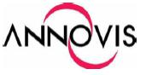

Annovis Bio Presented at the 14th Clinical Trials on Alzheimer’s Disease Conference

With additional data, the primary, secondary, and exploratory endpoints were met in Phase 2a study

BERWYN, PA., November 12, 2021 -- Annovis Bio, Inc. (NYSE American: ANVS) ("Annovis" or the "Company"), a clinical-stage drug platform company addressing Alzheimer's disease (AD), Parkinson's disease (PD), and other neurodegenerative diseases, today reported new data on ANVS401 from the Company’s Phase 2a study during the 14th Clinical Trials on Alzheimer's Disease conference (CTAD).

ANVS401 is an oral translational inhibitor of neurotoxic aggregating proteins (TINAPs) currently being developed for AD, AD in Down Syndrome, and PD. In the Phase 2a trial, ANVS401 was shown to be well-tolerated and safe, and its pharmacokinetics was found to be in line with levels measured earlier in humans, meeting both the primary and secondary endpoints. Additionally, exploratory endpoints were met when the Phase 2a data showed that ANVS401 treatment resulted in statistically significant improvement in motor function in PD patients and cognition in AD patients.

Data from the Phase 2a clinical trial presented today at CTAD showed that treatment with ANVS401 reduced neurotoxic proteins in both AD and PD patients (Figure 1). Further, ANVS401 decreased inflammation and improved axonal integrity and synaptic functions in both AD and PD patients (Figure 2 and Figure 3). All values are in comparison to placebo and are based on all data points.

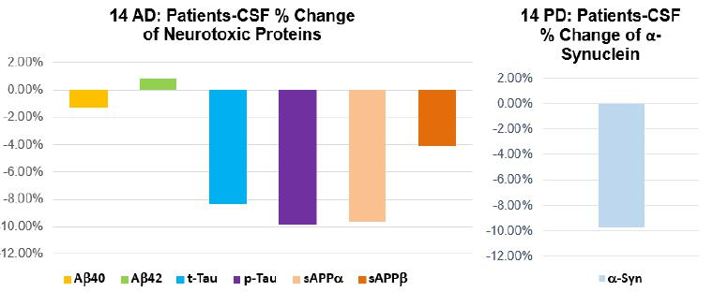

Figure 1 - APP (and its downstream products), t-Tau, and p-Tau are the neurotoxic proteins involved in AD, while α-Synuclein (α-Syn) is the neurotoxic culprit of PD.

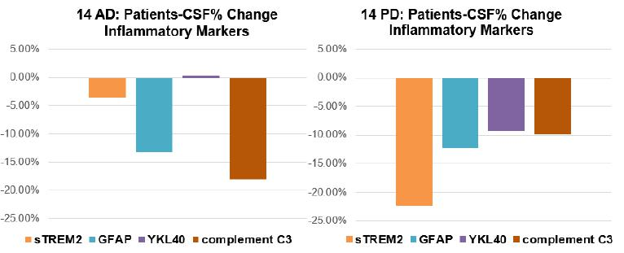

Figure 2 - Inflammatory markers are lowered in both AD and PD patients, showing a stabilization of inflammation in both neurodegenerative disorders.

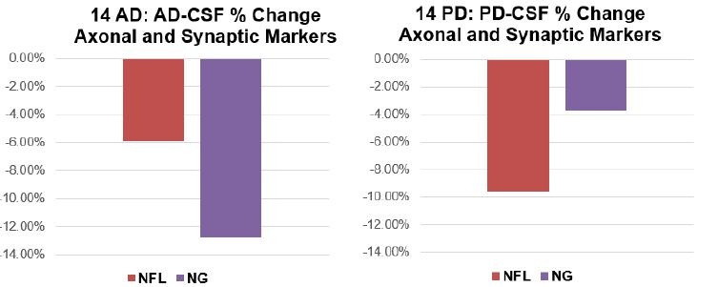

Figure 3 - Neuronal and synaptic markers are lowered in both AD and PD patients, meaning that the nerve cells are healthier.

This data strengthens the understanding of optimal ANVS401-induced neurotoxic protein reduction in both animal models and humans. In the Phase 2a study, most biomarkers and inflammatory markers of both AD and PD treated patients were reduced by 3 to 20% at ANVS401 doses that saw significant improvement in cognition and function. This aligns with AD and PD mouse model studies that showed APP and α-Syn were reduced by 5 to 20% and 3 to 10%, respectively, at ANVS401 doses that also saw significant improvement in cognition and function. This suggests that slight changes in ANVS401-reduced neurotoxic proteins result in significant downstream effects in both animals and humans.

“We believe we have begun to unravel the relationship between biomarker reduction and efficacy, a topic that has been a focus of research for some time. By comparing biomarker levels at fully effective doses of ANVS401 in both mice and humans suffering from AD and PD, we see that a small reduction in biomarkers and inflammatory markers is sufficient to lead to statistically significant improvements in outcomes,” commented Founder, President and CEO of Annovis Maria Maccecchini, Ph.D. “Meeting primary endpoints and the reversal of the toxic cascade combined with improvements in cognition and function are the foundation for us to ask the FDA for two meetings – one to move into two phase 3 clinical trials for AD and one to move into two phase 3 clinical trials for PD.”

The primary endpoint of the Phase 2a clinical trials, safety, was met as no serious adverse events (AEs) and no AEs leading to dosage withdrawal were observed in both Phase 2a clinical trials. It should be noted that most AEs were due to spinal fluid collection, which typically results in headaches and back aches in patients. Another endpoint was pharmacokinetics and the plasma levels of ANVS401 measured in this study corresponded to plasma levels seen in previous human studies.

A replay of the presentation will be available on demand on the conference website after 48 hours. The presentation slides will be also available on the Investors & Media tab of the Annovis website.

About Annovis Bio, Inc.

Headquartered in Berwyn, Pennsylvania, Annovis Bio, Inc. (Annovis) is a clinical-stage, drug platform company addressing neurodegeneration, such as Alzheimer's disease (AD), Parkinson's disease (PD), and Alzheimer's in Down Syndrome (AD-DS). We believe that we are the only company developing a drug for AD, PD, and AD-DS that inhibits more than one neurotoxic protein and, thereby, improves the information highway of the nerve cell, known as axonal transport. When this information flow is impaired, the nerve cell gets sick and dies. We conducted two Phase 2 studies: one in AD patients and one in both AD and PD patients. In the AD/ PD study our drug improves memory loss and dementia associated with AD, as well as body and brain function in PD.
For more information on Annovis Bio, please visit the company's website www.annovisbio.com and follow us on LinkedIn and Twitter.

Forward-Looking Statements

Statements in this press release contain "forward-looking statements" that are subject to substantial risks and uncertainties. Forward-looking statements contained in this press release may be identified by the use of words such as "anticipate," "expect," "believe," "will," "may," "should," "estimate," "project," "outlook," "forecast" or other similar words, and include, without limitation, statements regarding the timing, effectiveness, and anticipated results of ANVS401 clinical trials. Forward-looking statements are based on Annovis Bio, Inc.'s current expectations and are subject to inherent uncertainties, risks and assumptions that are difficult to predict. Further, certain forward-looking statements are based on assumptions as to future events that may not prove to be accurate. These and other risks and uncertainties are described more fully in the section titled "Risk Factors" in the Annual Report on Form 10-K for the year ended December 31, 2020, filed with the Securities and Exchange Commission. Forward-looking statements contained in this announcement are made as of this date, and Annovis Bio, Inc. undertakes no duty to update such information except as required under applicable law.

###

Media and Investor Contact:
Nic Johnson
Russo Partners, LLC
(303) 482-6405
nic.johnson@russopartnersllc.com

