UNITED STATES
SECURITIES AND EXCHANGE COMMISSION
Washington, D.C. 20549

SCHEDULE 14A

Proxy Statement Pursuant to Section 14(a) of
the Securities Exchange Act of 1934 (Amendment No. )

Filed by the Registrant x

Filed by a Party other than the Registrant ¨

Check the appropriate box:

¨ Preliminary Proxy Statement

¨ Confidential, for Use of the Commission Only (as permitted by Rule 14a-6(e)(2))

¨ Definitive Proxy Statement

x Definitive Additional Materials

¨ Soliciting Material under §240.14a-12

Annovis Bio, Inc.

(Name of Registrant as Specified in Its Charter)

(Name of Person(s) Filing Proxy Statement, if other than the Registrant)

Payment of Filing Fee (Check the appropriate box):

x No fee required.

¨ Fee paid previously with preliminary materials.

¨ Fee computed on table in exhibit required by Item 25(b) per Exchange Act Rules 14a6(i)(1) and 0-11.

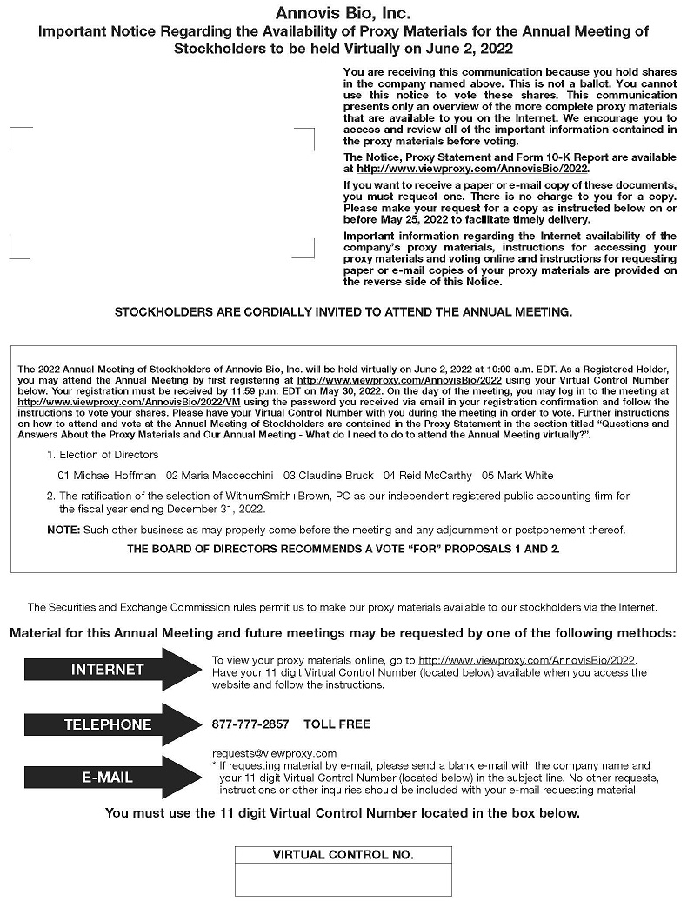
Annovis Bio, Inc. Important Notice Regarding the Availability of Proxy Materials for the Annual Meeting of Stockholders to be held Virtually on June 2, 2022 You are receiving this communication because you hold shares in the company named above. This is not a ballot. You cannot use this notice to vote these shares. This communication presents only an overview of the more complete proxy materials that are available to you on the Internet. We encourage you to access and review all of the important information contained in the proxy materials before voting. The Notice, Proxy Statement and Form 10-K Report are available at http://www.viewproxy.com/AnnovisBio/2022. If you want to receive a paper or e-mail copy of these documents, you must request one. There is no charge to you for a copy. Please make your request for a copy as instructed below on or before May 25, 2022 to facilitate timely delivery. Important information regarding the Internet availability of the company’s proxy materials, instructions for accessing your proxy materials and voting online and instructions for requesting paper or e-mail copies of your proxy materials are provided on the reverse side of this Notice. STOCKHOLDERS ARE CORDIALLY INVITED TO ATTEND THE ANNUAL MEETING. The 2022 Annual Meeting of Stockholders of Annovis Bio, Inc. will be held virtually on June 2, 2022 at 10:00 a.m. EDT. As a Registered Holder, you may attend the Annual Meeting by first registering at http://www.viewproxy.com/AnnovisBio/2022 using your Virtual Control Number below. Your registration must be received by 11:59 p.m. EDT on May 30, 2022. On the day of the meeting, you may log in to the meeting at http://www.viewproxy.com/AnnovisBio/2022/VM using the password you received via email in your registration confirmation and follow the instructions to vote your shares. Please have your Virtual Control Number with you during the meeting in order to vote. Further instructions on how to attend and vote at the Annual Meeting of Stockholders are contained in the Proxy Statement in the section titled “Questions and Answers About the Proxy Materials and Our Annual Meeting - What do I need to do to attend the Annual Meeting virtually?”. 1. Election of Directors 01 Michael Hoffman 02 Maria Maccecchini 03 Claudine Bruck 04 Reid McCarthy 05 Mark White 2. The ratification of the selection of WithumSmith+Brown, PC as our independent registered public accounting firm for the fiscal year ending December 31, 2022. NOTE: Such other business as may properly come before the meeting and any adjournment or postponement thereof. THE BOARD OF DIRECTORS RECOMMENDS A VOTE “FOR” PROPOSALS 1 AND 2. INTERNET TELEPHONE E-MAIL The Securities and Exchange Commission rules permit us to make our proxy materials available to our stockholders via the Internet. Material for this Annual Meeting and future meetings may be requested by one of the following methods: To view your proxy materials online, go to http://www.viewproxy.com/AnnovisBio/2022. Have your 11 digit Virtual Control Number (located below) available when you access the website and follow the instructions. 877-777-2857 TOLL FREE requests@viewproxy.com * If requesting material by e-mail, please send a blank e-mail with the company name and your 11 digit Virtual Control Number (located below) in the subject line. No other requests, instructions or other inquiries should be included with your e-mail requesting material. You must use the 11 digit Virtual Control Number located in the box below. VIRTUAL CONTROL NO.

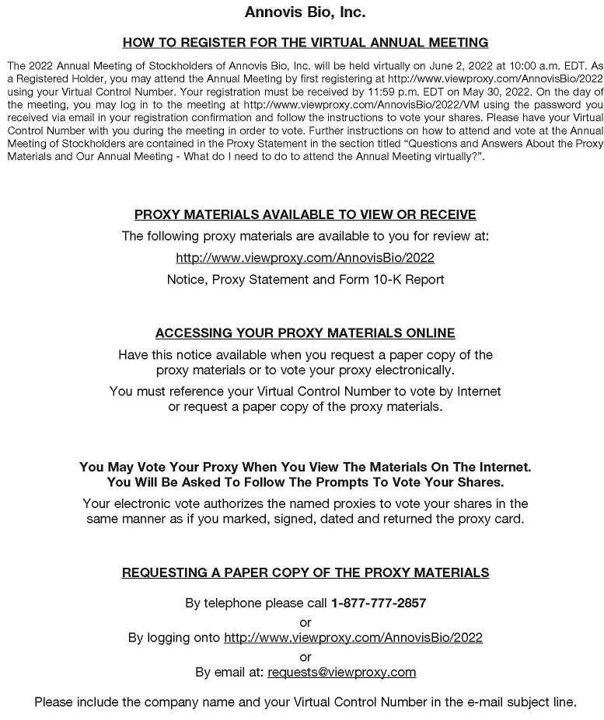
Annovis Bio, Inc. HOW TO REGISTER FOR THE VIRTUAL ANNUAL MEETING The 2022 Annual Meeting of Stockholders of Annovis Bio, Inc. will be held virtually on June 2, 2022 at 10:00 a.m. EDT. As a Registered Holder, you may attend the Annual Meeting by first registering at http://www.viewproxy.com/AnnovisBio/2022 using your Virtual Control Number. Your registration must be received by 11:59 p.m. EDT on May 30, 2022. On the day of the meeting, you may log in to the meeting at http://www.viewproxy.com/AnnovisBio/2022/VM using the password you received via email in your registration confirmation and follow the instructions to vote your shares. Please have your Virtual Control Number with you during the meeting in order to vote. Further instructions on how to attend and vote at the Annual Meeting of Stockholders are contained in the Proxy Statement in the section titled “Questions and Answers About the Proxy Materials and Our Annual Meeting - What do I need to do to attend the Annual Meeting virtually?”. PROXY MATERIALS AVAILABLE TO VIEW OR RECEIVE The following proxy materials are available to you for review at: http://www.viewproxy.com/AnnovisBio/2022 Notice, Proxy Statement and Form 10-K Report ACCESSING YOUR PROXY MATERIALS ONLINE Have this notice available when you request a paper copy of the proxy materials or to vote your proxy electronically. You must reference your Virtual Control Number to vote by Internet or request a paper copy of the proxy materials. You May Vote Your Proxy When You View The Materials On The Internet. You Will Be Asked To Follow The Prompts To Vote Your Shares. Your electronic vote authorizes the named proxies to vote your shares in the same manner as if you marked, signed, dated and returned the proxy card. REQUESTING A PAPER COPY OF THE PROXY MATERIALS By telephone please call 1-877-777-2857 or By logging onto http://www.viewproxy.com/AnnovisBio/2022 or By email at: requests@viewproxy.com Please include the company name and your Virtual Control Number in the e-mail subject line.

